Name ______________________
Landscape Auditing
Table of Contents
Description 3
Vocabulary 3
Demonstration 3
Materials/Tools 3
Activity #1 -- Basic Audit Procedure 4
Materials/Tools 4
Initial Observations 4
Procedure 4
Questions 8
Activity #2 -- Audit Analysis 9
Activity #3 -- Irrigation Scheduling 10
Activity #4 – Exploring Sprinkler Performance 11
Analysis 11
Questions: 12
How the data Was collected 12
Do your own test 12
Teacher’s Notes 14
Next Generation Science Standards 14
Glossary 15
Resources 16
Calculators and Other Resources 16
Appendix A – Sample Sprinkler Specifications 17
Appendix B – Sprinkler Performance Hunter PGJ 18
Densogram 40 PSI 35x35 Square. 18
Densogram 20 PSI 35x35 Square Spacing. 18
Sprinkler Profile 40 PSI. 19
Sprinkler Profile 20 psi 19
Appendix C – Average Evapotranspiration Durham California 20
Appendix D – Sprinkler Types 21

Description
The activity will develop observation and computational skills. The analysis requires synthesis of the available data to draw conclusions and make recommendations.
The purpose of the activity is to practice basic auditing of landscape irrigation systems using the Irrigation Association format. The purpose of an irrigation audit is to:
- Measure the performance of an irrigation system
- Determine the rate water is applied to the landscape for the purpose managing the irrigation system.

Vocabulary
- Audit
- Average
- Representative sample
- Distribution Uniformity
- Low Quarter
- Precipitation Rate
- Evapotranspiration (ET)
- Radius (sprinkler)
- Root Zone

Demonstration
Demonstrate common sprinkler problems so students can recognize issues. Ask how these problems might affect the even application of water. See examples of profiles and SPACE densogram.

Materials/Tools
- Sprinkler stand with a pressure gauge
- Small rotor sprinkler (ex. Hunter PGJ)
- Hose
- Tape
- Specifications for the sprinkler

Procedure:
- Setup the sprinkler and run at a normal pressure from a hose bib (about 40 psi). Observe the stream and measure the radius. Compare to specifications at the operated pressure.
- Reduce the pressure to 20 psi and repeat your observations. What has changed? Can you see the difference in the stream breakup?
- Return the sprinkler to vertical and normal pressure. Tilt the head 20 degrees (a “leaner”). Repeat the radius measurement in the direction of the tilt and on the opposite side. Compare to normal.

Activity #1 -- Basic Audit Procedure

Materials/Tools
24 containers (they need to be the same, soup cans or freezer containers will work)
Graduated cylinders (50 or 100 ml)
100’ tape measure
Wire flags
Watch

Optional:
Pressure gauges
Samples of fixed pop up spray head, rotor head (show and tell)

Initial Observations
An important part of understanding how an irrigation system performs is to observe the site and irrigation system in operation. Make notes and take photos. Some basic things to look for are:
- Dry and wet spots (look for water grass and other weeds)
- Type of sprinkler heads: pop-up, rotor, impact
- Make/Model/Nozzle size of sprinklers.
- Overspray (watering of concrete or buildings)
- Sprinklers that don’t rotate
- Head not rotating to properly cover the area (arc is set wrong)
- Crooked sprinklers, buried (too low) sprinklers
- Broken sprinklers (head missing or does not pop up)
- Plugged sprinklers
- Miss-matched heads or nozzles

Procedure
- Review the data collection forms.
- As a group determine how you will conduct the audit.
- Start the sprinkler system and mark the sprinkler locations with the flags. Turn off the system.
- Set out the container typically 2’ from each head and between sprinklers. The key here is to collect a representative sample of all areas. Containers should be level. Don’t place containers behind trees (in the shadow of a sprinkler). USE an MINIMUM of 8 containers. USE 16, 20 or 24 containers for better results.
- Start the system and run long enough to catch measurable water in all the containers. Typically for spray heads 5-10 min, for rotors 30-45 min.
- While the test is running:
  - Measure the site with the tape and draw a map. Indicate the location of each sprinkler with a circle. Note the dimensions of the area and spacing of the sprinklers on the map.
  - Draw the approximate location of each container (use an “X”). No need to measure.
  - Determine the make/model of the sprinklers and if possible the nozzle size. Note this on the map.
  - Note other factors that might affect your test like wind, low pressure, plugged sprinklers, leaning sprinklers.
- Turn off the system and record the run time on your data sheet.
- Carefully pour the water from each container into the graduated cylinder and record the volume on your data sheet.
- Determine the area of the container opening in square inches. Area = π R2 for round containers. Record this on your data sheet.
- Calculate the Distribution Uniformity (DU) as follows:
  - Mark on your sheet the lowest 25% (quarter) of your readings.
  - Calculate the average of the lowest 25% (the “low quarter”)
  - Calculate the average of all the readings.
  - Divide the low quarter average by the overall average to determine the DU.
  - Note: Calculations can be done online at:
http://www.agedweb.org/water/DUcalc/DUCalcHTML.htm
  - Calculate the average precipitation rate (PR) using your average catch.
PR=(ml x 3.66)/(min. x catchment area)
- Compare your results to the standards below. How does the site “measure up”?

Rating of Lower Quarter Distribution Uniformity (DULQ) for Sprinkler Zones
Type of Zone | Excellent (%) | Very Good (%)* | Good (%) | Fair (%) | Poor (%)**
Fixed Spray | 75 | 65 | 55 | 50 | 40
Rotor | 80 | 70 | 65 | 60 | 50
Impact | 80 | 70 | 65 | 60 | 50
* Irrigation Association Minimum Acceptable Standard
** DU’s below this level should not be used to schedule irrigations.

Area Map
Sketch the area being audited. Note sprinkler and catchment locations. Locate controller location(s) and zones (- - - line), major features, direction.



Precipitation Rate Analysis Worksheet
Location |  |  |  | Date
Start time |  | Stop time |  | Elapsed time (min)
Catchment area (sq. in) |  |  |  | System Pressure
DU (calc): |  |  |  | Average PR (calc)

Container # | Volume (ml) | Low Quarter
Average
DU=Average LQ ÷Overall Average

PR=(ml x 3.66)÷ (min. x catchment area)

Questions
Answer the following questions using complete sentences.
- Describe how your measured DU compares to the Irrigation Association standards.
- How does the pressure compare with the range published by the manufacturer?
- How does the sprinkler spacing compare with the radius in the manufacturers specification sheet? Use the measured
- A system is converted from a high flow (PR=1 in./hr) to a low flow (PR=.3 in./hr). Assuming the DUlq remains the same will this save water?
- What does the 3.66 constant do in the PR calculation? Can you determine how it is calculated?
- Explain why nozzle size is important rotor sprinkler system where some sprinklers are ¼, ½, or full circle.

Activity #2 -- Audit Analysis
- Compare your DU analysis to your initial observations. How does this site measure up?
- Using the manufactures web site look up the sprinkler model and nozzle. Compare the published radius and pressures to your observations.
- Review your notes on your initial observations. Do these explain your findings? For example was the catch low in a dry spot.
- Write a report that describes your:
  - Initial observations
  - Procedure for the audit
  - Findings (DU)
  - Conclusions/Recommendations

Activity #3 -- Irrigation Scheduling
Plants like lawn (turf) use predictable amounts of water. The goal of good irrigation management is to replace water in the soil as it is used by the plant. Since turf grass has a shallow root zone it is generally watered frequently. Think of the soil in the root zone as a reservoir that the plant can withdraw water from like a bank account. Unlike your bank account water that runs off or drains below the root zone is lost. Using the precipitation rate schedule the runtime for the system. Water use by the plants varies by the season with the peak use in California generally being late June or early July. Typical peak use in the Central Valley is about .20 inches of water per day. Many newspapers report ETo – the potential Evapotranspiration weekly. Turf grass is usually 70%-80% of this value (called the Kc). If you were to water every other day and the ETo = .25 in/day then you might expect turf to be using .2 in./day. Over two days this would be .4 in. To calculate the runtime you need to know the precipitation rate (from your audit).
Runtime Worksheet
PR: ______________ DU: ____________
ETo  (inches per day) | Kc | ETc | Days | Water to Apply | Runtime  (min)
Using the above example
.25 | 80% | .20 | 2 | .40 | 60  (DU=.77, PR=.5)

Useful Formula:
ETc=ETo X Kc
Water to Apply = ETc x Days (between irrigations)
RT (simple method) = Water to Apply ÷ (DU X PR) X 60 min/hr
RT (Complex method)* = Water to Apply ÷ ((.6 X (.4 X DU)) X PR) X 60 min/hr
* a more sophisticated method that takes in to account lateral movement of water in the soil.

Activity #4 – Exploring Sprinkler Performance
Sprinklers are designed to operate at specific pressures and spacing. Recommended pressures are shown in the manufacturers published chart. A common rule-of-thumb is to space sprinklers at published radius. For example the Hunter PGJ sprinkle chart shows a pressure range of 30 to 50 PSI and a radius of 31’ for a #3 nozzle at 40 psi. A common cause of low performance as measured by the Distribution Uniformity (DU) are systems operating at lower pressures or sprinklers installed too far apart. A desirable DU for sprinklers is 75% or better. Using the online “SPACE” tool explore how pressure and spacing affect the DU. The data below was collected for a Hunter PGJ sprinkler with a #3 nozzle.
 | Pressure | 20 PSI | 40PSI
 | Catchment Size (sq.In.) | 14 | 14
 | Time (minutes | 30 | 30
 | Catchment Spacing (ft) | 2 | 2
Catchment # | Distance | Volume (ml) | Volume (ml)
1 | 2 | 54 | 40
2 | 4 | 40 | 46
3 | 6 | 20 | 22
4 | 8 | 20 | 20
5 | 10 | 16 | 20
6 | 12 | 16 | 18
7 | 14 | 18 | 16
8 | 16 | 20 | 20
9 | 18 | 24 | 18
10 | 20 | 26 | 22
11 | 22 | 30 | 20
12 | 24 | 2 | 20
13 | 26 |  | 20
14 | 28 |  | 10
15 | 30 |  | 2

Analysis
Enter the data for 20 PSI and run the analysis for the spacings listed in the table below. Record the average precipitation rate (PR) and Distribution Uniformity of the Low Quarter (DU_{lq}).
Rectangular Spacing (ft) | Average PR | DU_{lq}
25 x 25
30 x 30
35 x35

Enter the data for 40 PSI and run the analysis for the spacings listed in the table below. Record the average precipitation rate (PR) and Distribution Uniformity of the Low Quarter (DU_{lq}).
Rectangular Spacing (ft) | Average PR | DU_{lq}
25 x 25
30 x 30
35 x35

Questions:
- How does the precipitation rate vary with the pressure? Hint: Compare at the the two pressures at the SAME spacing.
- How does the precipitation rate vary with the spacing? Hint: Look at ONE pressure and different spacings.
- Describe the difference in DU between the two pressures at 30x30 spacing.
- If these tests are typical what change in DU and precipitation rate would you expect to see if the pressure in a sprinkler system drops?

How the data Was collected
A single sprinkler was setup. Catchments were placed on a radius from the sprinkler every 2 feet. The sprinkler was operated at a specific pressure and time (see test data). Catchments were recorded.

Do your own test
- Place the sprinkler you want to test in a sprinkler stand like those that attach to a hose.
- Insert a pressure gauge between the hose and the sprinkler. Note: You can make a sprinkler stand from PVC pipe that has a ½”x1/2”x1/4” SST tee installed and use this for the pressure gauge.
- Place the stand in an open and level place like a driveway or parking lot.
- Turn on the sprinkler and adjust the pressure with the faucet. Note that the pressure needs to be fairly constant. Note the radius distance. Turn off the sprinkler.
- Using a tape measure place a mark every two feet along the radius.
- Setup catchments on the marks. If using Orbit style catchments you will need to make stands so they can be used on a hard surface. These can be made by cutting 1 ½” or 2” PVC pipe into 3” lengths.
- Note the time and start the sprinkler. Run long enough to catch measurable amounts in the catchments. Typically about 20-45 minutes.
- Shut off the sprinkler, record the time, and read the catchments.

Teacher’s Notes
The audit process is more than an excuse to play in the sprinklers. It represents a concrete example of using science for the practical purpose of improving water application and potentially saving water. Some suggestions for preparation of this activity:
- Select a site where the audit can be done by running one zone – no other zone overlaps the area. Otherwise you will need to run each zone that covers the audit area and it will take more time.
- Determine ahead how to run the time clock manually or operate the valves manually. Time clocks are often locked and differ widely in operation.
- Determine ahead about how long you will need to run the audit by placing a few catchments out and running the system. You need to collect measureable water. Hint: Most clocks can be manually set to run for a fixed time. During your audit set the clock and the sprinkler will automatically turn off at the end of the test (no time keeping required).
- Purchase a plastic tub to keep catchments and tools. Easier to hall about. Be sure to dry catchments before storage or cut holes in the tub for vents.
- Catchment containers can be purchased at a “dollar” store. Bean cans work well also. Orbit makes inexpensive catchments that can be directly read. See: Home Depot or Amazon.
- Pressure gauges, adapters, pipe fittings can be purchased at most irrigation suppliers. These folks may also have examples of heads that they will donate.

Next Generation Science Standards
HS-ETS1.A Defining and Delimiting Engineering Problems
HS-ETS1.B Developing Possible Solutions
HS-ETS1. C Optimizing the Design Solution
MS-ESS3.3 Earth and Human Activity- Apply scientific principles to design a method for monitoring and minimizing a human impact on the environment.
HS-ESS3.4 Earth and Human Activity- Evaluate or refine a technological solution that reduces impacts of human activities on natural systems

Glossary

Audit or Irrigation Audit | A detailed review of an irrigation system, including tests to determine overall system efficiency, identify problems areas that need correction, and determine an ideal watering schedule.
Average | Also called a mean, computed by dividing the total of all values by the number of values. For example, the mean of 1, 2, 3, 4, and 5 is (15 ÷ 5) = 3. It is the most common and best general purpose measure of the mid-point (around which all other values cluster) of a set of values, but is prone to distortion by the presence of extreme values.
Crop Factor (Kc) | The factor (constant) that relates ETo (reference ET) to a particular crop. Most crops use less water than ETo. Kc can also vary by stage of crop development. For example grapes will less water when the leaves are not fully developed.
Distribution uniformity [DU] {%, decimal} | Measure of the uniformity of irrigation water over an area. (ASAE, 1998). The higher the DU the more uniform the application of the water.
Distribution uniformity of lower quarter*[DUlq] {%, decimal} | Ratio of the average of the lowest one-fourth of measurements of irrigation water infiltrated (or applied) to the average depth of (the total) irrigation water infiltrated (applied). (ASAE, 1998)
Evapotranspiration [ET] {in./day, in./week, mm/wk, mm/day } | Combination of water transpired from vegetation and evaporated from the soil and plant surfaces. (ASAE, 1998)  crop [ETc]: Crop evapotranspiration is the quantitative amount of ET within the cropped area of a field, and which is associated with growing of a crop. (Burt, et al. 1997) Same as plant water requirement.  [ETo] Rate of evapotranspiration from an extensive surface cool-season green grass cover of uniform height of 12 cm, actively growing, completely shading the ground, and not short of water. (Mecham, Brent, 1999. Unpublished; also see ASCE, 1990)
Precipitation rate [PR] {in./h, mm/h} | Rate at which a sprinkler system applies water to a given area. (NRCS, 1997)  Precipitation rate for a system is the average precipitation rate of all sprinklers in a given area regardless of the arc, spacing, or flow rate of each head. (Monroe, 1993)
Radius of throw {ft, m} | Distance from the sprinkler head to the furthest point of water application and is used only for heads with circular wetting patterns.
Representative sample | A small quantity of something such as customers, data, people, products, or materials, whose characteristics represent (as accurately as possible) the entire batch, lot, population, or universe.
Root Zone | The depth of soil where active plant roots are found.
Spacing {ft, m} | between sprinklers: Distance from one sprinkler to the next one along a row.  between rows (of sprinklers): Distance between adjacent rows of sprinklers.  equilateral triangular spacing: Sprinklers are spaced in an equilateral triangular pattern.  rectangular spacing: Sprinklers are spaced in a rectangular pattern.  row spacing: Distance between the rows of sprinklers.  head to head spacing: Sprinklers are spaced so that each head throws water to the adjacent heads.  triangular spacing: Sprinklers are spaced in a triangular pattern.

Resources
Manufacturers Web Sites for sprinkler specifications. Each of these sites has specifications for sprinklers. They will vary slightly in format.
Rainbird - http://www.rainbird.com/
Hunter – http://www.hunterindustries.com/
Toro - http://www.toro.com/en-us/irrigation/pages/default.aspx

Calculators and Other Resources
Irrigation Association - http://www.irrigation.org/Resources/Resources_Splash.aspx
Online DU Calculator - http://www.agedweb.org/water/DUcalc/DUCalcHTML.htm
ETo – CIMIS – http://cimis.dwr.ca.gov

Appendix A – Sample Sprinkler Specifications
Hunter PGJ

Appendix B – Sprinkler Performance Hunter PGJ
Densograms show the precipitation rate in an area where sprinklers overlap. Colors indicate different precipitation rates in the pattern.

Densogram 40 PSI 35x35 Square.
Normal pressure. DU=77%
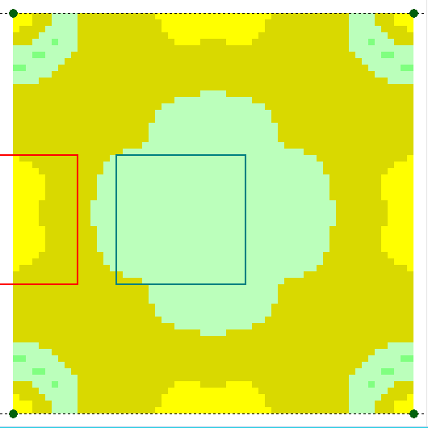

Densogram 20 PSI 35x35 Square Spacing.
Under pressure condition. Less stream breakup. Center dry and dry around the head. DU=52%
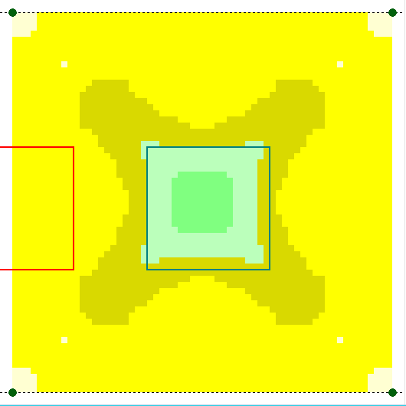

Sprinkler profiles deterime coverage. Note how the change in pressure affects the radius and precipation rate along the profile.

Sprinkler Profile 40 PSI.

Sprinkler Profile 20 psi

Appendix C – Average Evapotranspiration Durham California
Graph compares Reference ET (ETo) to water needs of warm (Bermuda) and cool (blue grass) season turf.
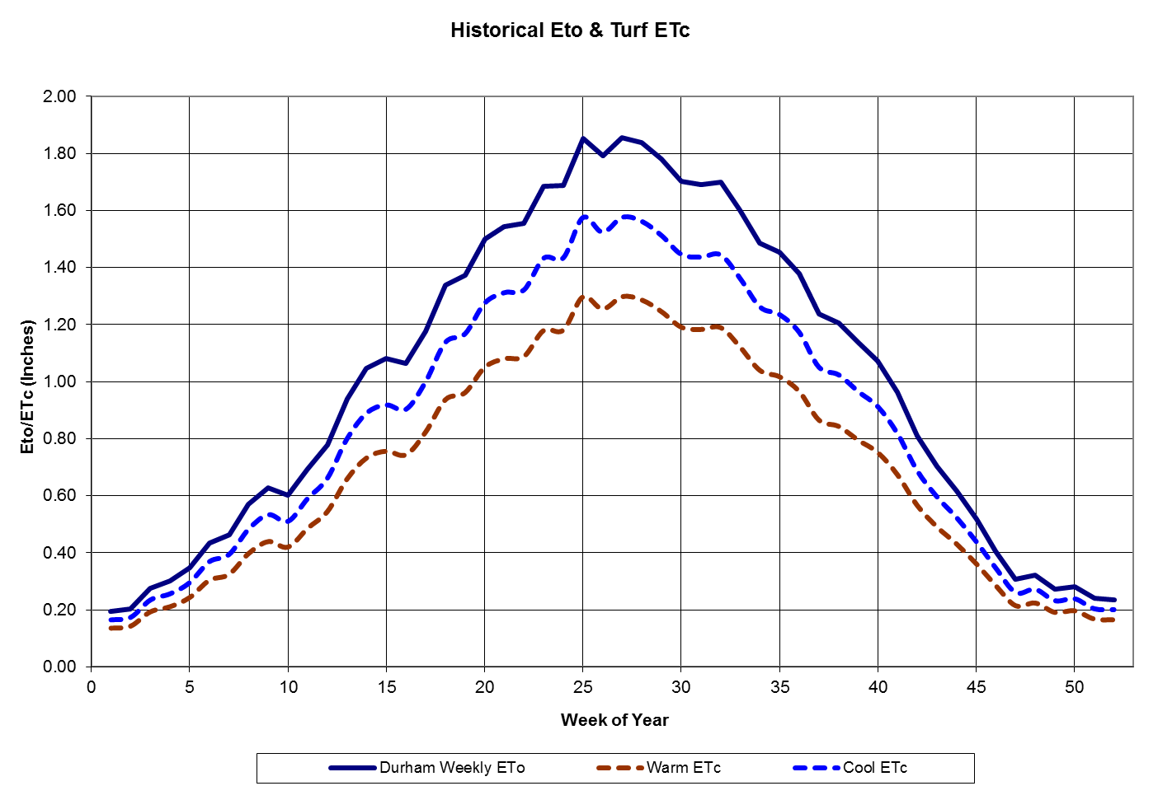

Appendix D – Sprinkler Types
Fixed pop-up spray heads  (ex. Rainbird 1800) | - Produce a fan type spray  - Commonly found in ¼, ½, and full circle. Other patterns are available.  - Flow is designed to match the area of coverage (“matched precipitation rate”). ¼ circle will have 25% of the flow of a full circle.  - Spacing limited to about 15’  - PR in the range of 1-2” per hour are common. Runoff is a common issue.
Rotor heads  (ex. Hunter PGJ) | - 1 or 2 water streams.  - Rotate in part or full circle  - Nozzles are interchangeable to provide a range of flow options. Flow is independent of rotation arc.  - PR varies with nozzle size and area covered. For example a #4 nozzle will apply 4 times the water in a 1/4 circle than in a full circle.  - Rotors are internal gear driven by water flow.  - PR in the range of .4-.8 inches per hour are common.
Impact | - Impact sprinklers are driven by an external arm deflected by the water stream. PR is similar to rotors.

