Basic Steps for Reading Ballots

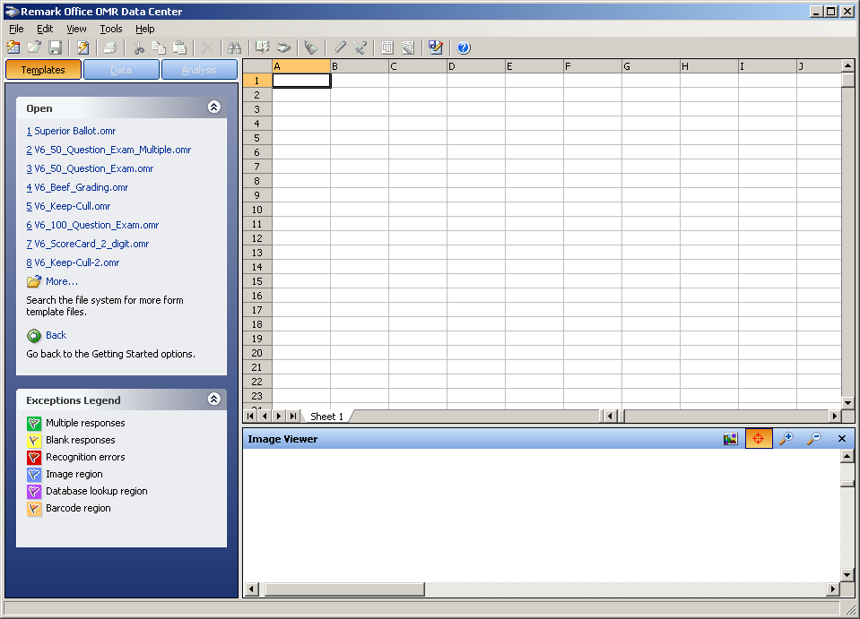
Choose Ballot Template
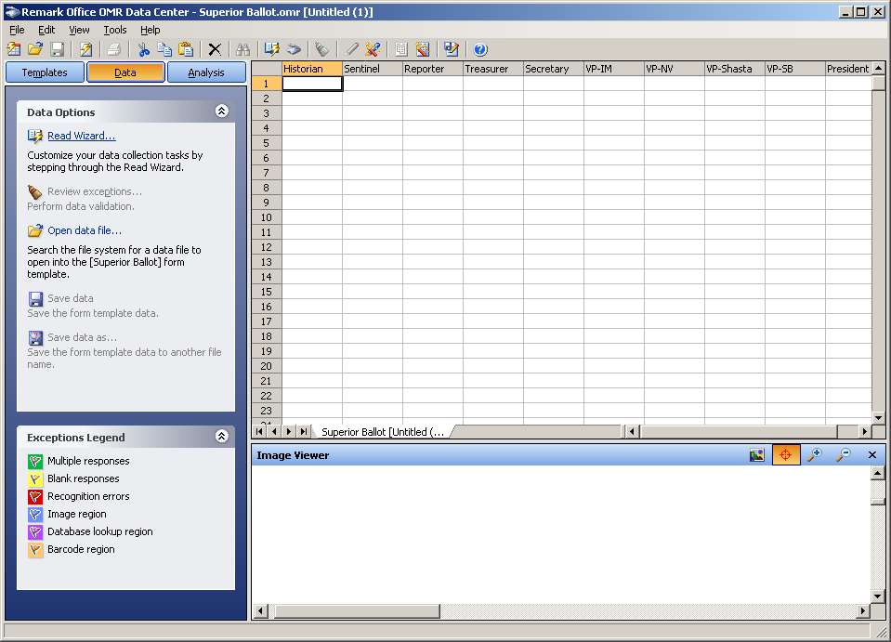
Use the Read Wizard to read ballots
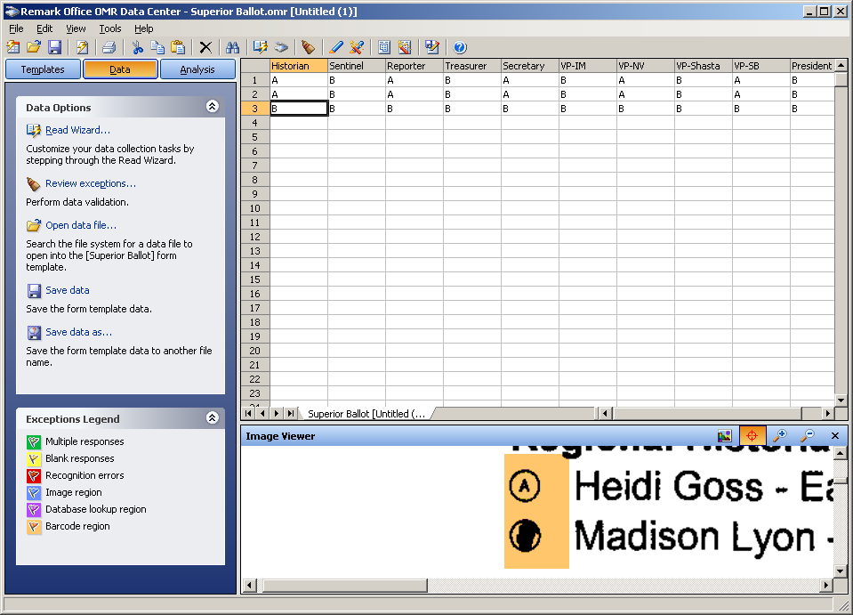

Review exceptions as needed. Then choose Analysis | Easy Survey
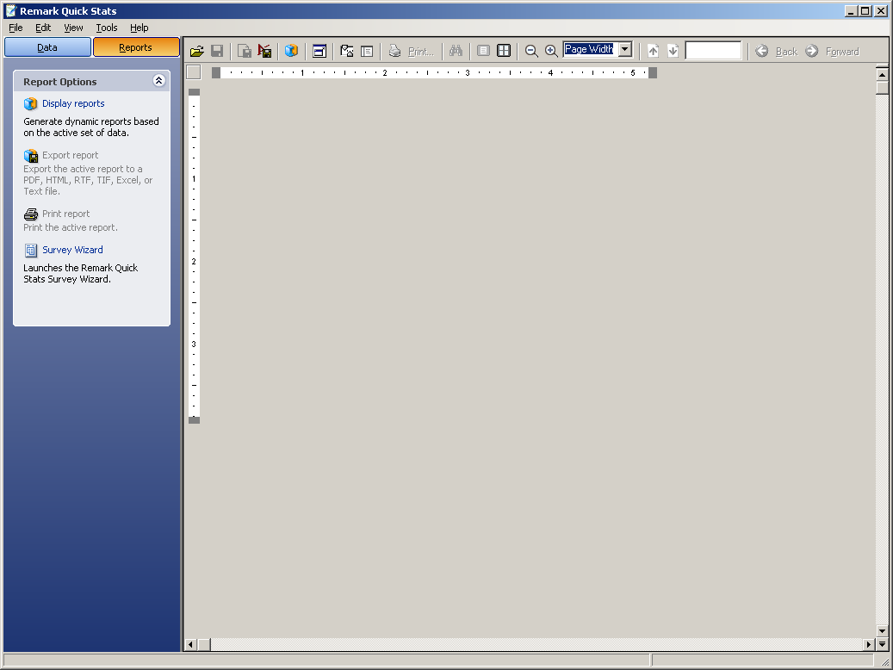

Select Display Reports
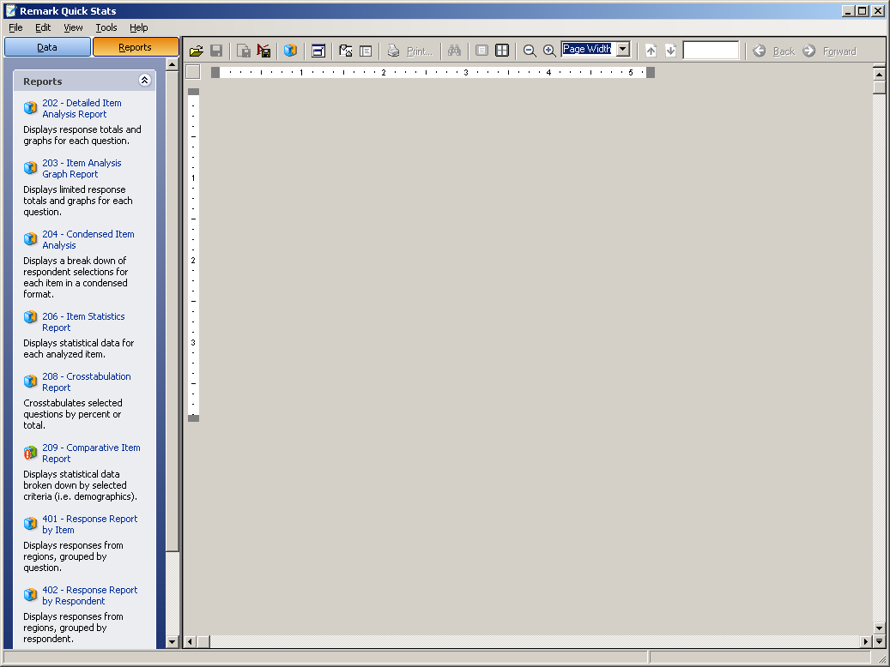

Choose Condensed Item Analysis
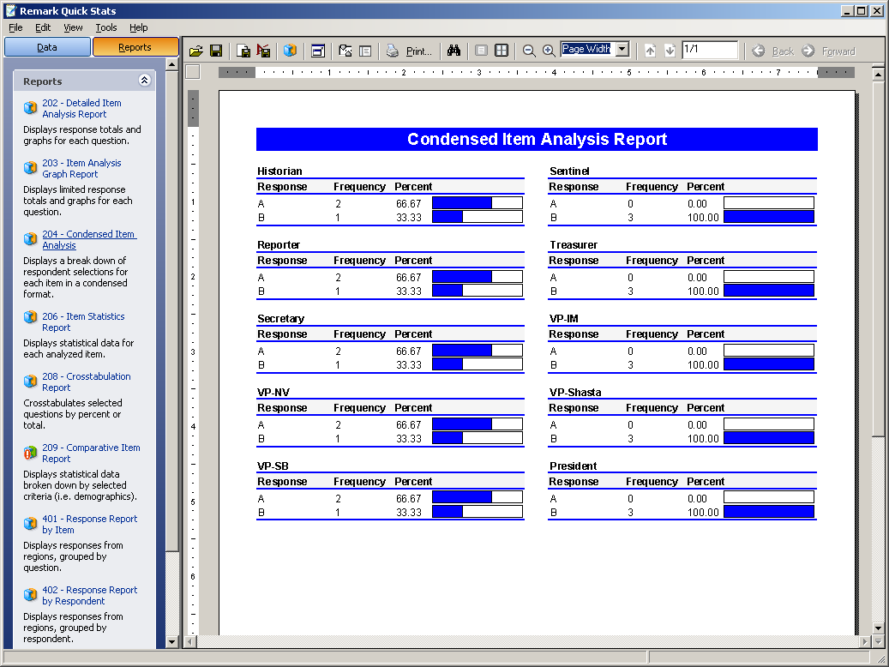

Print the report and align the letters with the names on the ballot.

