Retrieving Orthophotos from Microsoft's Terraserver

Mircosoft's TerraServer web site provides access to USGS Orthophoto that can be downloaded free of charge. For a description of orthophotos see: http://nsdi.usgs.gov/products/doq.html
- Using a web browser open the TerraServer site at: http://terraserver.homeadvisor.msn.com/
- Using the Find on the screen enter a place to begin. (See Figure 1.) For example, Hanford, CA. Or use the Advanced Find to enter latitude and longitude. Or click on the world map.
- Experiment with the controls on top of the image to zoom in or out. (See Figure 2.) Use the arrows around the image to "pan" to other areas. Note: If you have a higher resolution monitor you may want to change the image size to medium or large (see menu bar above the image). The pixel resolution is shown in meters (ex. 16m) above the image.
- When you have the image you want choose "Download" from the menu bar.
- Follow the directions on the download page (Figure 3) to download the image. A few tips!
  - Images are geo-referenced in UTM and will not align with data projected in other projections or in geographic coordinates.
  - If you are downloading several images use a consistent naming convention to insure that you can find the images later.
  - To import into ArcView you will need to turn on the JPG extension (see menu option File | Extensions)
  - TerraServer will provide georeferencing data in the form of an Arv View "world" file. An option exists on the download page to download this file. Some guidelines: The world file must have the same name as the image. For example: MyImage.JPG and MyImage.JPGW. When downloading the world file the web page makes it difficult to save the file with the correct extension (.JPGW), in the dialog box change "Save as type" to "All files", then type in the complete filename (ex. hanford.jpgw). See Figure 4. If your file is named incorrectly Arc View will not recognize it.
- Opening the saved image(s) in Arc View. Start Arc View and enable the JPG Extension. Create a new view. Add an image theme and select the files you saved in TerraServer. Change the view properties to meters to get an accurate scale. Note: Orthophotos can be used to create accurate base maps like field maps or street locations. Consider:
  - That most of the aerial photos were made in the early 1990's.
  - Base maps will be in UTM, but they can be re-projected into Geographic Coordinate System (GCS) for use with a GPS unit. (Use WGS-84.) Arc View's Projection Utility extension will perform this task.
- Note: Images can also be viewed in Arc Explorer.
Figure 1 -- TerraServer Home Page
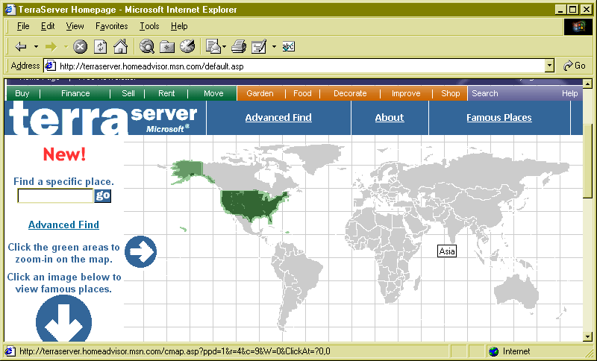

Figure 2 - Image Page
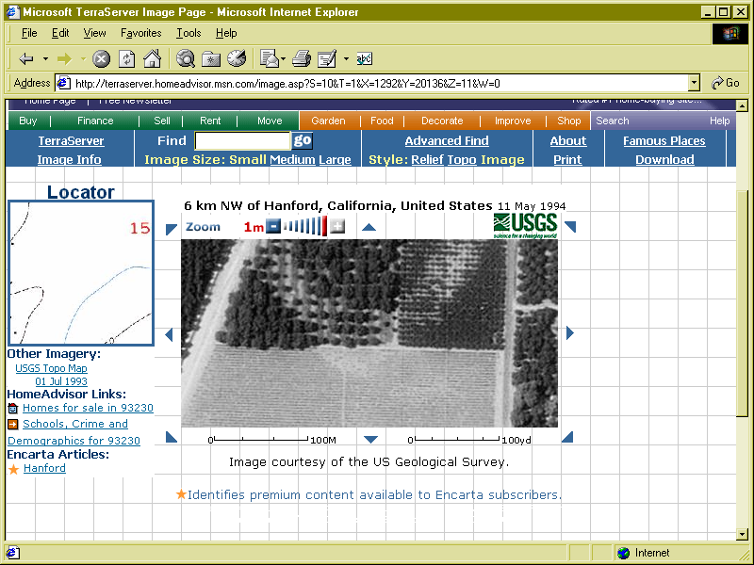
Figure 3 - Download Page
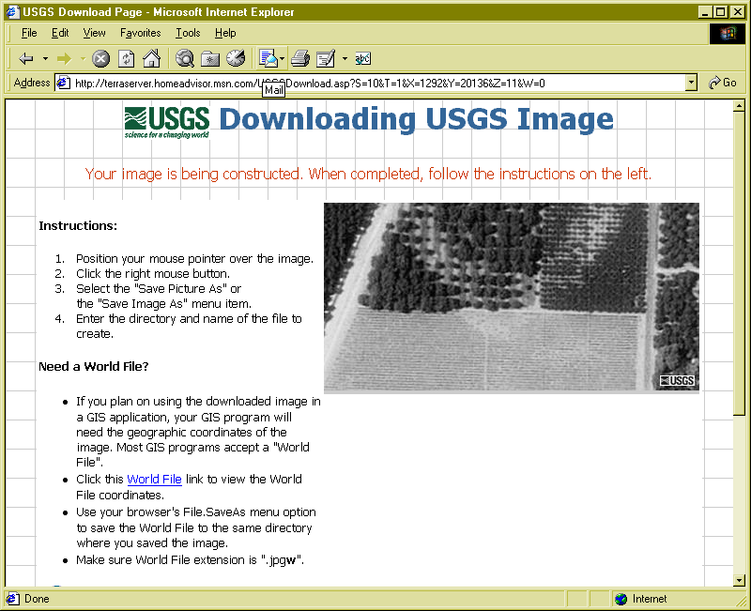

Figure 4 - Download dialog for world files
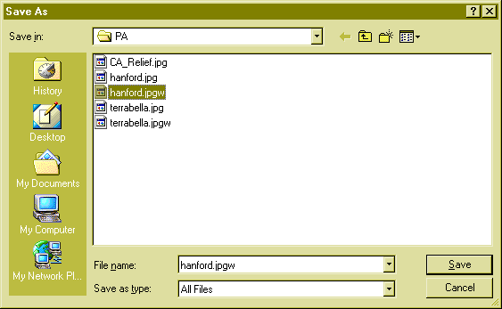
Figure 5 - Sample World File
1.000000
0.000000
0.000000
-1.000000
258200.000000
4027400.000000

How images are registered to a map

Images are stored as raster data, where each cell in the image has a row and column number. Shapefiles and ARC/INFO coverages are stored in real-world coordinates. In order to display images with coverages or shapefiles, it is necessary to establish an image-to-world transformation that converts the image coordinates to real-world coordinates. This transformation information is typically stored with the image.
Some image formats, such as ERDAS, IMAGINE, BSQ, BIL, BIP, GeoTIFF, and grids, store the georeferencing information in the header of the image file. ArcView uses this information if it is present. However, other image formats store this information in a separate ASCII file. This file is generally referred to as the world file, since it contains the real-world transformation information used by the image. World files can be created with any editor. They can also be created using ARC/INFO’s REGISTER command.

World file naming conventions

It’s easy to identify the world file which should accompany an image file: world files use the same name as the image, with a "w" appended. For example, the world file for the image file mytown.tiff would be called mytown.tiffw and the world file for redlands.rlc would be redlands.rlcw. For workspaces that must adhere to the 8.3 naming convention, the first and third characters of the image file’s suffix and a final "w" are used for the world file suffix. Therefore, if mytown.tif were in a an 8.3 format workspace, the world file would be mytown.tfw. If redlands.rlc was in an 8.3 format workspace, its world file would be redlands.rcw.

For images that lack an extension, or have an extension that is shorter than three characters, the "w" is added to the end of the file name without altering it. Therefore the world file for the image file terrain would be terrainw; the world file for the image file floorpln.rs would be floorpln.rsw.

How the georeferencing information is accessed

The image-to-world transformation is accessed each time an image is displayed (e.g., when you pan or zoom). The transformation is calculated from one of the following sources, listed in order of priority:

· the world file
· the header file (if the image type supports one)
· from the row/column information of the image (an identity transformation)

Because a world file has higher priority, you can override the header file transformation information by creating your own world file.

World file contents

The contents of the world file will look something like this:

20.17541308822119
0.00000000000000
0.00000000000000
-20.17541308822119
424178.11472601280548
4313415.90726399607956

When this file is present, ArcView performs the image-to-world transformation. The image-to-world transformation is a six-parameter affine transformation in the form of:

x1 = Ax + By + C

y1 = Dx + Ey + F

where

x1 = calculated x-coordinate of the pixel on the map
y1 = calculated y-coordinate of the pixel on the map
x = column number of a pixel in the image
y = row number of a pixel in the image
A = x-scale; dimension of a pixel in map units in x direction
B, D = rotation terms
C, F = translation terms; x,y map coordinates of the center of the upper-left pixel
E = negative of y-scale; dimension of a pixel in map units in y direction

Note The y-scale (E) is negative because the origins of an image and a geographic coordinate system are different. The origin of an image is located in the upper-left corner, whereas the origin of the map coordinate system is located in the lower-left corner. Row values in the image increase from the origin downward, while y-coordinate values in the map increase from the origin upward.

The transformation parameters are stored in the world file in this order:

20.17541308822119 - A
0.00000000000000 - D
0.00000000000000 - B
-20.17541308822119 - E
424178.11472601280548 - C
4313415.90726399607956 - F

Note ArcView does not rotate, or warp, images. If your world file has non-zero rotation terms (D and B parameters), the image may change its position relative to vector data in the same view when you zoom or pan. Use the ARC/INFO RECTIFY command to properly rotate the image.

Arc View Help © ESRI

