Precision Ag GPS Exercise
Introduction:
The purpose of this exercise is to:
- Familiarize you with the operation of uncorrected of GPS equipment.
- Learn how to create a simple perimeter map using GPS.
- To gain knowledge of how data is captured and transferred to GIS software.
In the Field:
This exercise describes the use of the Garmin Etrex GPS (about $99), but any GPS unit that provides data in decimal degrees could be used.
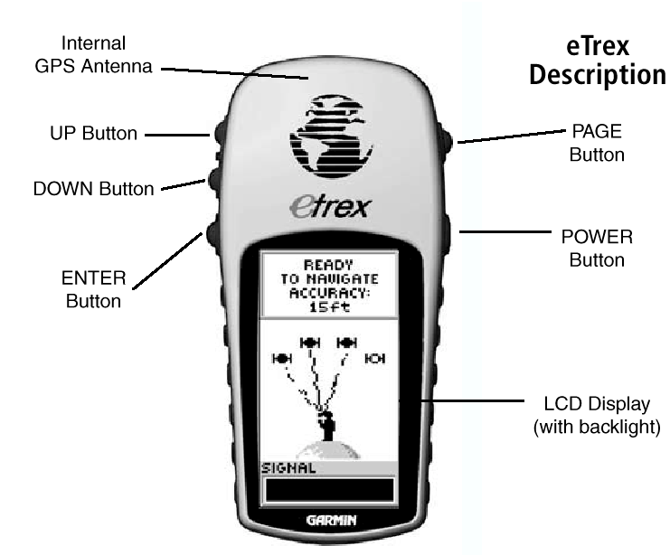
- Turn on the GPS unit by holding the Power Button until the unit powers up. Wait until the unit acquires the GPS satellites. (Pictures of the other screen used in this exercise can be found at the end of the document.)
- Answer the following questions:
  - What is the estimated accuracy shown on the Skyview page? ______________ ft. This number is based on the satellite geometry. DOP or Dilution of Precision is a similar estimate and is reported on more expensive GPS units.
N
  - Record the satellites in use (dark) on the diagram.
- Using the page button change to the Pointer Page. The unit should display Decimal Degrees at the bottom of the display. (e.x, W 119.12345). Use the down button to change the display as needed.
- Locate the points marked in the field and take a reading at each point. IMPORTANT: The location of the GPS reading is at the antenna, be sure locate the antenna directly over the point.
- Write down the readings below (record all of the digits).
Station Number | Latitude | Longitude | Accuracy (ft)
N
- Record the satellites in use now.
- Compare the satellites in use and their position to the diagram when you started the exercise. How have they changed? How did the accuracy change?

Complete the following in the computer lab. This portion of the activity will allow you to overlay the data collected by all of the groups. You should note the accuracy of the different systems and how this might influence what type of GPS equipment you use for different precision applications.
In the Lab:
- Enter the Station number, latitude, longitude, and accuracy separated by a comma into a text file. Save the file in the directory given by the instructor.
- Start ArcView as directed by the instructor.
- Import your text file as a table.
- Create an event theme (polygon)
- Compare your data to the other points on the map.
- Print a map using a layout.
- Review the specifications for the GPS receiver. How is the accuracy reported and what does this mean?
Garmin Etrex Performance
Receiver: Differential-ready, 12 parallel channel GPS receiver continuously tracks and uses up to 12 satellites to compute and update your position
Acquisition Times:
- Warm: approx. 15 seconds
- Cold: approx. 45 seconds
- AutoLocate™: approx. 2 minutes
Update Rate: 1 second, continuous
Accuracy:
- Position: 15 meters (49 feet) RMS (assumes S/A is off)
- Velocity: 0.1 knot RMS steady state
Dynamics: 6g's
Interfaces: RS232 with NMEA 0183, RTCM 104 DGPS data format and proprietary GARMIN
Antenna: Built-in patch

Physical
Size: 4.4"H x 2.0"W x 1.2"D (11.2 x 5.1 x 3.0 cm)
Weight: 5.3 ounces (150 g) with batteries
Display: 2.1"H x 1.1"W (5.4 x 2.7 cm) high-contrast LCD with bright backlighting
Case: Waterproof to IEC 529 IPX7 standards
Temperature range: 5°F to 158°F (-15°C to 70°C)
Data storage: Indefinite; no memory battery required

Power
Source: 2 AA batteries (not included)
Battery Life: Up to 22 hours

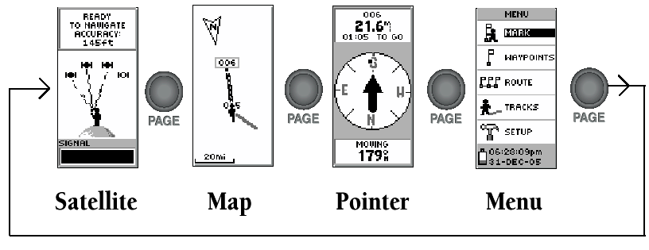
Etrex Pages. Use the Page button to change the current page viewed.
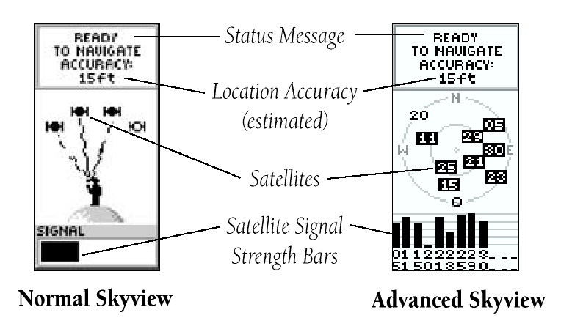
Skyview Page
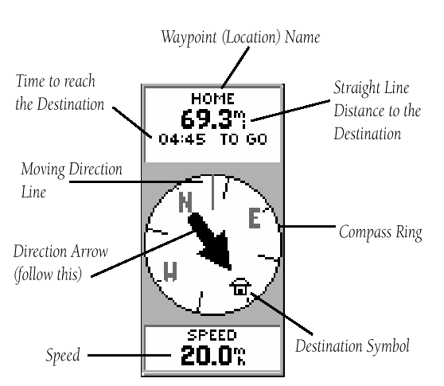
Pointer Page

