Obtain permission from instructor before operating this machine |  | Wood Lathe



Safety suggestions
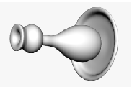
- Eye protection must be worn when operating this machine.
shape spinning wood
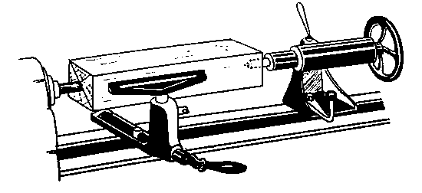
- Ensure all locks are secure and test the free rotation of the wood before starting the lathe.

- The tool rest should be within ½” (12 mm.) of the work.
- Do not touch the spinning work with your hands.
- Confine long hair and loose clothing.
- Hold the chisel firmly, place it on the tool rest with your forward hand touching the tool rest.
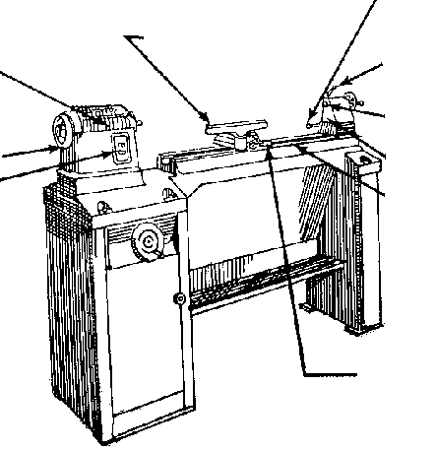
- Remove the tool rest when sanding
Tailstock locking
clamp
Tool rest
Spindle lock
Headstock
Spindle
Hand wheel
Power switch
Tailstock
Bed
Tool rest lock
Wood Lathe

Name …………………..

Class …………………….

Date ………………………

Safety Quiz

1. | The speed of the lathe is not important for safe operation. | T | F
2. | Eye protection is not necessary when turning. | T | F
3. | A gap of 1” is safe between the tool rest and the wood. | T | F
4. | Stock for face plate turning should be pre-cut round prior to mounting.  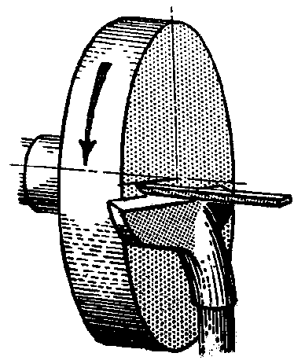 | T | F
5. | It is safe to feel for smoothness while turning. | T | F
6. | Chisels should be held firmly. | T | F
7. | Remove the tool rest when sanding. | T | F
1.
2.
3.
4.
5.
6.
7.
8.
9.

10.

