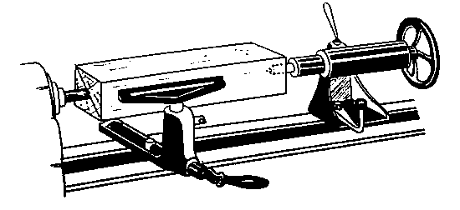
Wood Lathe graphics:


Spindle turning

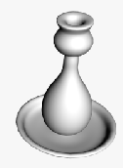

sample

Cartoon
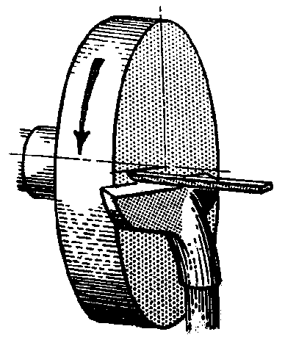

Faceplate

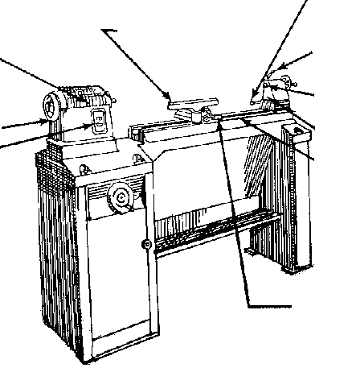
Headstock
Hand wheel
Power switch
Tool rest
Tailstock locking
clamp
Spindle lock
Spindle
Tailstock
Bed
Tool rest lock

Machine 1

Machine 2
1.
2.
3.
4.
5.
6.
7.
8.
9.

10.

