Obtain permission from instructor before operating this machine |  | Thickness Planer
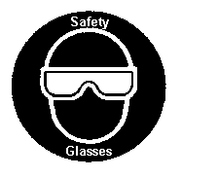
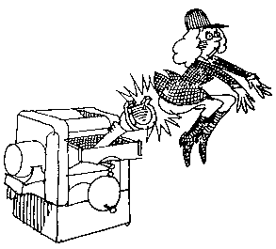

Safety suggestions
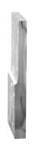
- Do not plane wood with cracks, loose knots, nails etc.
smooth and reduce
wood in thickness
- Adjust the planer opening smaller than the thickness of the wood. Maximum cut is 1/8” (3mm.).
- Turn on the dust collector, open the chute…
- Stand to the side when feeding wood into the planer.
- Do not look through the throat of the planer when the machine is operating.
- Do not remove chips when the machine is running.
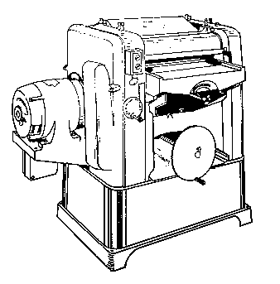
- Wood must exceed the machine’s minimum length ( ______ __).
Depth of cut gage

Elevating handwheel
Table
Throat
Variable feed speed control
Power switch

Thickness Planer

Name …………………..

Class …………………….

Date ………………………

Safety Quiz

1. | The maximum cut should not exceed 1/8” (3mm.). | T | F
2. | Eye protection is not necessary when planing. | T | F
3. | 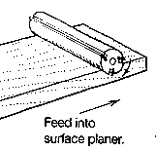  Wood will plane smooth if the grain slopes downward away from the operator. | T | F
4. | Never clean chips when the machine is running. | T | F
5. | Do not look into the machine the planer is running. | T | F
6. | Wood shorter than ……….” (…….mm.) may be planed. | T | F
2.

6.
5.
4.
1.
3.

