Thickness Planer graphics:
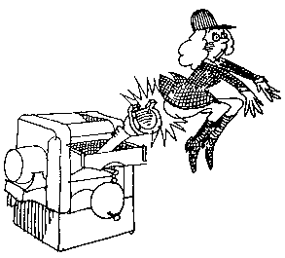

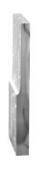
sample
Cartoon

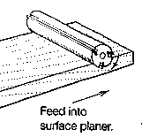

feed direction

Machine 1
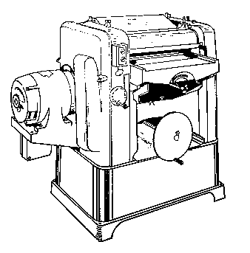
Depth of cut gage

Elevating handwheel
Table
Throat
Variable feed speed control
Power switch

Machine 2
2.

6.
5.
4.
1.
3.

