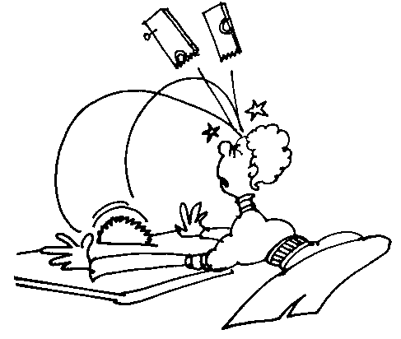
Table Saw graphics:

Cartoon

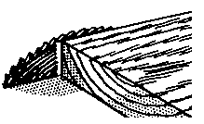
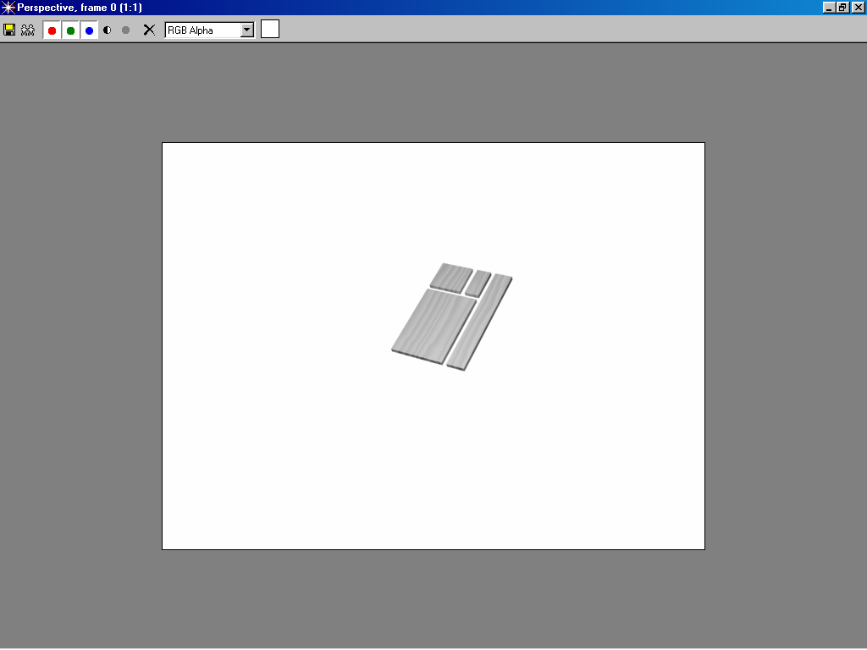
Blade height sample

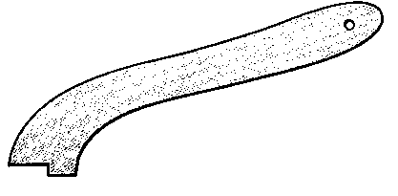
Push stick

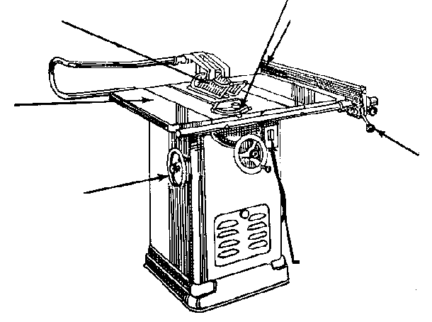
Machine 1
Guard

Table

Tilt handwheel
Height handwheel
Mitre gage
Fence

Fence clamp
Power switch

Machine 2
1.

2.

3.
4.
8.
7.

