Obtain permission from instructor before operating this machine |  | Spot Welder
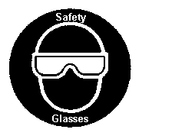
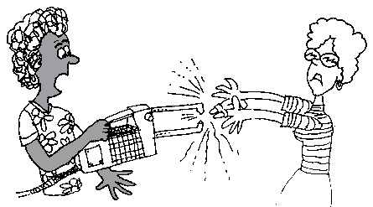

Safety suggestions
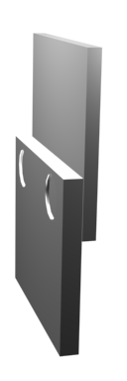
- Do not weld in damp areas or with wet hands.
fuse sheet metal
With electricity
- Do not touch the tips, tongs or welded material after welding as they become very hot.
- The metal being welded must be clean and dry.
- Tong tips should be clean (emery cloth) and cone shaped (file).
- Galvanized metal must have the galvanized coating removed prior to welding
- Do not leave the spot welder plugged in when not in use. .
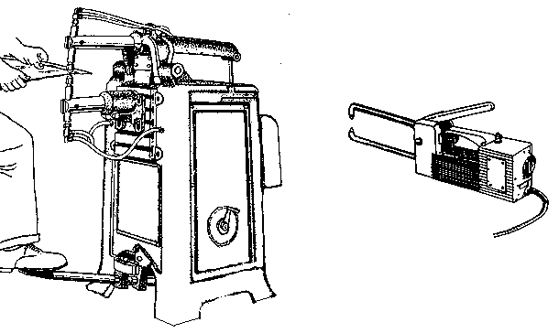
Tongs
Tips
Lever/ switch
Timer

Spot Welder

Name …………………..

Class …………………….

Date ………………………

Safety Quiz

1. | It is safe to use the spot welder in damp areas. | T | F
2. | Eye protection is not necessary when spot welding. | T | F
3. | The metal and the tong tips are very hot after welding.  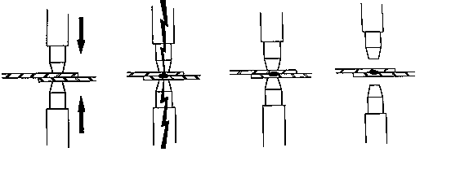  Pressure is applied.  Welding current  Hold  Release  Hot! | T | F
4. | The metal being welded must be clean and dry. | T | F
5. | Welding time is determined by the metal thickness. | T | F

1.
2.
3.
4.

