Spot Welder graphics:

sample
Cartoon
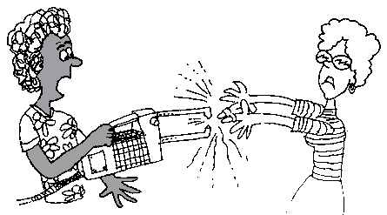
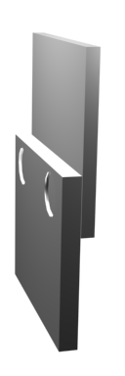

Spot welding

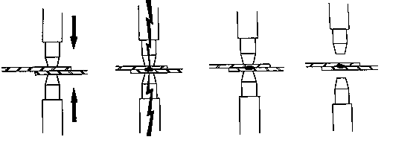
Pressure is applied.
Welding current
Hold
Release
Hot!

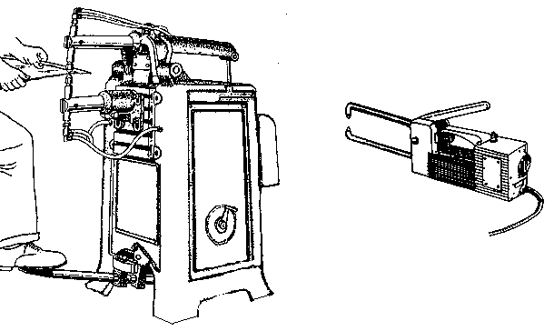
Machine 1
Tongs
Tips
Lever/ switch
Timer

Machine 2
1.
2.
3.
4.

