Obtain permission from instructor before operating this machine |  | Soldering Iron


Safety suggestions
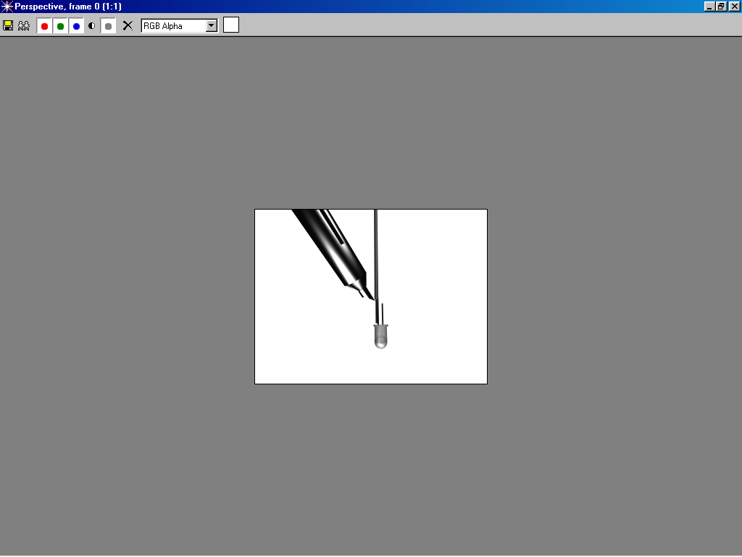
- Work in a well ventilated area. Avoid breathing soldering fumes.
Connecting electrical
components
- Check the power cord for damage before plugging it in
- Do not leave an unattended soldering iron plugged in.
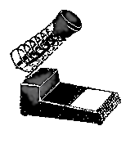
- Clean the soldering iron tip with a moistened sponge/towel. Do not flip excess soldering off the tip.
- For solder to bond properly, materials must be clean and hot enough to melt the solder.
- Store the hot iron in a soldering stand.
- Handle hot objects with extreme care, report any burns to your instructor.
Soldering Gun
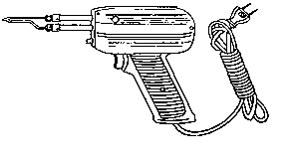

Soldering tip
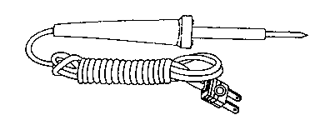
Insulated handle
Soldering Iron
Soldering Iron

Name …………………..

Class …………………….

Date ………………………

Safety Quiz

1. | Work in a dry, well ventilated area. | T | F
2. | Components must be clean and hot. | T | F
3. | Apply only just enough solder to colour components silver.  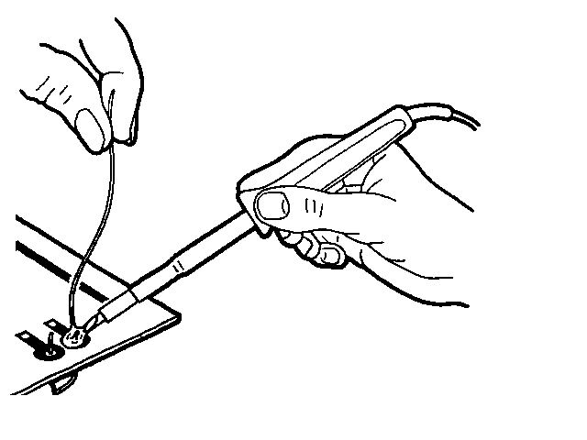 | T | F
4. | Store hot irons in a proper stand. | T | F
5. | Immerse a burn injury immediately in cold clean water, report to your instructor. | T | F
1.
3.
2.
4.

