Obtain permission from instructor before operating this machine |  | Scroll Saw
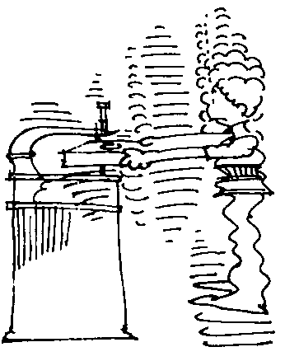

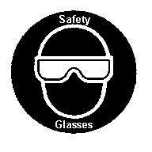

Safety suggestions
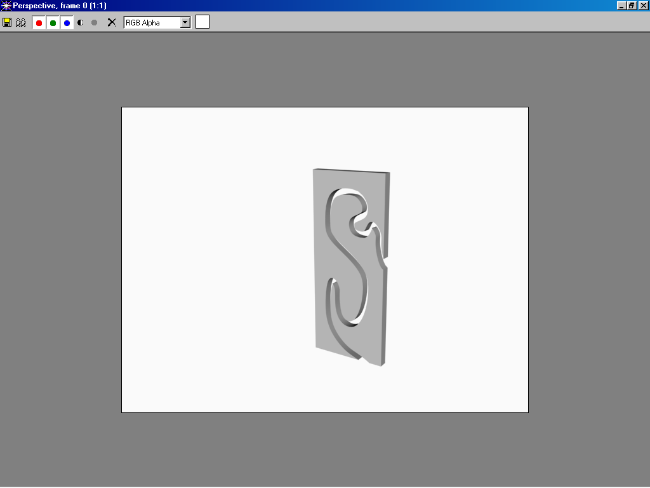
- Eye protection must be worn at all times.
Intricate cuts in various materials
- Lower the hold-down so that the spring fingers rest lightly on the work.
- Hold the material with your fingers away from the “line of cut”.
- Avoid overloading the blade by feeding the stock too fast.
- Avoid twisting the blade by turning too fast.
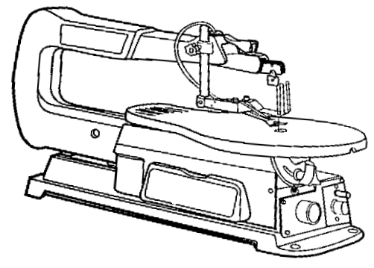
- Adjust the speed to achieve most efficient cutting action.
Hold-down lock
Blade tension lever
Guard

Hold-down

Blade
Table tilt lock
Power switch
Speed control

Name …………………..

Scroll Saw Class …………………….

Date ………………………

Safety Quiz

1. | Eye protection is not necessary when sawing. | T | F
2. | 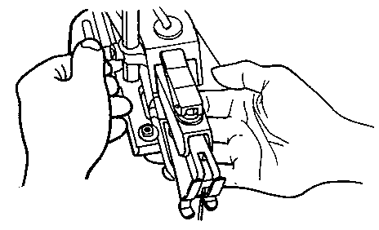  Lower the hold down until it rests on the work. | T | F
3. | Fingers should be placed on the “line of cut”. | T | F
4. | Turn corners only when feeding the stock. | T | F
5. | If the blade jams, do not stop the saw. | T | F
6. | High speed is best for all materials. | T | F
1.
2.
3.

5.
6.
7.
8.
4.

