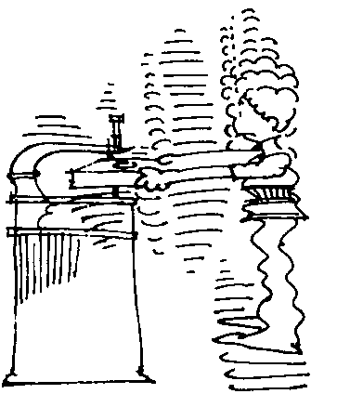
Scroll Saw graphics:

Cartoon

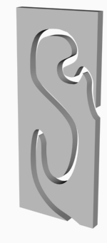
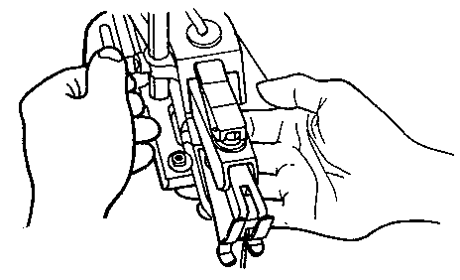
Sample hold – down

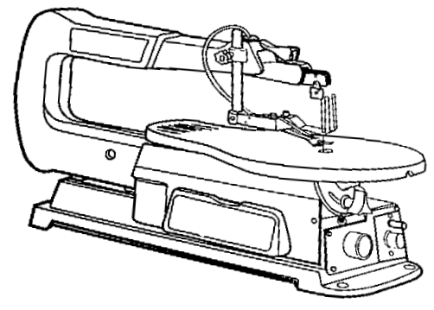
Machine 1
Hold-down lock
Blade tension lever
Guard

Hold-down

Blade
Table tilt lock
Power switch
Speed control

Machine 2
1.
2.
3.

5.
6.
7.
8.
4.

