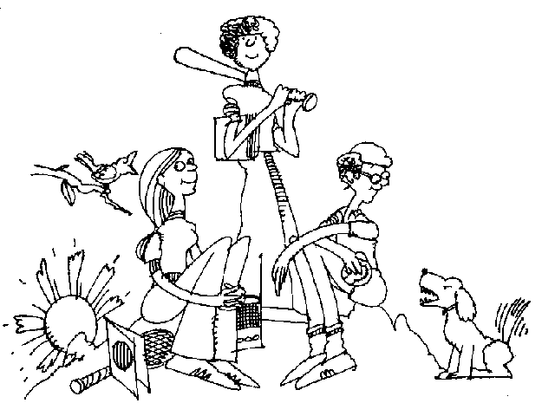
Safety – your decision
What have you got to lose?
Watching a sunset.
Looking into the eyes of your friend.
Listening to music.
Hiking, camping, fishing, snow boarding, dancing, swimming.
Playing with your dog.

Drawing, painting, craftwork. Playing an instrument.
Going to college, university, travelling.
Getting a good job.
Raising a family.
… you could lose

