Obtain permission from instructor before operating this machine |  | Sabre Saw
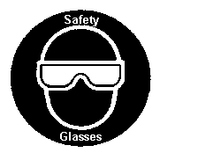
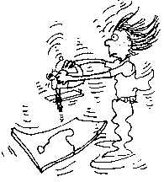

Safety suggestions

- Select an appropriate blade for the material being cut.
Irregular cuts in
various materials
- Do not change/install blades with the power cord plugged in. Properly secure the blade in the chuck.
- Ensure the switch is in the “Off” position before plugging cord in..
- Press the base firmly against your material before starting.
- Do not force the blade into the material use a firm, even pressure.
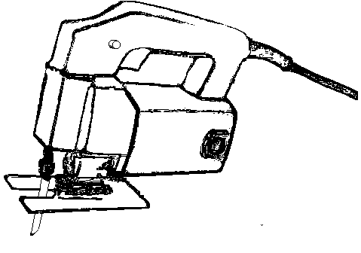
- Secure the material being cut.
Trigger switch
Base
Chuck
Blade
Angle scale

Sabre Saw

Name …………………..

Class …………………….

Date ………………………

Safety Quiz

1. | Many types of blades are available. Be sure you are using the correct blade for the material you are cutting. | T | F
2. | 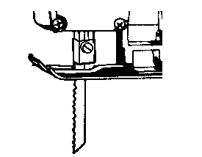  When installing a blade, ensure the blade is properly secured in the chuck. | T | F
3. | Eye protection is not necessary when using a sabre saw. | T | F
4. | Keep the base tight against your material.  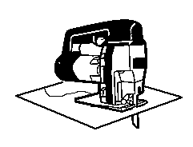 | T | F
5. | Cut with a steady, even pressure. Do not force the blade. | T | F
5.
3.
1.
2.
4.

