Sabre Saw graphics:

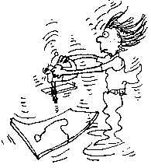

sample
Cartoon

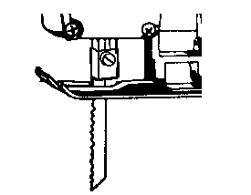
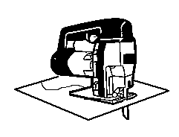
chuck downward pressure

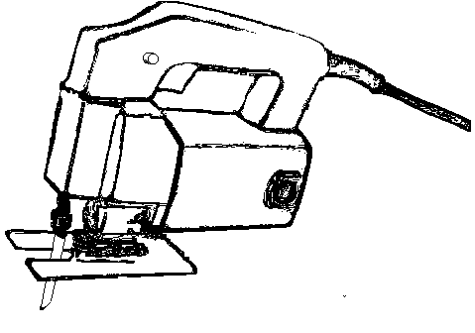
Machine 1
Trigger switch
Base
Chuck
Blade
Angle scale

Machine 2
5.
3.
1.
2.
4.

