Router graphics:

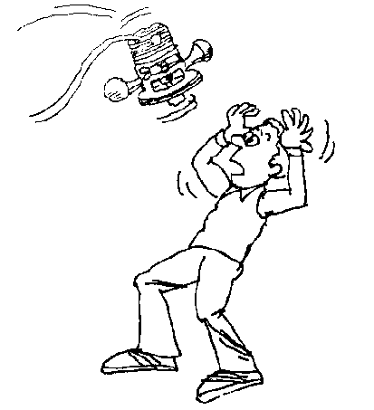
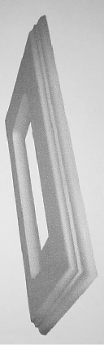
sample
Cartoon

Feed direction router movement
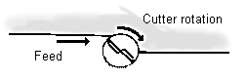
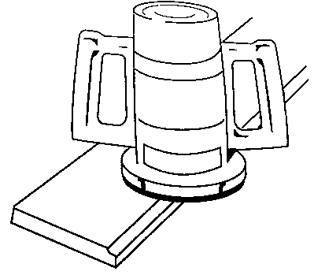
Feed direction

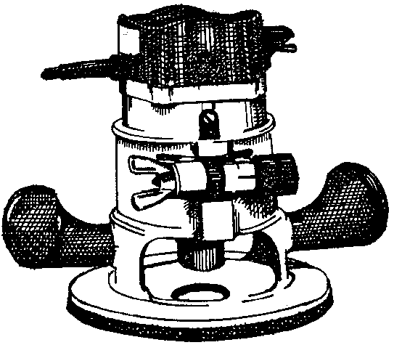
Power switch
Depth adjustment
Base
Depth adjustment lock
Collet chuck

Machine 1

Machine 2
3.
4.
5.

1.
2.

