Obtain permission from instructor before operating this machine |  | Radial Arm Saw

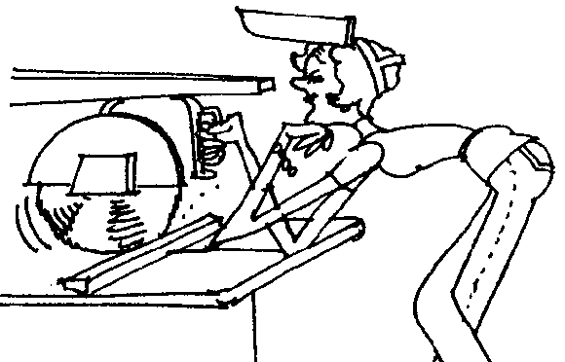

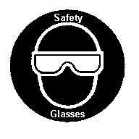

Safety suggestions
- Eye protection must be worn at all times.
Cutting wood to length
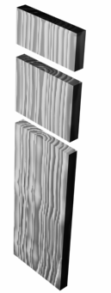
- Ensure that all machine guards are in place and that the saw travels freely on the arm before turning on the saw.
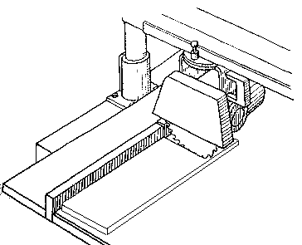
- Adjacent to the blade, the stock must be flat on the table and its back edge supported by the fence.
- Apply pressure on to the fence with your left hand while controlling the saw with your right.
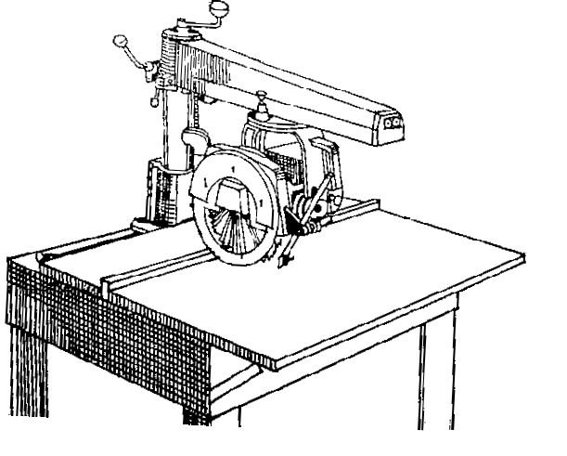
- Return the saw to the rear of the table on completion of the cut.
Arm
Handle
Kickback guard
Blade guards
Fence
.

Radial Arm Saw

Name …………………..

Class …………………….

Date ………………………

Safety Quiz

1. | Stock must rest securely on the table and along the fence. | T | F
2. | The saw tends to self-feed toward the operator.  Fence  Feed Direction  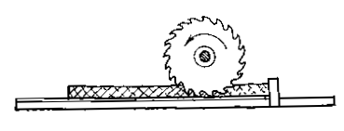 | T | F
3. | Apply pressure toward the fence with your left hand when cross cutting. | T | F
4. | Maintain a minimum distance of 4” (100 mm.) between your left hand and the blade path. | T | F
5. | Return the saw to the rear of the table on completion of the cut | T | F
6. | You may leave the machine as soon as the power is turned “Off”. | T | F
5.
4.
3.
1.
2.

