Obtain permission from instructor before operating this machine |  | Printed Circuit Board Tank
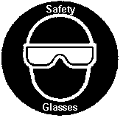
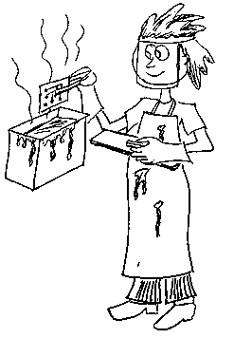

Safety suggestions
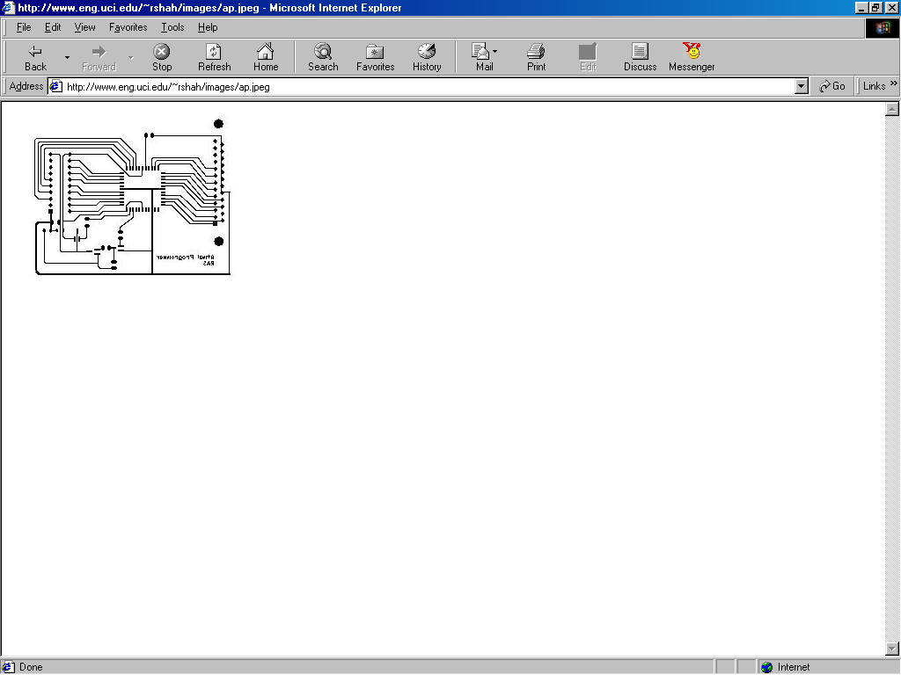
- Protective gear (face shield, gloves and apron) must be worn when using the tank.
etch printed
circuit boards
- The etchant chemical is corrosive. It can burn skin and eyes. It will also stain skin and clothes.
- Use tongs when handling circuit boards, be careful not to splash etchant.
- If etchant splashes in your eyes, flush immediately with cool water and inform your instructor.
- Etch your board for the time recommended, too long will ruin it.
- Rinse your printed circuit board thoroughly before touching it with your fingers.
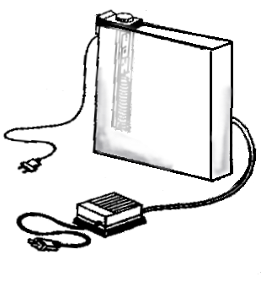
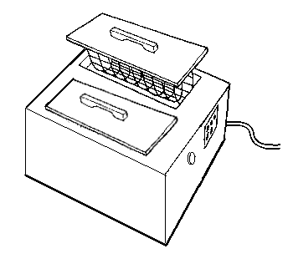

Heater

Tank

Air pump
Power switch
Printed Circuit Board

Tank Name …………………..

Class …………………….

Date ………………………

Safety Quiz

1. | 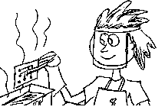  Eye protection is required when using the etching tank. | T | F
2. | The etching solution is safe to touch. | T | F
3. | Circuit boards may etch in the tank indefinitely. | T | F
4. | Etched boards must be thoroughly rinsed before touching them with your fingers. | T | F
3.
1.
2.
4.

