Obtain permission from instructor before operating this machine |  | Portable Electric Drill

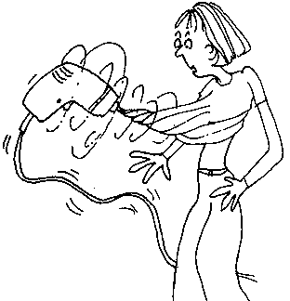


Safety suggestions
- Do not use in damp or wet areas.
cylindrical holes
- Unplug the power cord when changing drill bits.
- Ensure the bit is properly tightened before drilling.
- Secure the material being drilled to prevent it from spinning.
- Small bits require a faster speed. than larger bits.
- Drill with a steady even pressure, do not twist the drill.
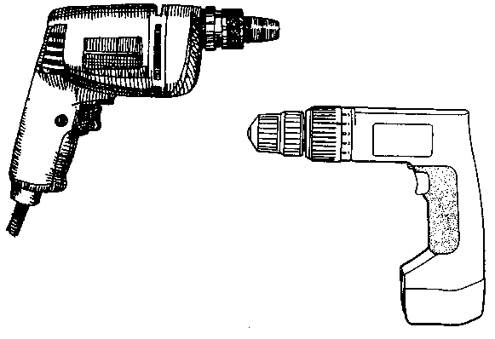
Reversing switch
Trigger switch
Chuck
Keyless chuck
Battery

Portable Electric Drill

Name …………………..

Class …………………….

Date ………………………

Safety Quiz

1. | Eye protection is not needed when drilling. | T | F
2. | Drills are safe to use in damp areas. | T | F
3. | 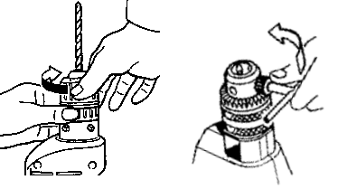  Tighten drill bits securely. | T | F
4. | Unplug the drill before changing the bit. | T | F
5. | Clamp material before drilling. | T | F
6. | Large diameter drill bits require faster speed than small bits. | T | F
3.
4.
1.
2.
5.

