Portable electric drill graphics:

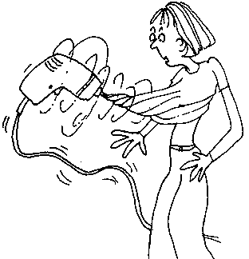
sample
Cartoon

bit / chuck

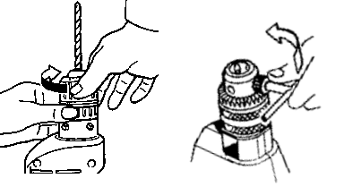

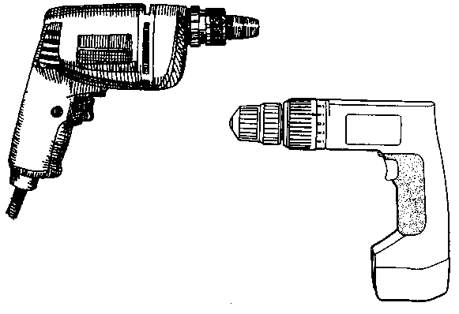
Machine 1
Reversing switch
Trigger switch
Chuck
Keyless chuck
Battery

Machine 2
3.
4.
1.
2.
5.

