Obtain permission from instructor before operating this machine |  | Portable Circular Saw

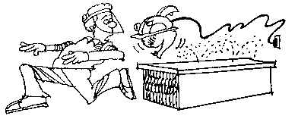
Safety suggestions
- Wear approved eye protection.
cut wood to length
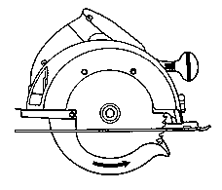
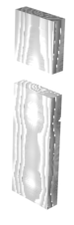
- Make all adjustments with the power cord unplugged.
- Be sure the power cord is clear of the blade.
- Ensure the retractable guard moves freely and is spring loaded.
- Tighten depth and tilt lock knobs.
- Secure the wood you are cutting.
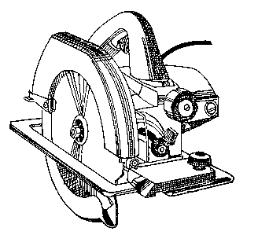
- Hold the saw with both hands.
Retractable guard
Depth lock
Tilt lock
Base
Switch
- Do not set the saw down until the blade has stopped moving.

Portable Circular Saw

Name …………………..

Class …………………….

Date ………………………

Safety Quiz

1. | Always check that the lower blade guard is spring-loaded and moves freely. | T | F
2. | 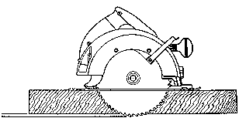  Adjust the blade depth so that a tooth extends beyond the thickness of the wood.  Lock | T | F
3. | Eye protection is not necessary when sawing.. | T | F
4. | 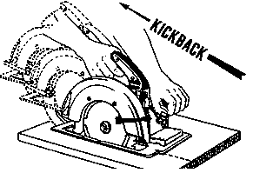  To minimize / control kickbacks, maintain a firm grip on the saw with both hands and cut straight. | T | F
5. | Never set the saw down until the blade stops moving. | T | F
5.
2.
3.
4.
1.

