Portable Circular Saw graphics:

sample
Cartoon
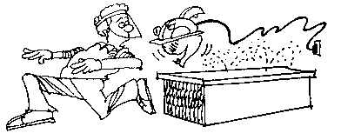
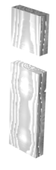

guards blade depth
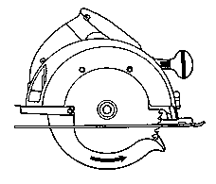
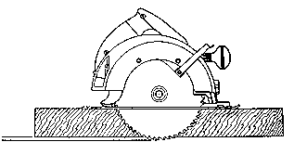

Lock

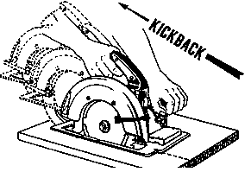
kickback

Machine 1
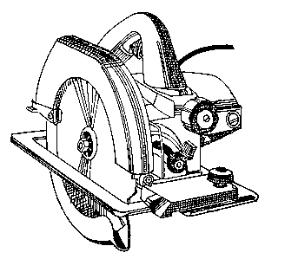
Retractable guard
Depth lock
Tilt lock
Base
Switch

Machine 2
5.
2.
3.
4.
1.

