Portable Belt Sander graphics:

sample
Cartoon

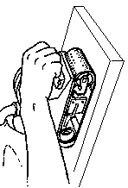

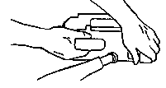
two hand use damaged belt
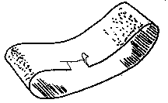

Machine 1

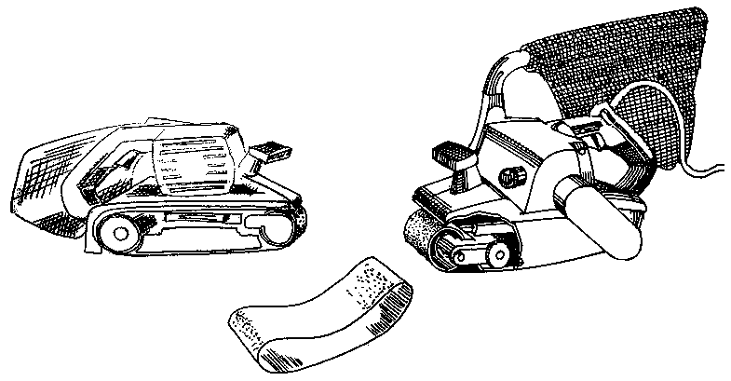
Dust bag
Power switch
Belt tracking mechanism
Belt tension lever

Machine 2
1.
2.
4.
3.

