Obtain permission from instructor before operating this machine |  | Oxy-Acetylene Welder
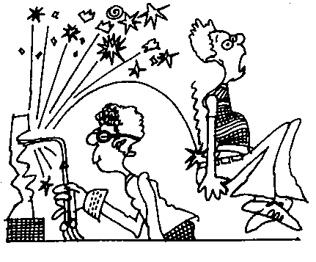
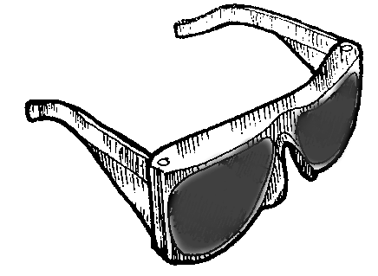
Safety suggestions
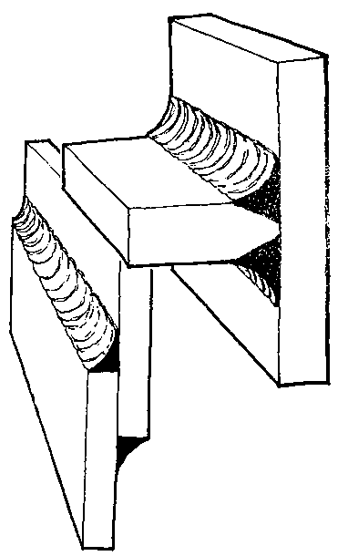
- Welding goggles and spark resistant clothing, leather gloves and apron must be worn.
weld steel
- Gas cylinders must be properly secured.
- Ensure adequate ventilation of the welding area..
- Obtain permission from your instructor prior to lighting the torch.
- Keep the flame and hot metal away from the hoses and tanks.
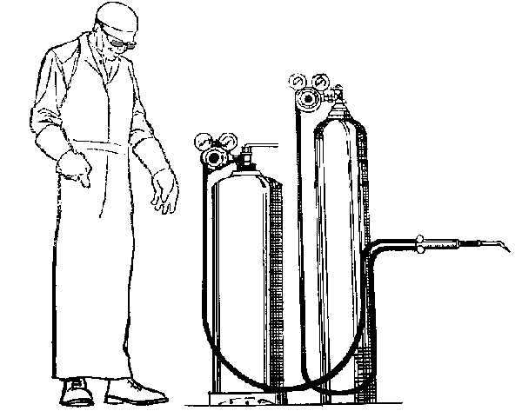
- Do not turn the acetylene gas on until you are ready to light the torch.
Goggles
Spark-clothing resistant
Acetylene tank
Oxygen tank
Hoses
Torch valves
Torch
Pressure regulator valves

Oxy-Acetylene Welder

Name …………………..

Class …………………….

Date ………………………

Safety Quiz

1. | Approved safety goggles and spark resistant clothing must be worn. | T | F
2. | Obtain approval from your instructor before lighting the torch. | T | F
3. | 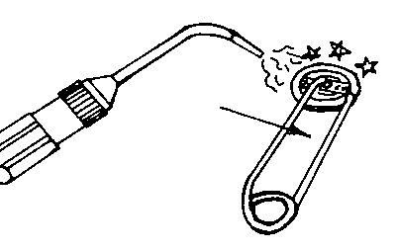  Always use a striker to ignite the torch. | T | F
4. | Ignite the acetylene, then turn on the oxygen. | T | F
5. | Closed containers are not hazardous to weld. | T | F
6. | Gas cylinders may be laid on the floor when not in use. | T | F
2.
1.
4.
5.
8.
6.
7.
3.

