Oxy-Acetylene Welder graphics:

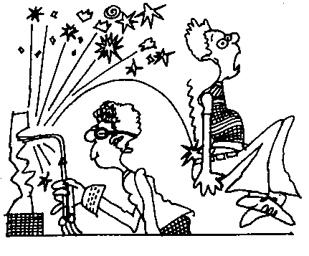
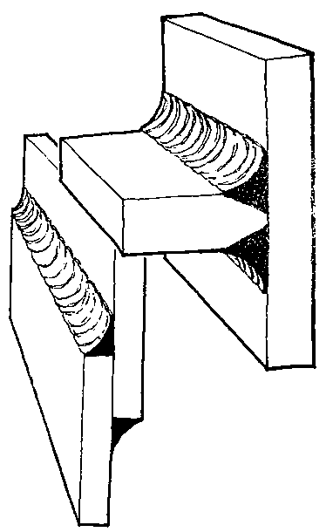
sample
Cartoon

striiker

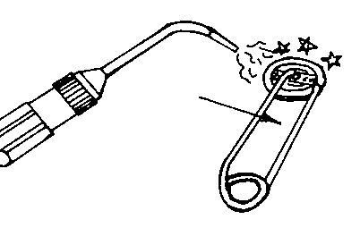

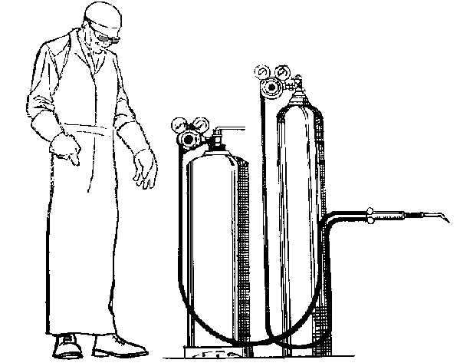
Goggles
Spark-clothing resistant
Acetylene tank
Oxygen tank
Hoses
Torch valves
Torch
Pressure regulator valves
Machine 1

Machine 2
2.
1.
4.
5.
8.
6.
7.
3.

