Mitre saw graphics:
sample
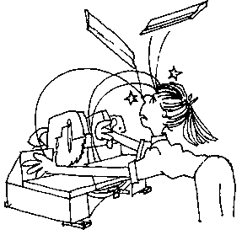
Cartoon

Machine 1
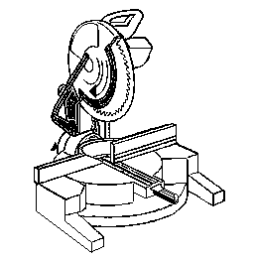
Handle
Vertical angle lock
Horizontal angle lock
Blade guard
Fence
Table

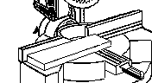
Cutting

Machine 2
1.
4.
3.
2.
5.
6.

