Obtain permission from instructor before operating this machine |  | Metal Squaring Shear
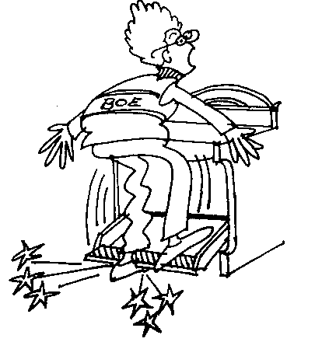

Safety suggestions
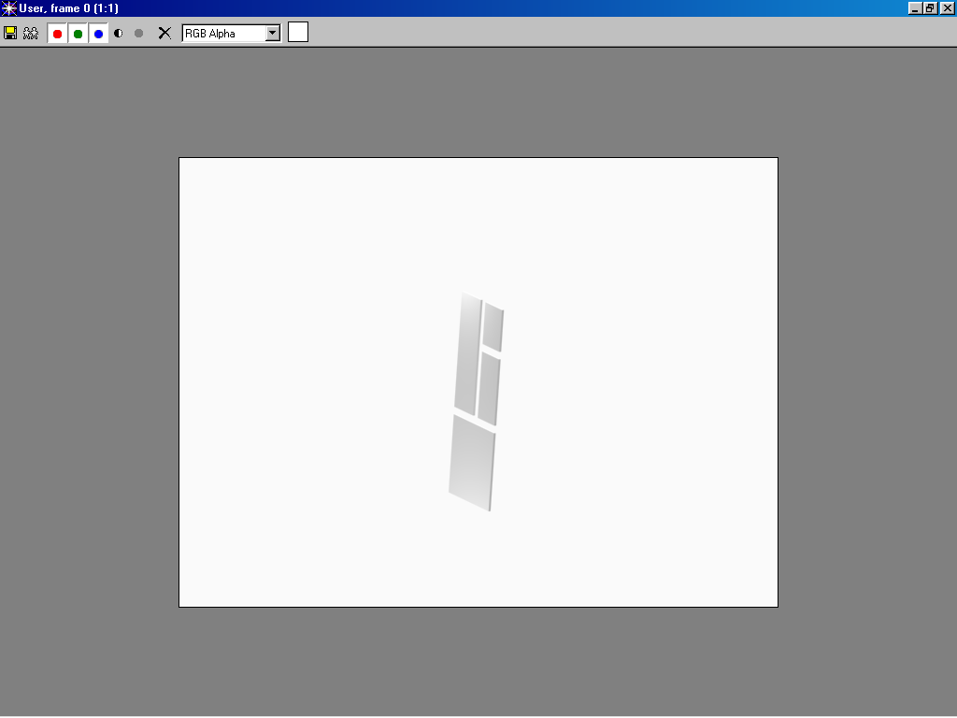
- Cut only sheet metal, wire may nick and ruin the blade.
Straight cuts in sheet metal
- Be careful when handling sheet metal, edges are sharp.
- Do not place a foot under the treadle.
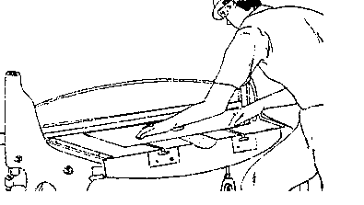
- Operate the machine from the treadle side only.
- Keep your fingers away from the hold-down guard and blade.
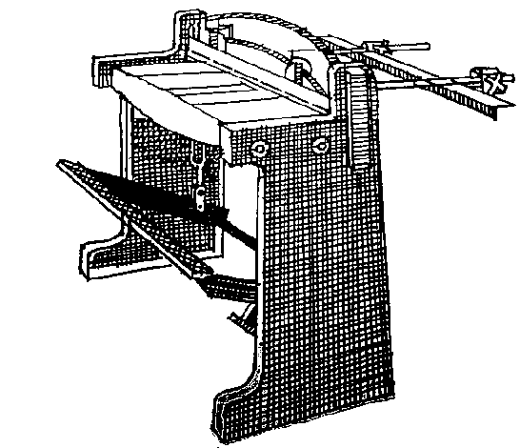
- Place all cuttings in the metal waste container.
Treadle
Hold-down guard
Blade
Side guides
Back gauge

Metal Squaring Shear

Name …………………..

Class …………………….

Date ………………………

Safety Quiz

1. | Feed and operate the machine from the treadle side only. | T | F
2. | Sheet metal edges are sharp. | T | F
3. | 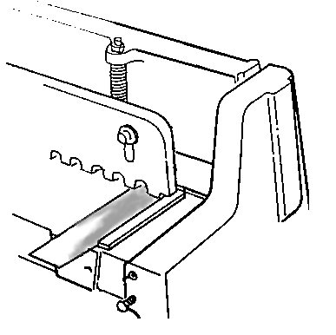  Use the side guides when cutting 90 degree angles. | T | F
4. | When necessary, the hold-down guard may be removed. | T | F
5. | Wire may be cut on the shear. | T | F
1.
3.
4.
2.
5

