Metal Squaring Shear graphics:

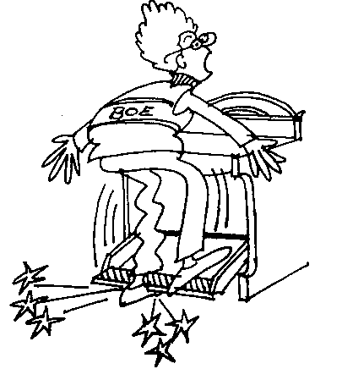
sample
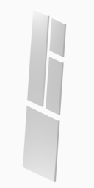
Cartoon

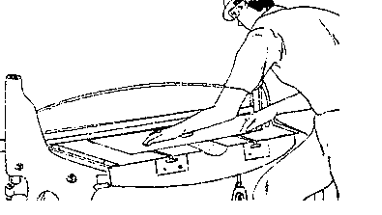
cutting

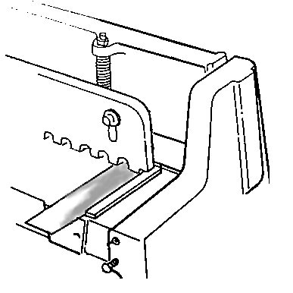
squaring

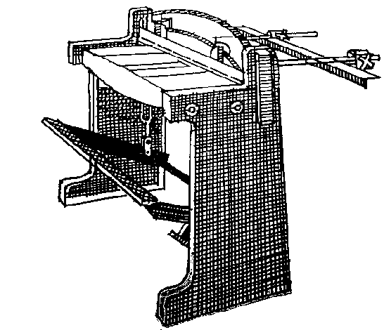
Machine 1
Treadle
Hold-down guard
Blade
Side guides
Back gage

Machine 2
1.
3.
4.
2.
5

