Obtain permission from instructor before operating this machine |  | Metal Lathe
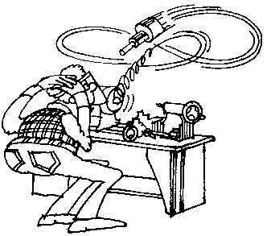
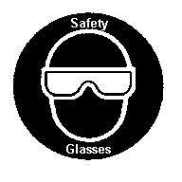

Safety suggestions
- Eye protection must be worn at all times.
shape cylindrical
metal objects
- Ensure all guards are in place.
- Remove all hand jewellery, restrain loose hair and clothing.
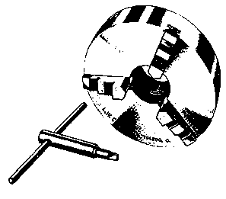
- Tighten all locks, spin the chuck by hand and have your instructor check your set-up before starting the machine.
- Do not leave the chuck key in the chuck.
- Do not leave a running machine unattended.
- Keep hands away from moving parts.
- Use a brush for removing chips. Do not use bare hands, the cuttings are very sharp.
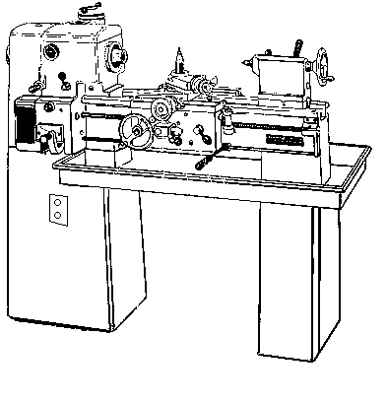
Power switch
Compound slide
Tailstock
Headstock
Bed
Chip pan
Speed control

Metal lathe

Name …………………..

Class …………………….

Date ………………………

Safety Quiz

1. | Eye protection is not necessary when turning metal. | T | F
2. | The chuck key should be stored in the chuck. | T | F
3. | 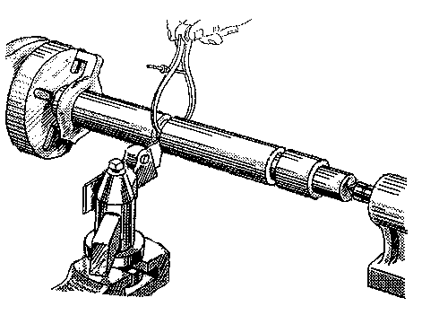  Measurements may be made while the machine is running. | T | F
4. | The machine should be run at top speed for all jobs. | T | F
5. | A brush should be used for removing shavings. | T | F
6. | Have your set-up checked by your instructor before starting the machine. | T | F
3.
7.
6.
2.
5.
4.
1.

