Metal Lathe graphics:
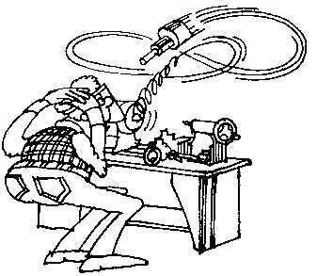

sample
Cartoon

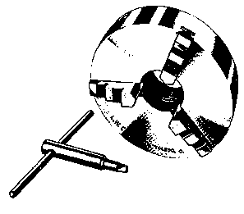
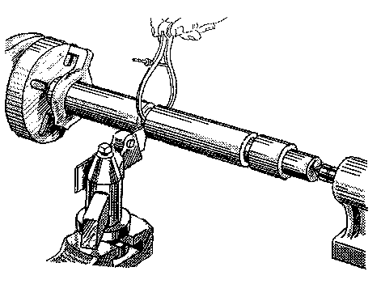
chuck key measuring

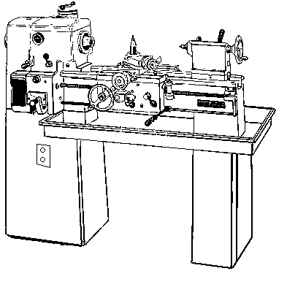
Power switch
Compound slide
Tailstock
Headstock
Bed
Chip pan
Speed control

Machine 1

Machine 2
3.
7.
6.
2.
5.
4.
1.

