Obtain permission from instructor before operating this machine |  | Jointer
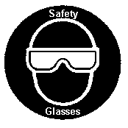
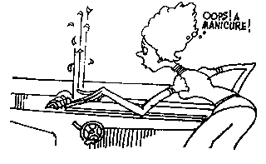

Safety suggestions
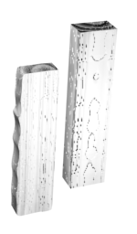
- Eye protection must be worn.
straighten irregular
wood surfaces
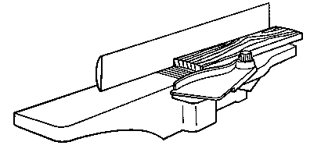
- Depth of cut should not exceed 1/8” (3mm.)
- Check to see that the guard is spring loaded and covers the cutterhead.
- Get assistance when jointing long pieces.
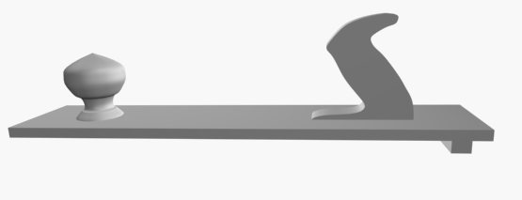
- Use a push stick for any stock shorter than the fence.
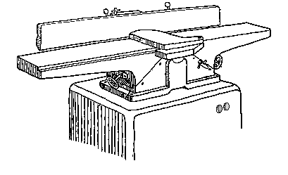
- The board being jointed must exceed the minimum length specified for the machine.
Fence
Outfeed table
Infeed table
Guard
Depth control
Power switch
Depth scale

Jointer

Name …………………..

Class …………………….

Date ………………………

Safety Quiz

1. | It is possible for the guard to stick and not cover the cutter. | T | F
2. | 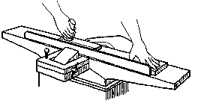  A push stick should be used on stock shorter than the fence. | T | F
3. | Eye protection is not necessary when operating the jointer. | T | F
4. | 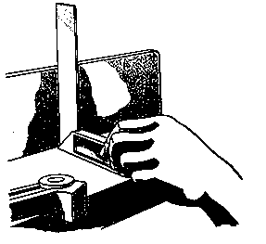  The fence should be set at 90 degrees to the table. | T | F
5. | Feed the wood in the direction opposing the cutterhead rotation. | T | F
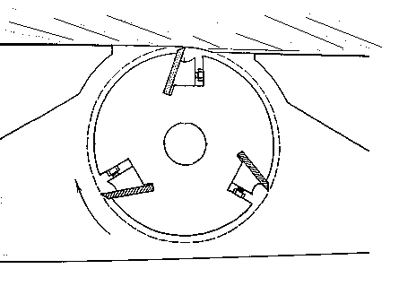
Feed
Cutter
6. | Wood will joint smooth if the grain  direction slopes down toward the  operator. | T | F
7. | Short stock is safe to joint. | T | F
2.
1.
4.
3.
5.
6.
7.

