Jointer graphics:

sample
Cartoon
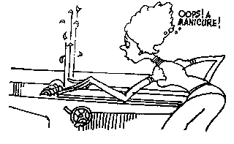
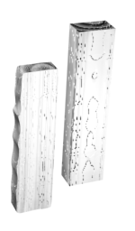

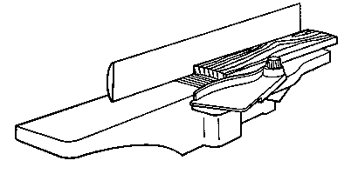
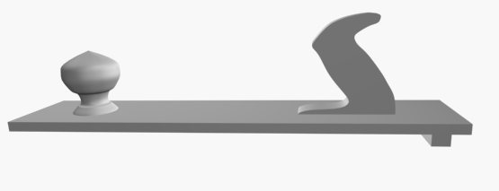
push stick
guard

jointing
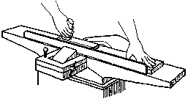
squaring the fence
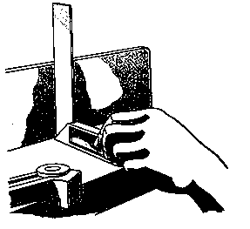

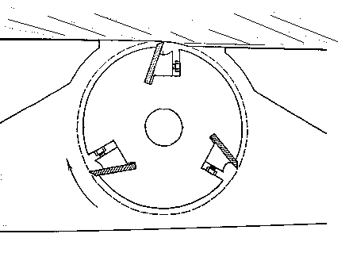
grain direction
Feed
Cutter

Machine 1

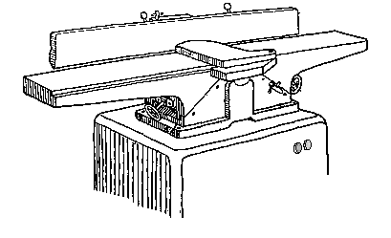
Fence
Outfeed table
Infeed table
Guard
Depth control
Power switch
Depth scale
Machine 2
2.
1.
4.
3.
5.
6.
7.

