Obtain permission from instructor before operating this machine |  | Hot Glue Gun

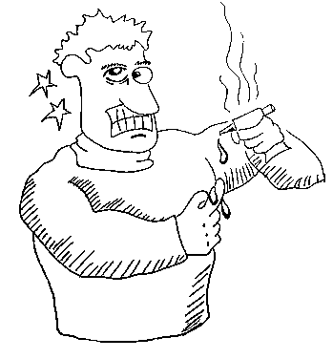

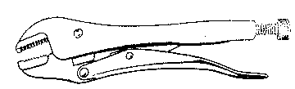

Safety suggestions
- Ensure your work area is clean and dry.
Bonding various materials
- Check the power cord for damage before plugging it in.
- Place the glue gun upright on its stand when not in use.
- Do not touch the metal nozzle after the gun heats up.
- Do not touch liquid hot glue. It can reach temperatures of 350 deg. F., (175deg. C.), hot enough to cause severe burns.
- Should a burn occur, immerse it immediately in cold, clean water, do not attempt to pick to glue off, and report the injury to your instructor.
- Do not store a heated gun on its side.
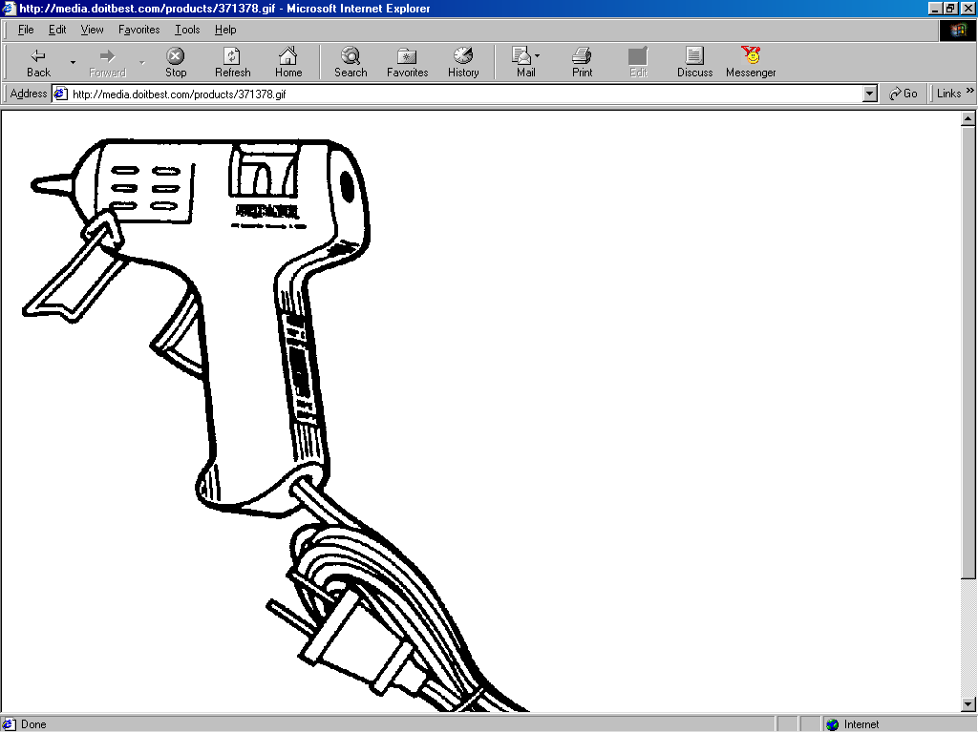
Nozzle
Stand
Trigger
Low/High temperature switch
Thermo-plastic glue sticks

Hot Melt Glue Gun

Name …………………..

Class …………………….

Date ………………………

Safety Quiz

1. | Always check the condition of the power cord before using. | T | F
2. | Store the hot gun in an upright position. | T | F
3. | Hardened glue can be liquefied by contact with the hot nozzle. | T | F
4. | 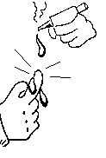  Hot glue on your skin should be wiped off. | T | F
5. | Cool hot glue burns immediately in cold, clean water. | T | F
1.
2.
3.
5.
4.

