Hot Glue Gun graphics:

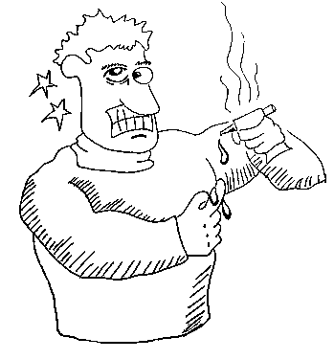
sample
Cartoon

Machine 1

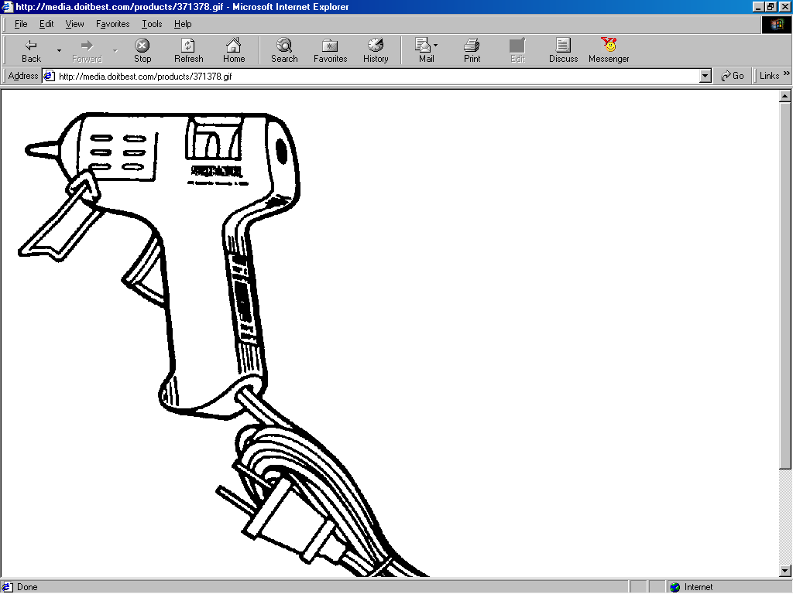
Nozzle
Stand
Trigger
Low/High temperature switch
Thermo-plastic glue sticks

Machine 2
1.
2.
3.
5.
4.

