Horizontal Band Saw graphics:

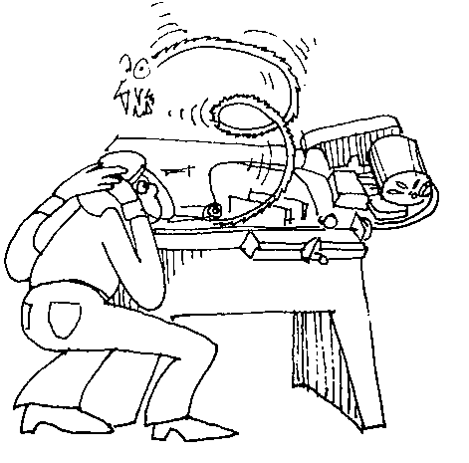
sample
Cartoon
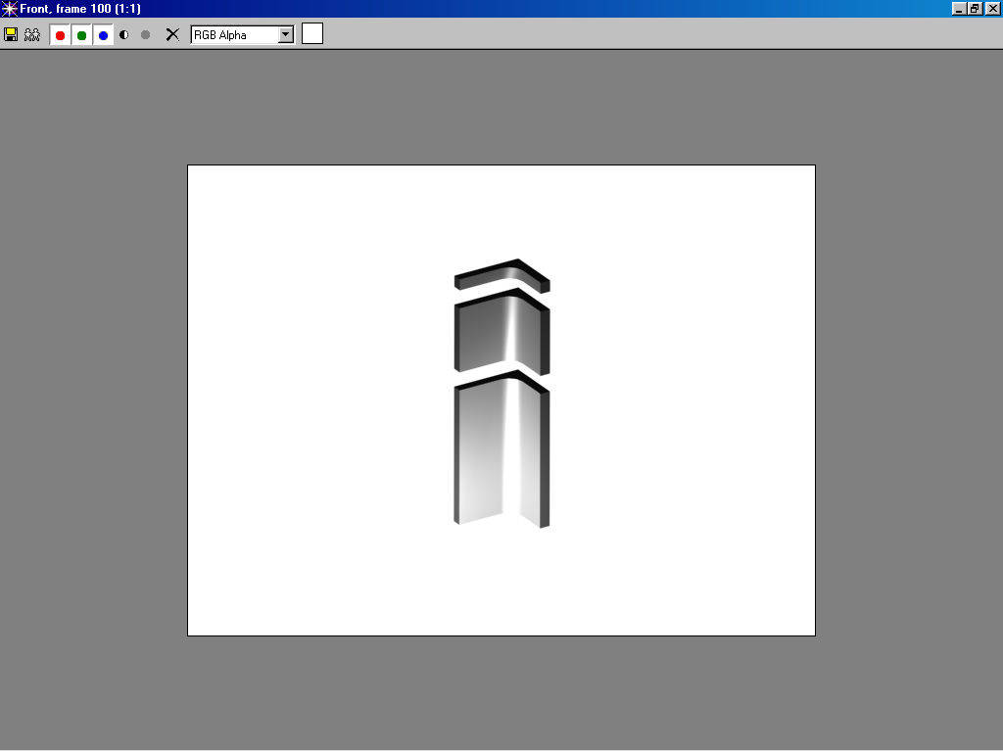

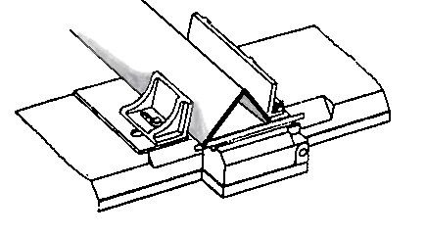
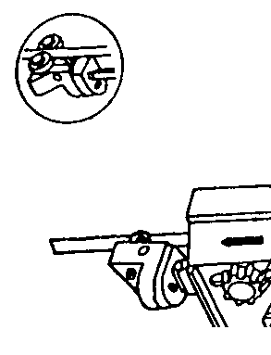
vise blade guides

Machine 1

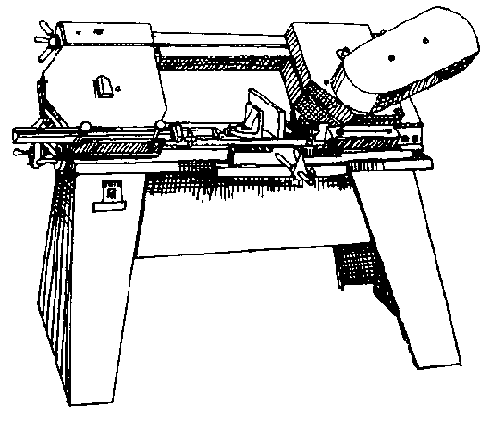
Wheel guard
Vise knob
Power switch
Blade
Belt guard
Vise
Machine 2

1.
2.
3.
4.
5.
6.

