Obtain permission from instructor before operating this machine |  | Grinder
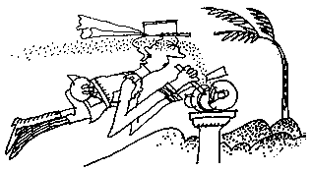


Safety suggestions
- Eye protection must be worn at all times.
shape ferrous metals
- Ensure that all guards are in place.
- The tool rest should be within 1/8” (3mm.) of the wheel.
- Do not grind materials on the side of the wheel.
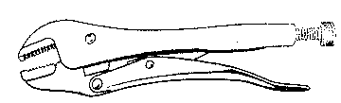
- Small pieces objects must be held with “vise-grip” type pliers.
- Do not use the grinder if the wheel is damaged.
- The transparent safety shield should be clean.
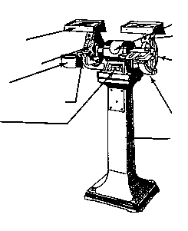
- Stand to one side when you start the machine.
Safety shield
Tool rest
Switch
Motor
Dust chute
Pedestal
Grinding wheel
Wheel guard
Spark deflector
Water pot

Grinder

Name …………………..

Class …………………….

Date ………………………

Safety Quiz

1. | 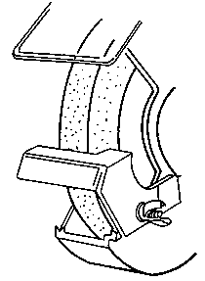  The tool rest should be adjusted to within 1/8” (3mm.) of the wheel. | T | F
2. | Eye protection is not necessary when grinding. | T | F
3. | You may leave the machine as soon as the switch is in the “Off” position. | T | F
4. | 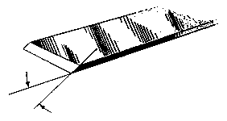  Bevel cutting tools should be ground to 25 deg. or 2x their thickness. | T | F
5. | The safety shield should be clean. | T | F
6. | Damaged wheels are safe to use. | T | F
7. | Use “vise-grip” type pliers to hold small pieces. | T | F
1.
2.
3.
4.
5.
6.
7.
8.
9.
10.

