Obtain permission from instructor before operating this machine |  | Drill Press
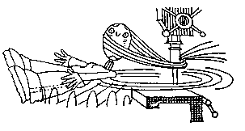

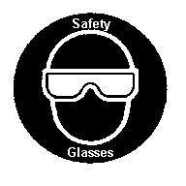

Safety suggestions
- Eye protection must be worn at all times.
cylindrical holes
wood
metal
plastic
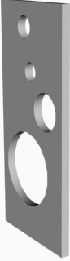
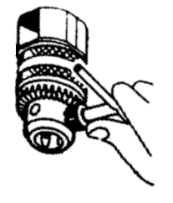
- Restrain loose clothing and hair. Remove hand jewellery.
- Clamp the material to the table where possible.
- Tighten the bit and remove the chuck key.
- Select an appropriate speed - fast for small holes, slow for large ones.
- If the material becomes caught by the bit. Step back and turn off the machine.
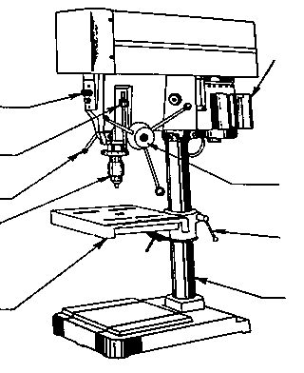
Power switch

Depth stop
Spindle lock
Chuck

Tilting table
Motor

Feed control
Table locking clamp
Column

Drill Press

Name …………………..

Class …………………….

Date ………………………

Safety Quiz

1. | 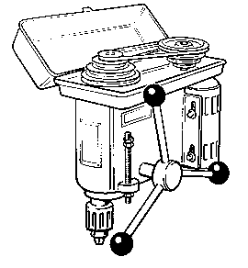  It is necessary to select the proper speed. | T | F
2. | The chuck key should be kept in the chuck at all times.  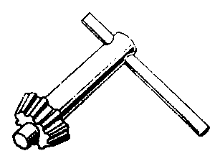 | T | F
3. | Work should be secured to the table where possible. | T | F
4. | A brush should be used to remove chips. | T | F
5. | Eye protection is not necessary when using a drill press.. | T | F
6. | The long end of the work should be to the left of the operator. | T | F
1.

2.
3.
4.

5.
6.

7.
8.
9.

