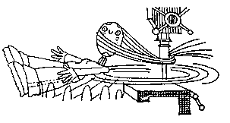
Drill Press graphics:

Cartoon

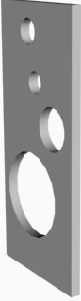

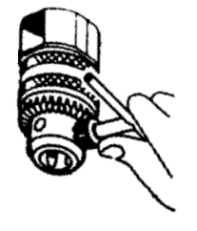
Sample Chuck key

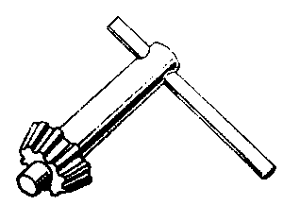
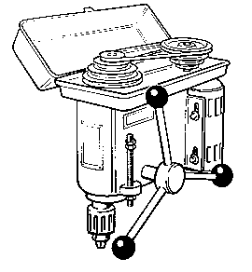
Key

Pulleys

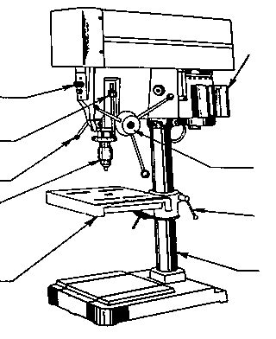
Machine 1
Power switch

Depth stop
Spindle lock
Chuck

Tilting table
Motor

Feed control
Table locking clamp
Column

Machine 2
1.

2.
3.
4.

5.
6.

7.
8.

