Disc Sander graphics:
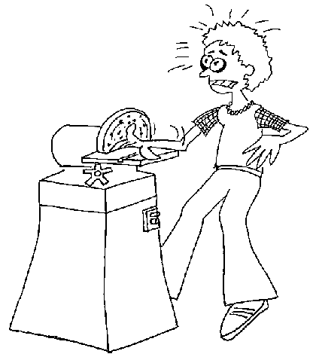

sample
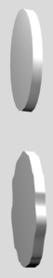
Cartoon

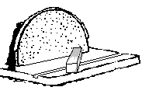
downward crepe
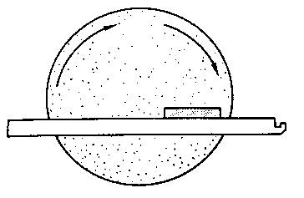
Side

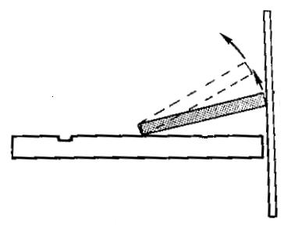
Uplift

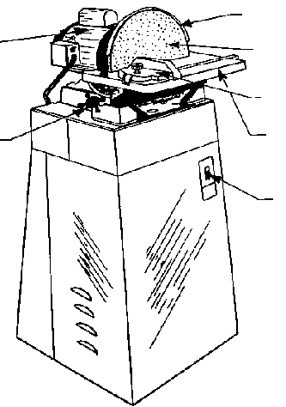
Machine 1
Motor
Table tilt lock
Disc guard
Sanding disc
Mitre gage
Table
Power switch

Machine 2
1.
2.
3.
4.
5.
6.
7.

