Obtain permission from instructor before operating this machine |  | Buffer
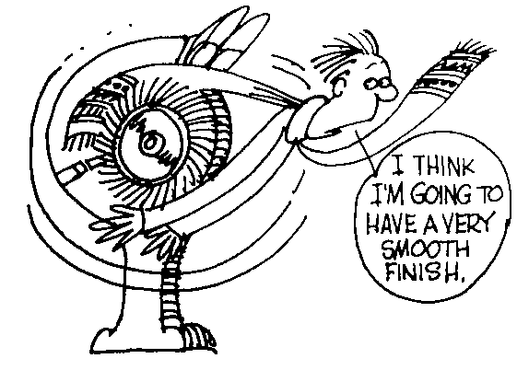

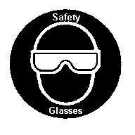

Safety suggestions
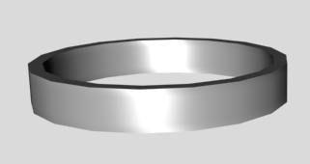
- Always wear eye protection.
Polish metal and plastic
- Stand to the side of the wheel when using the buffer.
- Do not buff wires, chain or small diameter tubing.
- Use extra caution when buffing near edges and corners.
- Always use the lower half of the wheel.
- Loose clothing and long hair are dangerous.
- Be sure that you are the only one in the safety zone..
- Apply compound to the wheel prior to use.

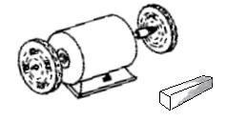
Buffing wheels
Power switch
Buffing compound

Buffer

Name …………………..

Class …………………….

Date ………………………

Safety Quiz

1. | Loose clothing or long hair must be contained. | T | F
2. | Eye protection is not necessary when buffing. | T | F
3. | A rag should be used to hold hot objects. | T | F
4. | Buff on the lower half of the wheel.  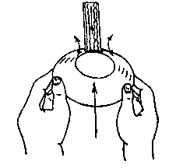 | T | F
5. | Stand to the side when buffing. | T | F
6. | Safety glasses are not necessary when buffing. | T | F
7. | Use extra caution when buffing objects with corners. | T | F
8. | The colour of the buffing compound indicates it’s intended use. | T | F
1.
3.
2.

