Buffer graphics:

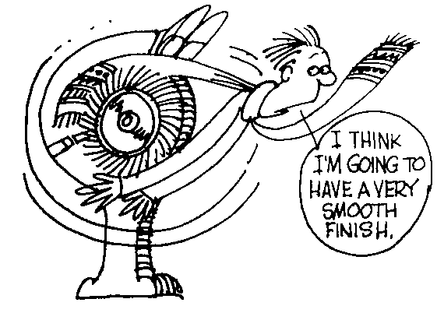
Cartoon

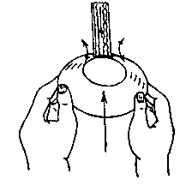

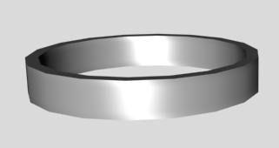
Sample Lower half

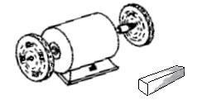
Buffing wheels
Power switch
Buffing compound

Machine 1

1.
3.
2.
Machine 2

