Obtain permission from instructor before operating this machine |  | Band Saw
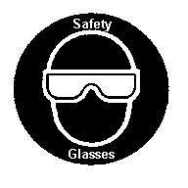
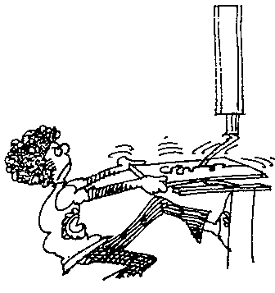

Safety suggestions

- Wear approved eye protection.
Saw irregular shapes
wood
plastic

- Eliminate loose clothing, confine long hair and remove jewellery from hands.
- Adjust the blade guard to within ¼” (6mm.) of the work.
- Remove cuttings only after the blade has stopped moving.
- Avoid backing out of the cut.
- Never place your fingers near the cut line. Maintain a safe distance ( ____ “, ____ mm., minimum) between your hands and the blade. Use a push stick when necessary.
- Consult your instructor when cutting large or irregularly shaped pieces.
- Do not leave the machine until after the blade has stopped moving.
Upper wheel guard
Blade support
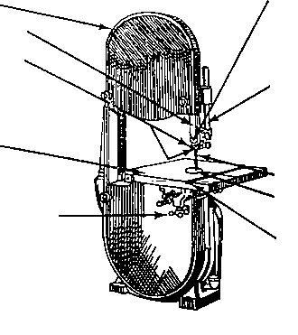
Blade guard
Blade guides
Guide post

Table

Blade
Table insert
Mitre gauge groove
Table clamp
Band Saw

Name …………………..

Class …………………….

Date ………………………

Safety Quiz

1. | It is safe to tilt the table when cutting bevels. | T | F
2. | The saw should be stopped by forcing a piece of wood against the blade. | T | F
3. | The blade guard should be adjusted to within ¼” (6mm.) of the work. | T | F
4. | 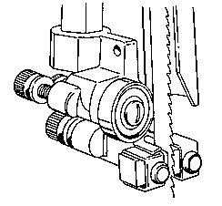  The blade guides should be adjusted tight against the blade. | T | F
5. | The hands should come no closer than 4” (10 cm.) from the blade. | T | F
6. | All adjustments should be made with the power turned off. | T | F
7. | Never place your fingers on the line you plan to cut. | T | F
4.

1.
8.
9.
10.
5.
2.
3.
6.
7.

