Band Saw graphics:

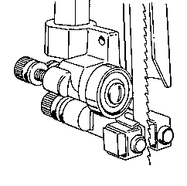
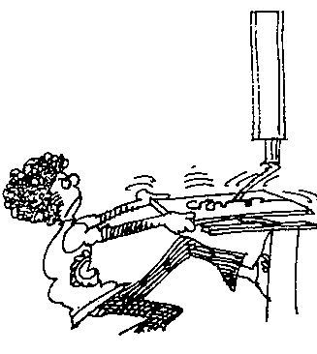

guides
irregular cut

cartoon

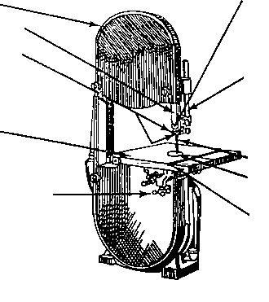
Table

Upper wheel guard
Blade
Table insert
Mitre gauge groove
Table clamp
Blade guard
Blade guides
Blade support
Guide post

Machine1

4.

1.
8.
9.
10.
5.
2.
3.
6.
7.

Machine 2

