Obtain permission from instructor before operating this machine |  | Arc Welder
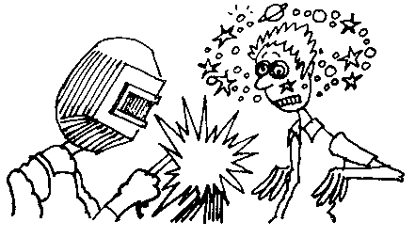
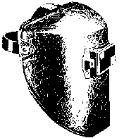

Safety suggestions
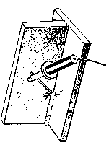
- An appropriate protective helmet must be worn when arc welding.
fusing 2 metals
together using an
electric arc
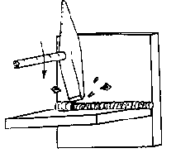
- Proper ventilation must be available
- Wear transparent eye protection when chipping slag
- Do not weld in wet areas.
- If available, use protective screens. Warn others nearby before striking an arc.
- Gloves and protective clothing must be worn.
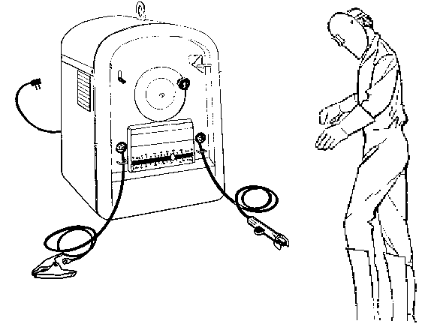
Power switch
Ground clamp
Electrode holder
Amperage adjustment
AC – DC switch
Hat
Helmet
Gloves
Long sleeves
Treated overalls
Leggings

Arc Welder

Name …………………..

Class …………………….

Date ………………………

Safety Quiz

1. |   Looking at an electric arc without appropriate welding glasses can cause permanent eye damage. | T | F
2. | Appropriate protective gloves and clothing must be worn. | T | F
3. | Closed containers are dangerous to weld. | T | F
4. | Welding without proper ventilation is dangerous. | T | F
5. | 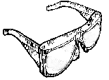  Eye protection is required when chipping slag. | T | F
6. | Warn others nearby before striking an arc. | T | F
1.
3.
4.
2.
11.
9.
10.
6.
8.
7.
5.

