Arc Welder graphics:
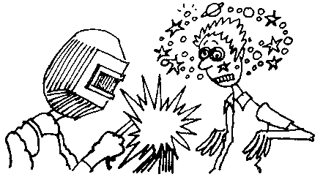
sample
Cartoon
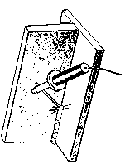

helmet

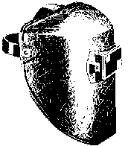
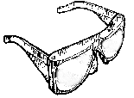
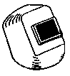

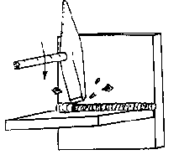
chipping slag

Machine 1
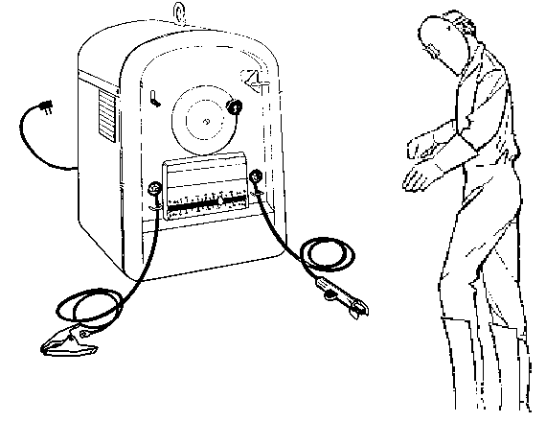
Power switch
Ground clamp
Electrode holder
Amperage adjustment
AC – DC switch
Hat
Helmet
Gloves
Long sleeves
Treated overalls
Leggings

Machine 2
1.
3.
4.
2.
11.
9.
10.
6.
8.
7.
5.

