Power tool qualification sample protocol

(A suggested method of linking power tool qualification to a project…)

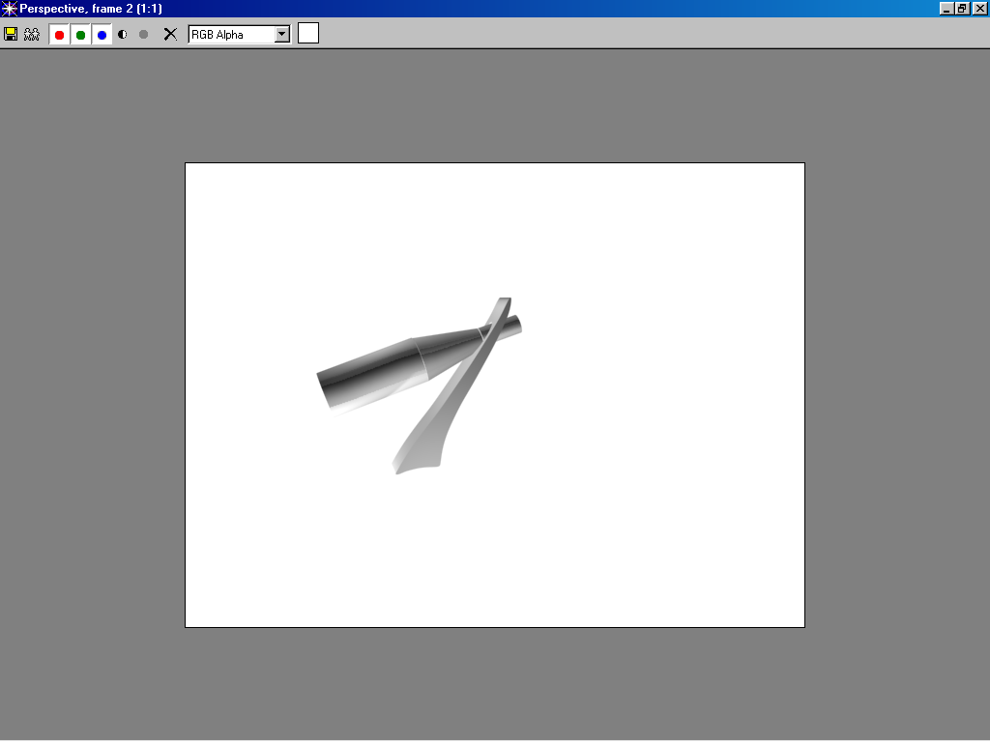
Introductory wood technology – Wine bottle holder (also works with 600 ml., 1 & 2 lt. plastic bottles)

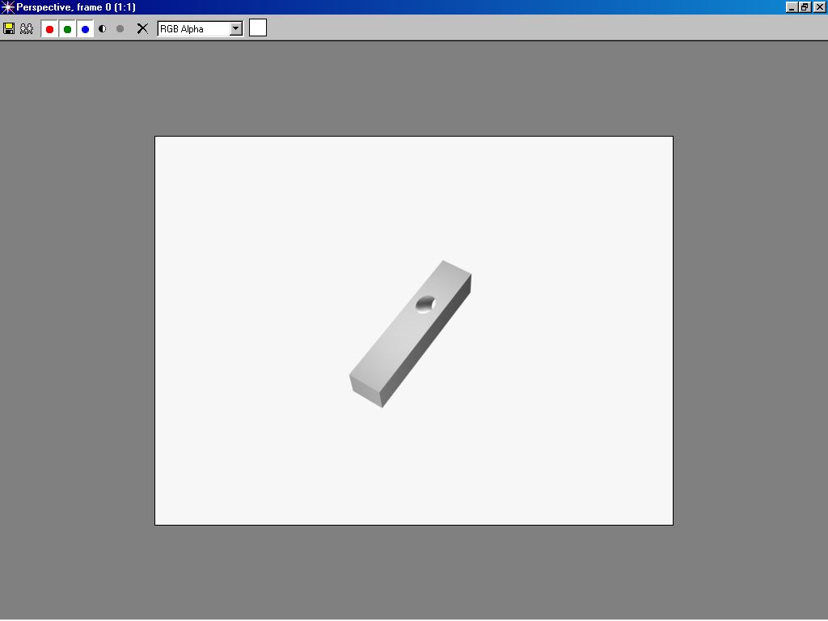
Students select their wood. Any relatively hard wood will do, 2” x 2” x 10” , (50 x 50 x 250 mm.) in size.
Have a drill press jigged up, a “forstner” type cutter works best. Chip-out on the exit side is not a big concern as the defects will disappear when band sawing to shape.
Demonstrate drilling the hole. Use the “Drill press” safety sheet as a discussion paper. Discuss the need for safety glasses and the risk of exposed rotating parts (entrapment cartoon). Have the students sign the ” Safety quiz” side and discuss each statement in turn. Have the students circle the appropriate True/False response. Take this opportunity to display various cutters and mention (briefly) the available portable electric drills.
Collect the safety sheets for correction and recording. Students drill their wood.
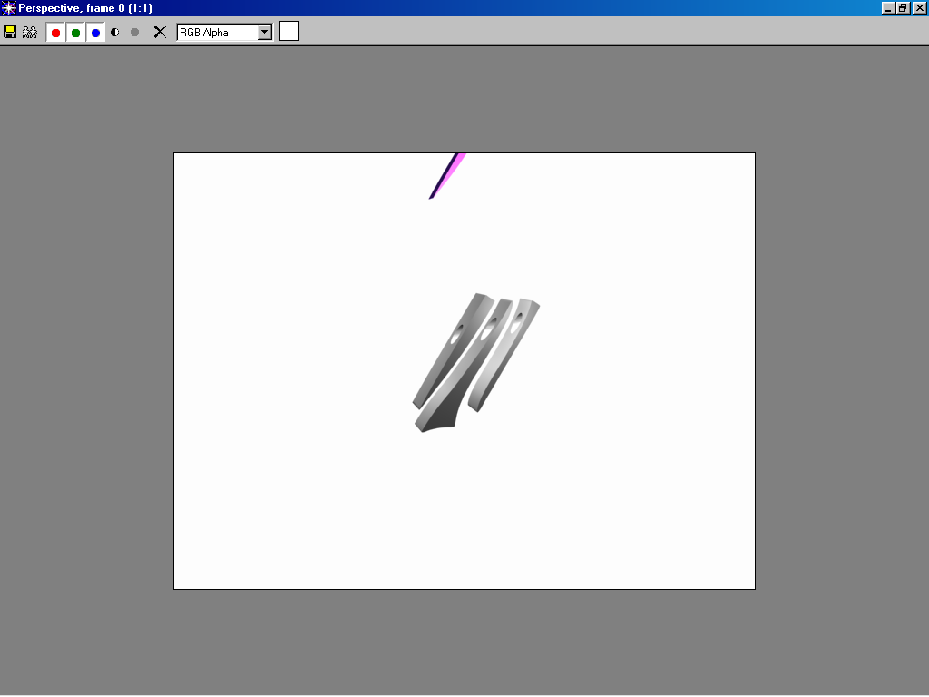
Next class:
Return and have students initialize your record sheet.
Demonstrate band sawing the sides to shape. Hand out the Band saw safety sheet. Discuss and complete as with the drill press. Be sure to set limits as to hand proximity to the blade and the use of a push stick.

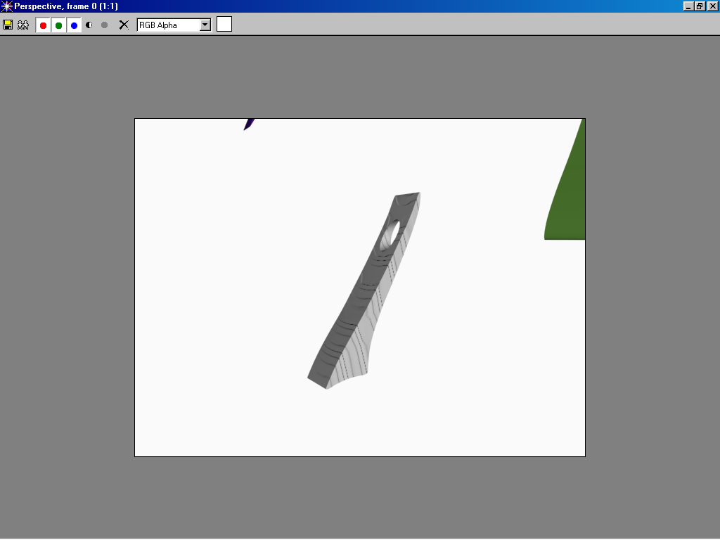
Demonstrate the use of power sanders (disc and spindle) for smoothing the contours.
Discuss the safety sheet(s) as before
Establish minimum safety margins (sand pieces no smaller than…, keep your fingers at least…… away from the sander.).
Demonstrate the use of crepe rubber blocks.
Collect the safety sheets, correct and record. Return them and have students sign your record list as soon as convenient.
Have the students shape their bottle holders with the power sanders and then smooth all surfaces / corners with hand sanding.

