Power and Stationary Tools
Table Saw 1
Band Saw 2
Radial Arm Saw 3
Jointer 4
Surface Planer 5
Stationary Belt Sander 6
Stationary Disk Sander 7
Power Miter Saw 8
Circular Saw 9
Portable Belt Sander 10
Portable Jig Saw/Saber Saw 11
Finish Sander 12
Power Plane 13
Router 14
Drill Press 15
Portable Drill 16
Air Impact Wrench 17
Portable Grinder 18
Grinder 19
Horizontal Band Saw 20
Shear 21
Arc Welder 22
Oxygen-Acetylene Welding 23
MIG-TIG Welding 24

Table Saw
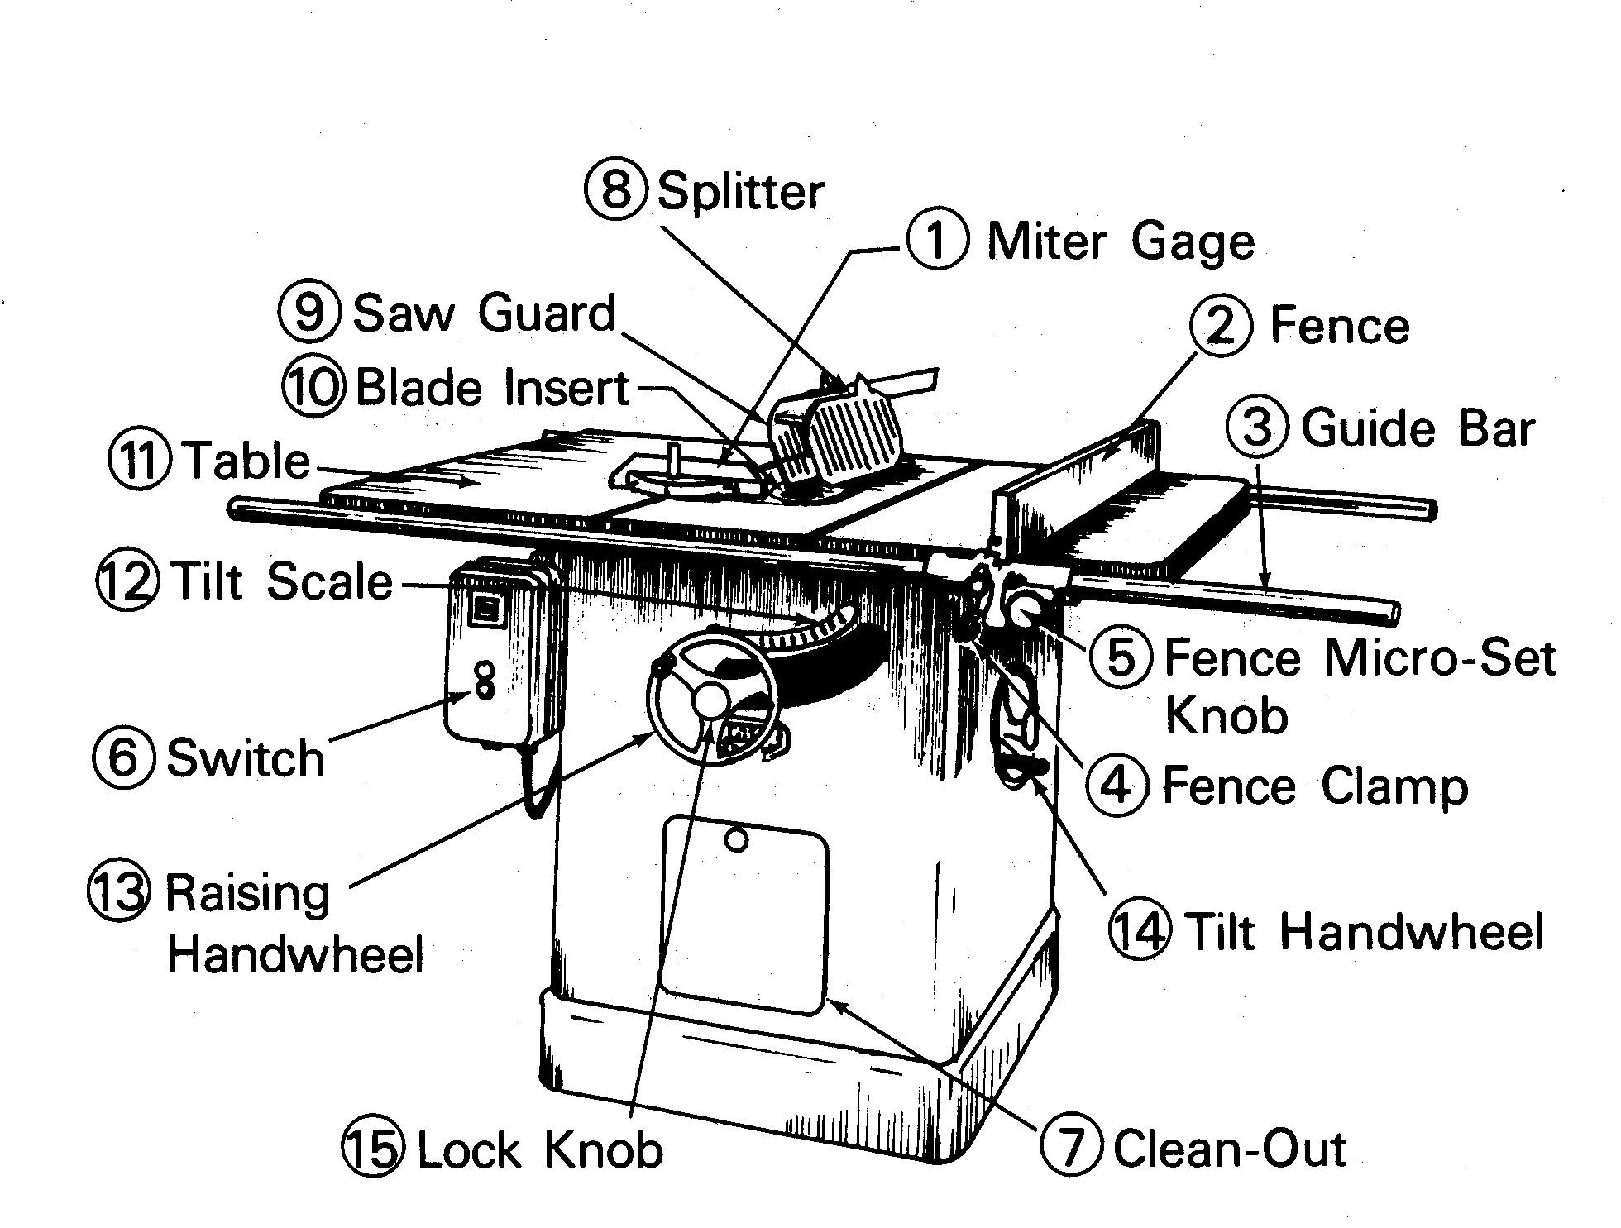

Band Saw
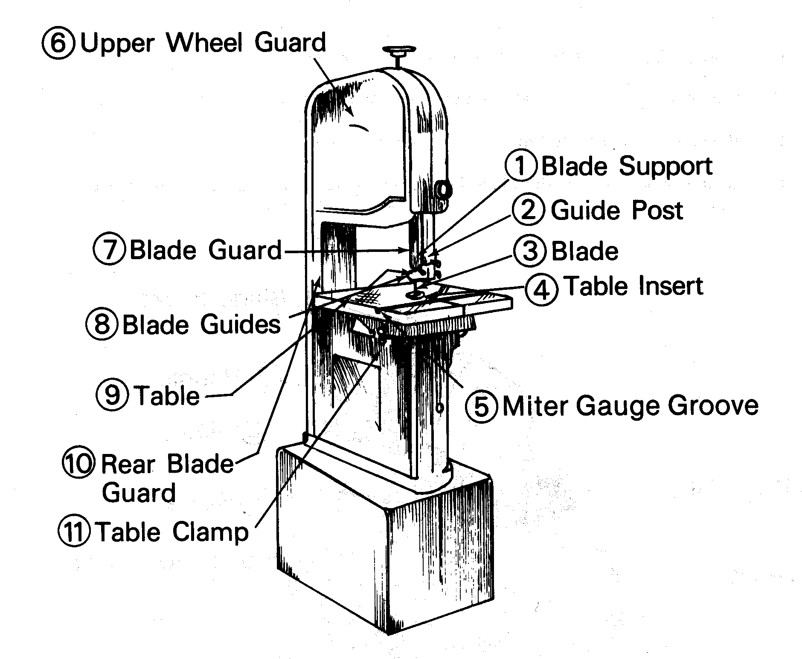

Radial Arm Saw
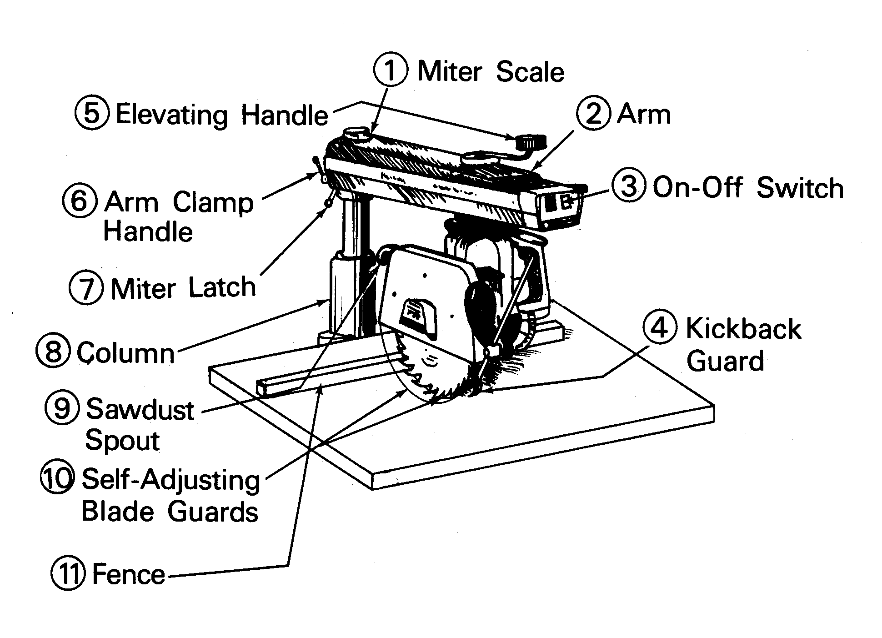

Jointer
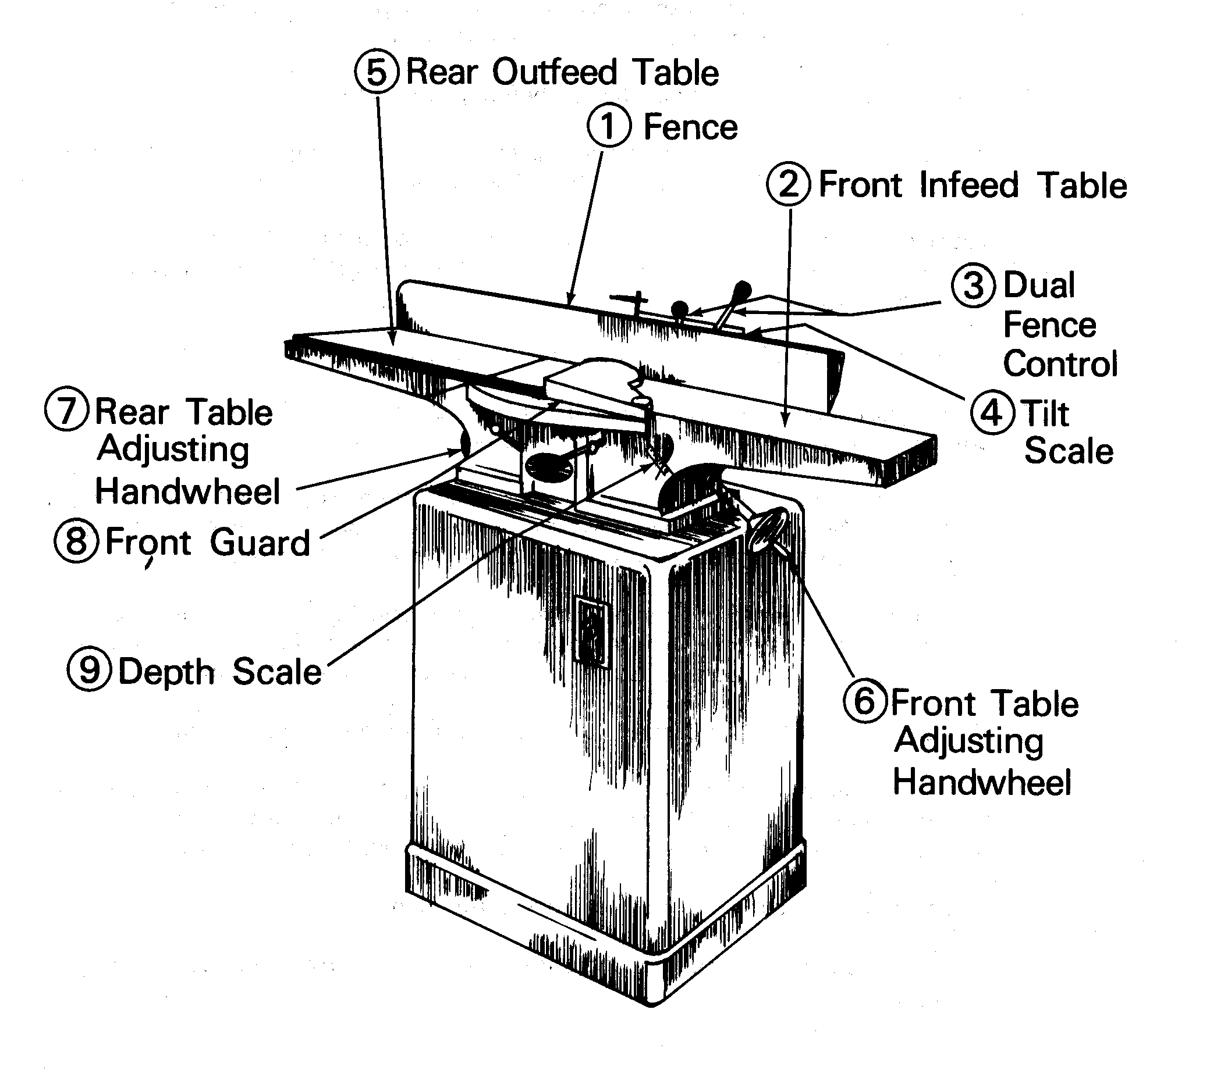

Surface Planer
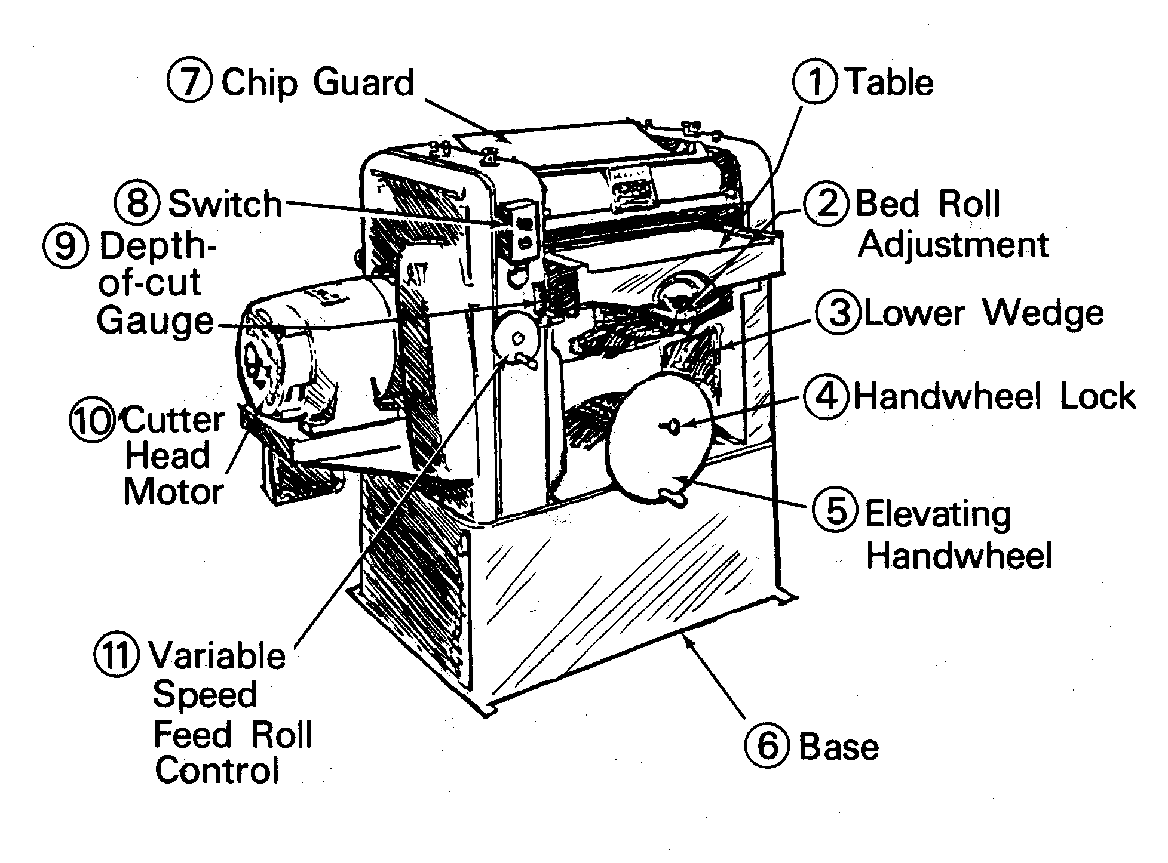

Stationary Belt Sander
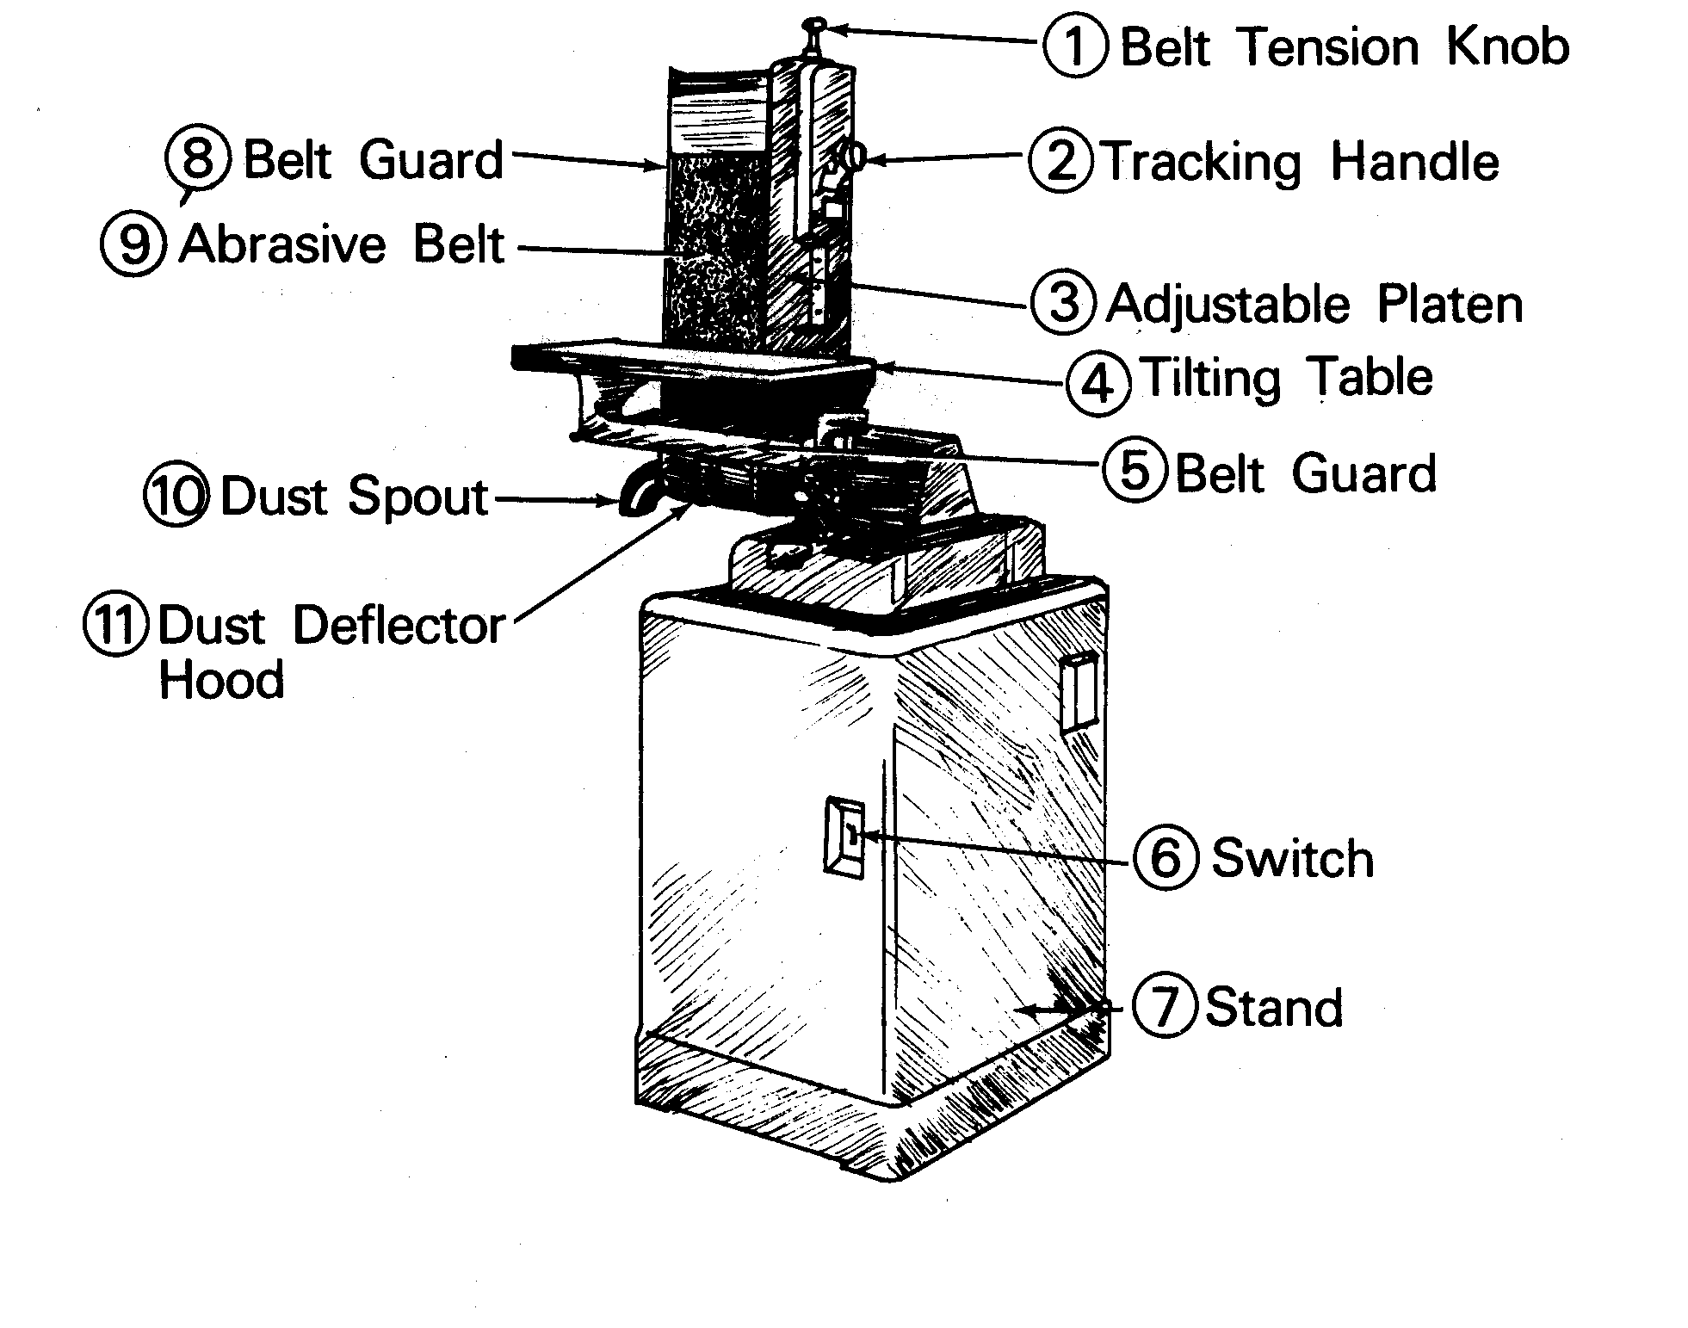

Stationary Disk Sander
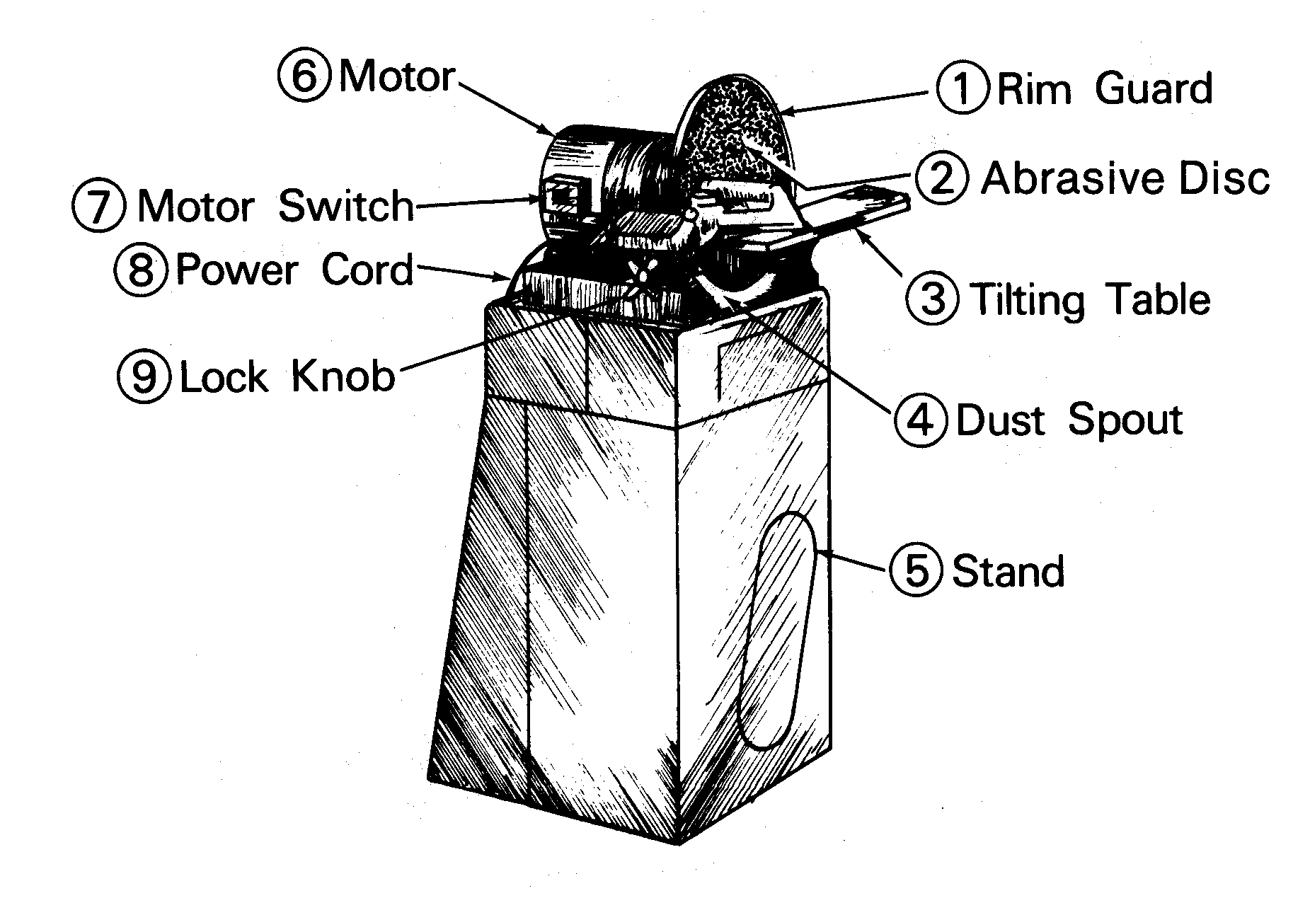

Power Miter Saw
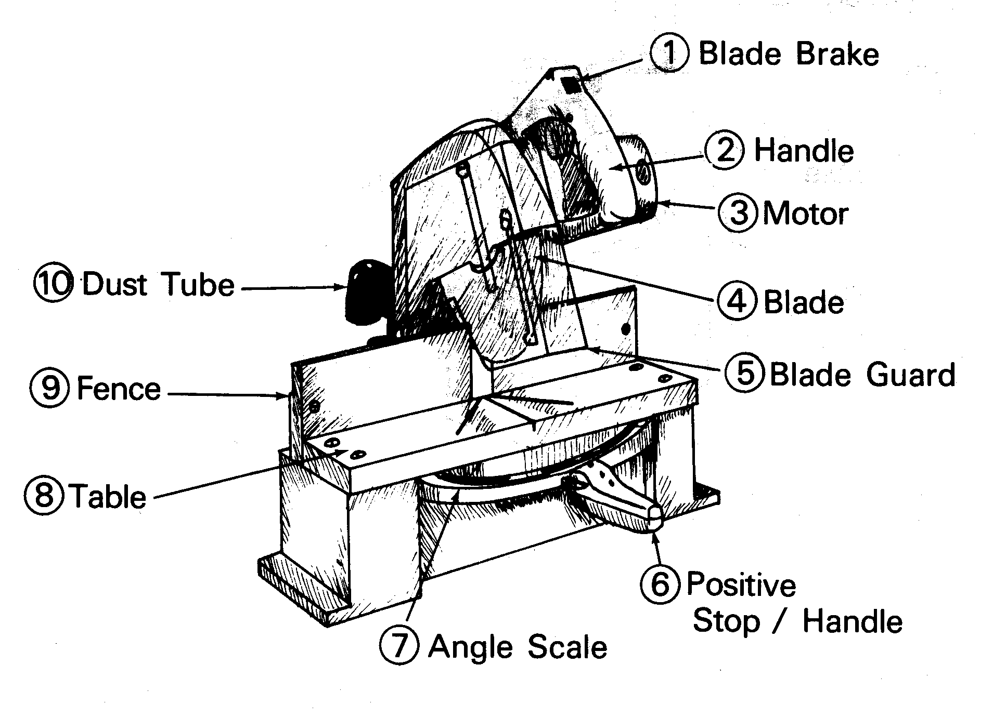

Circular Saw
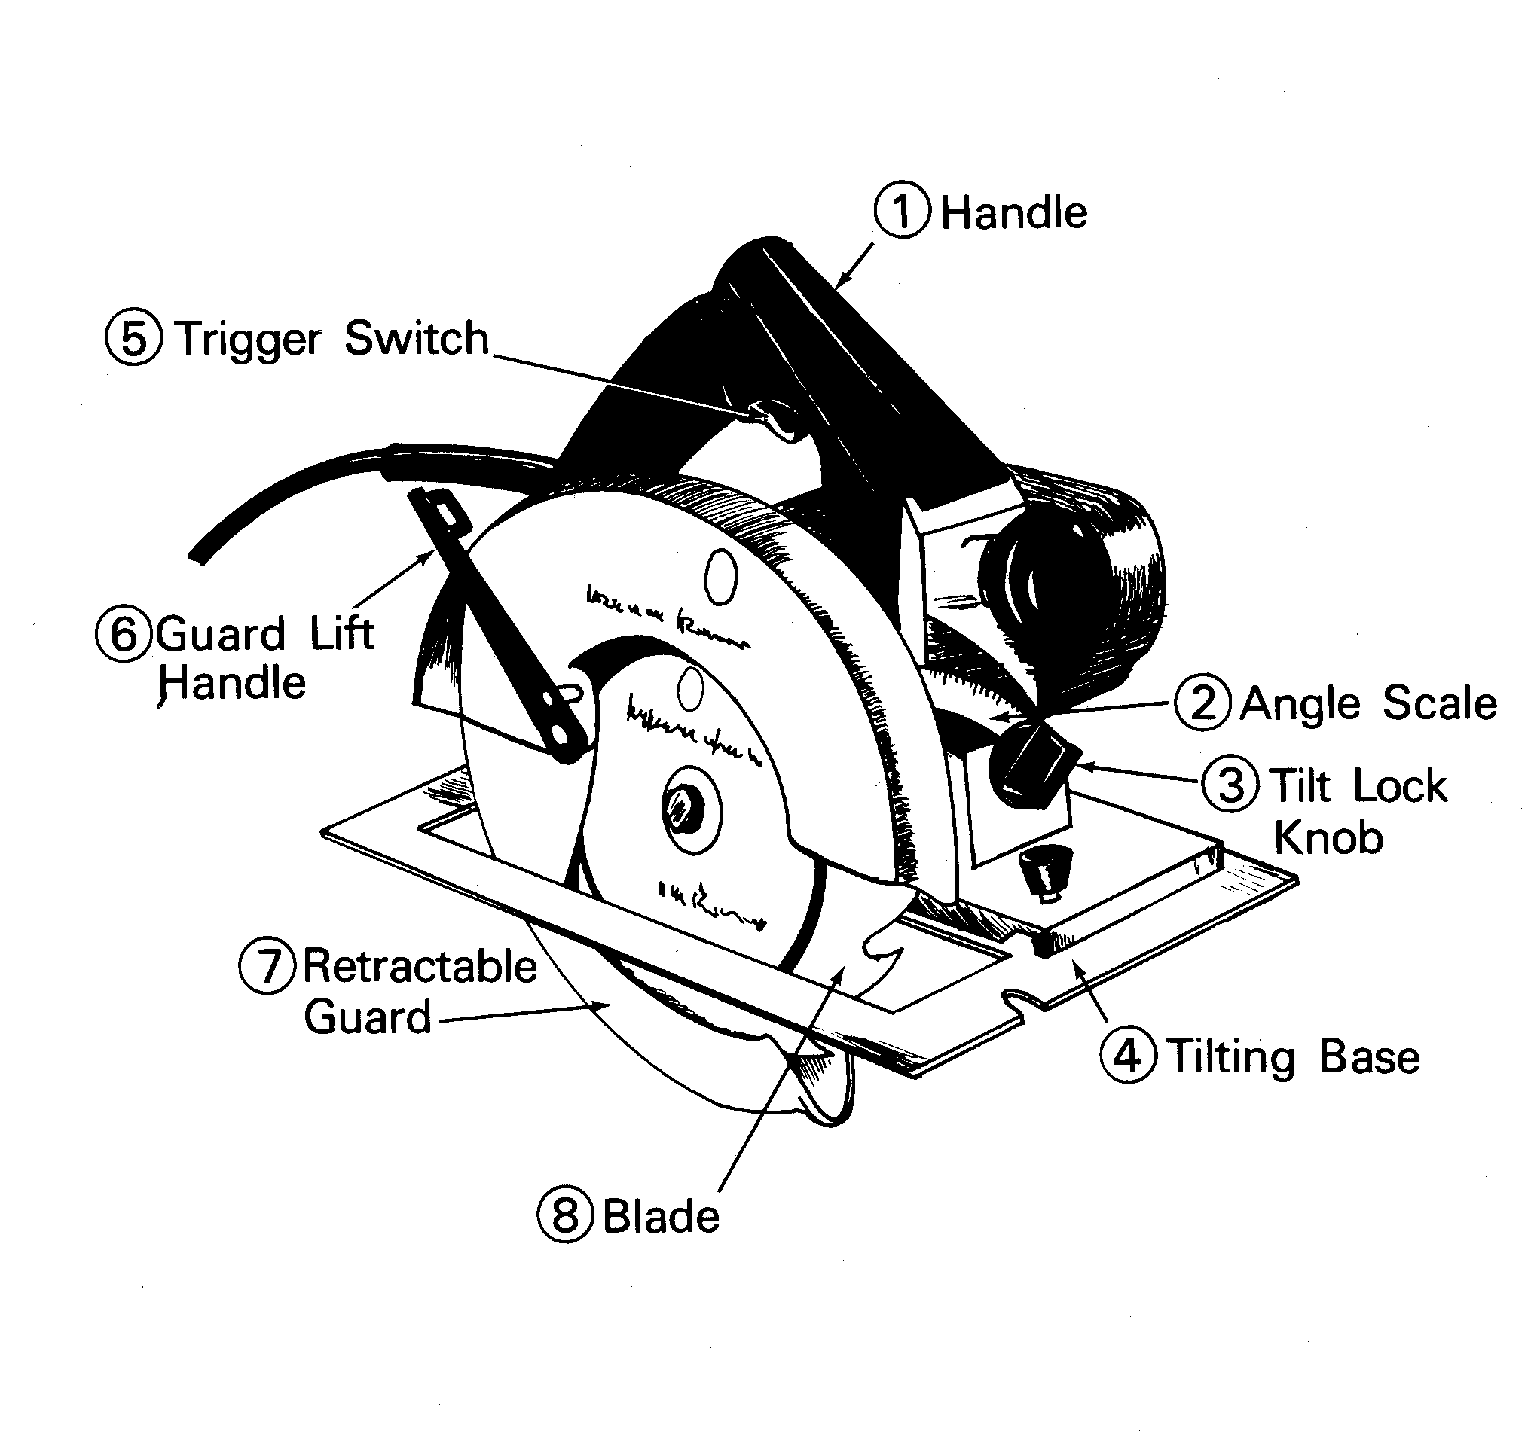

Portable Belt Sander
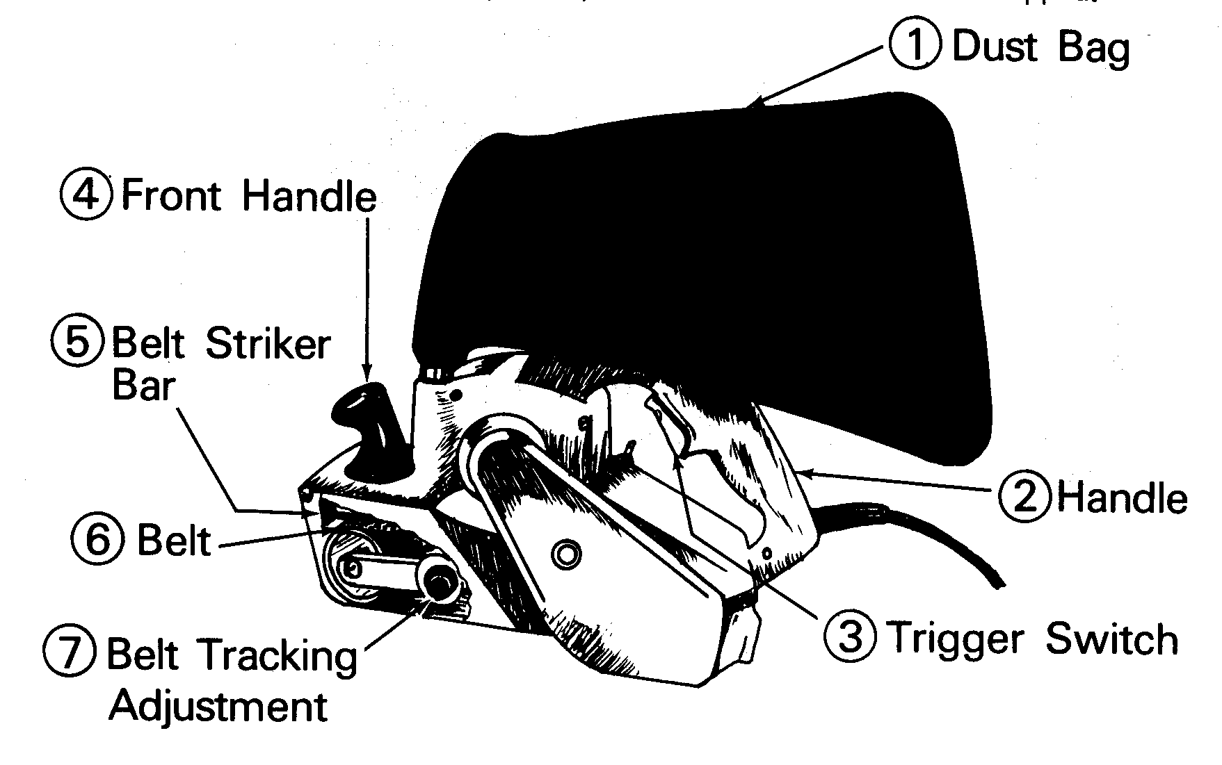

Portable Jig Saw/Saber Saw
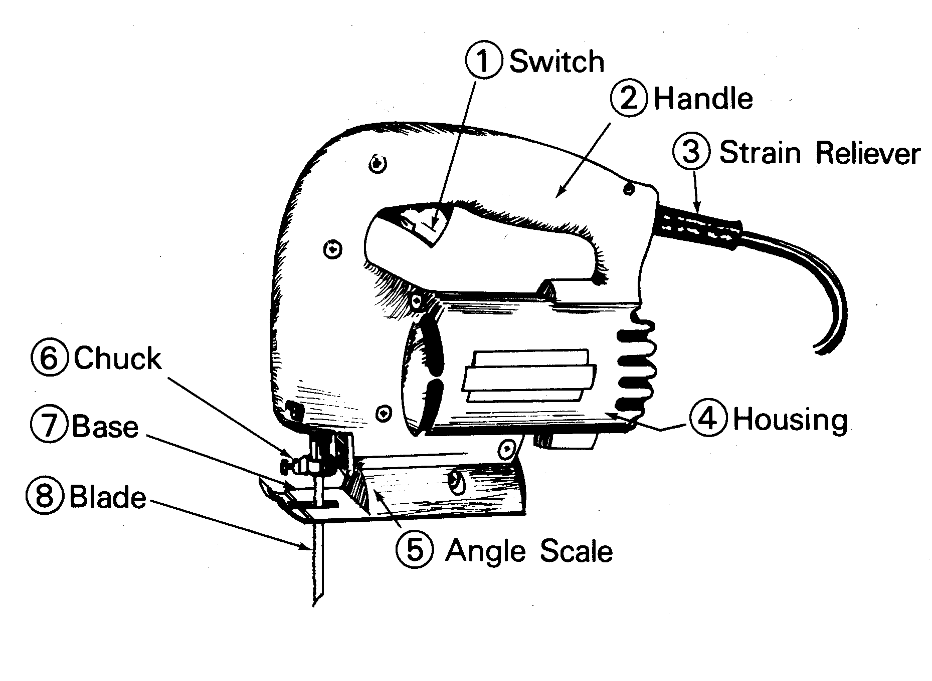

Finish Sander
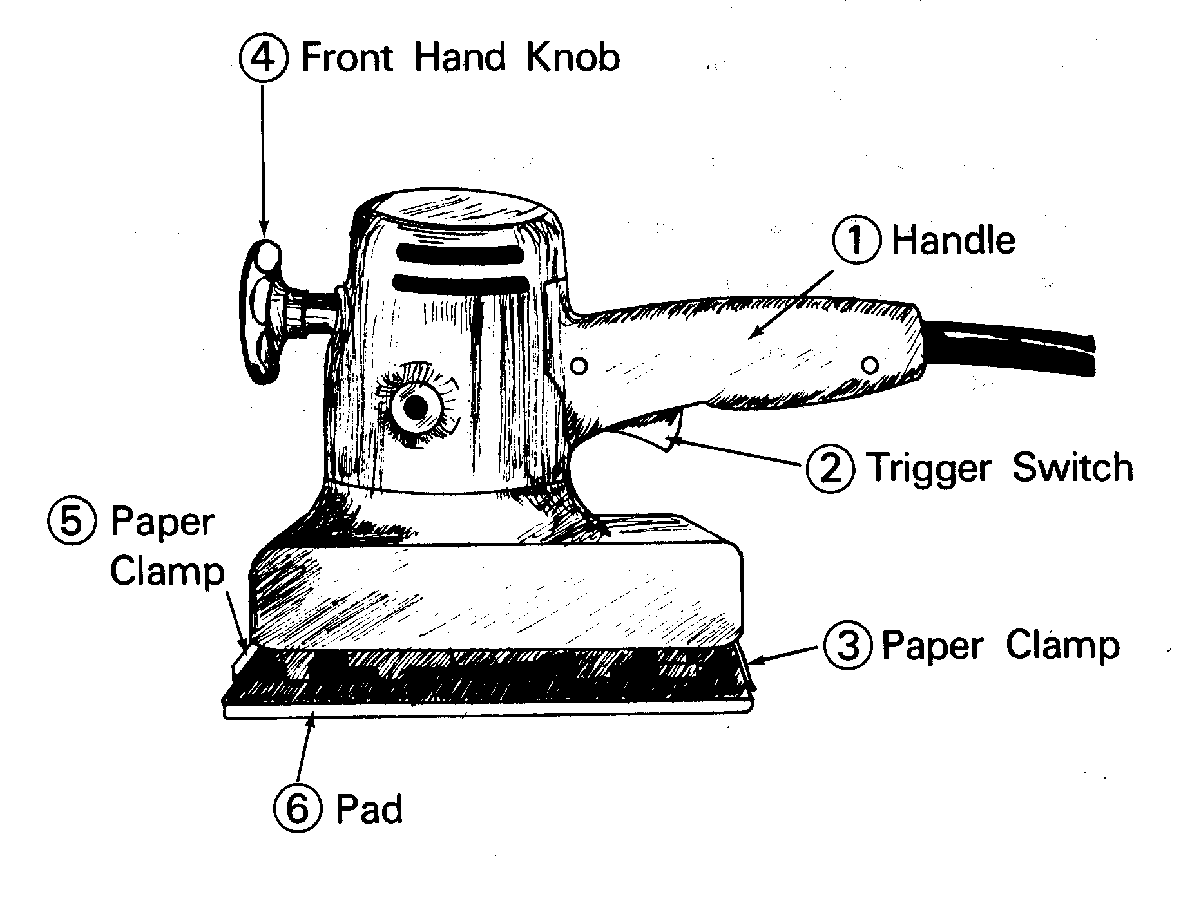

Power Plane
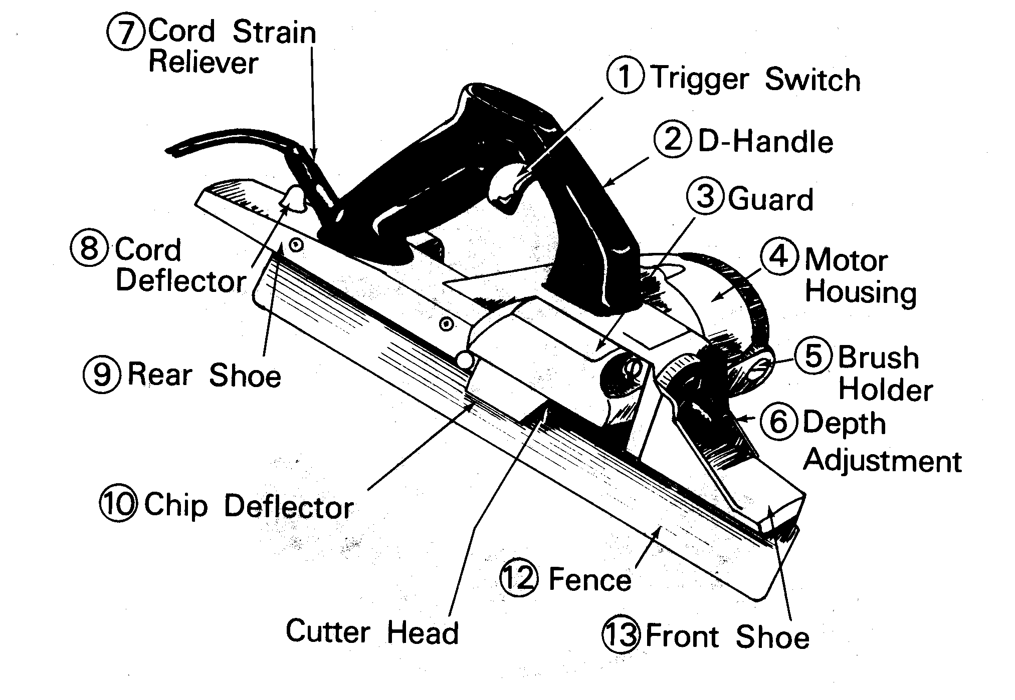

Router
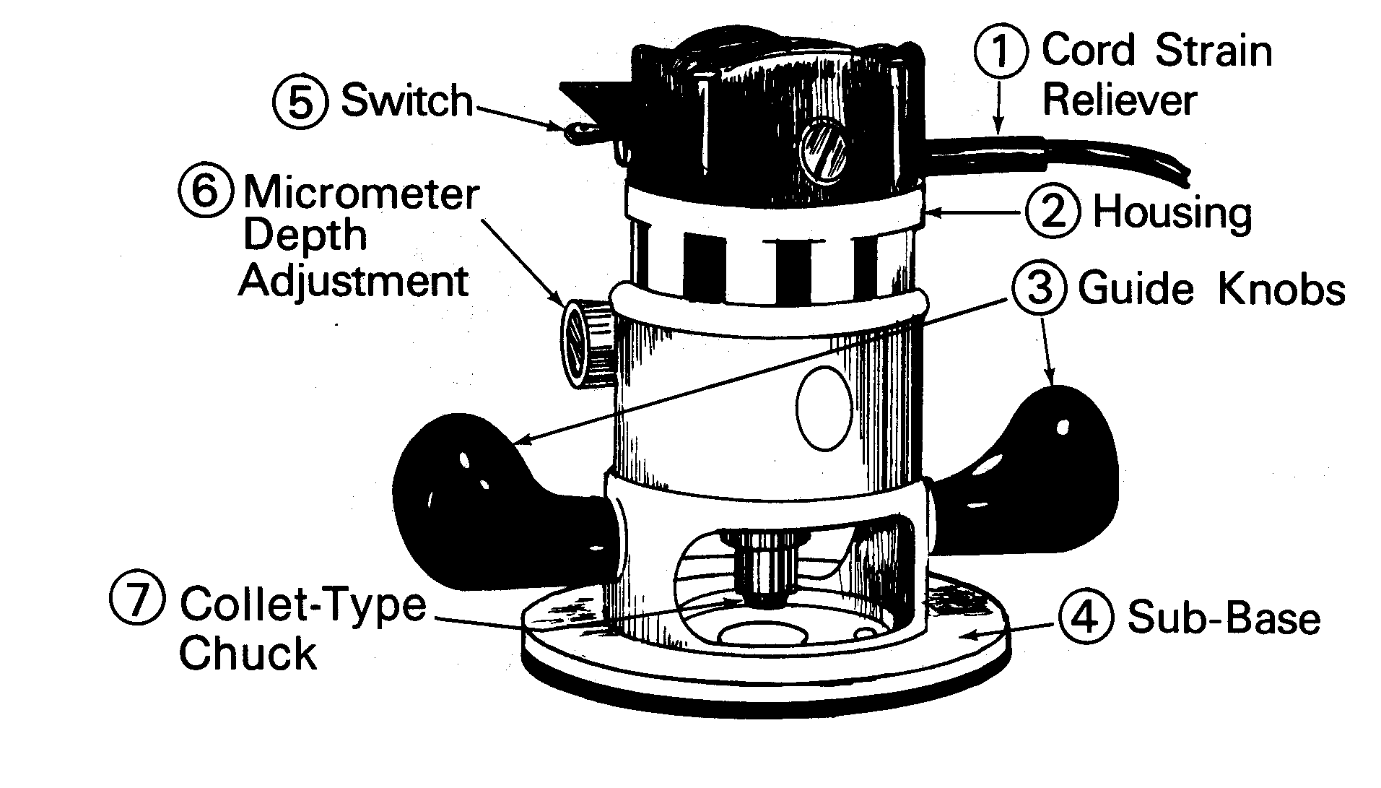

Drill Press
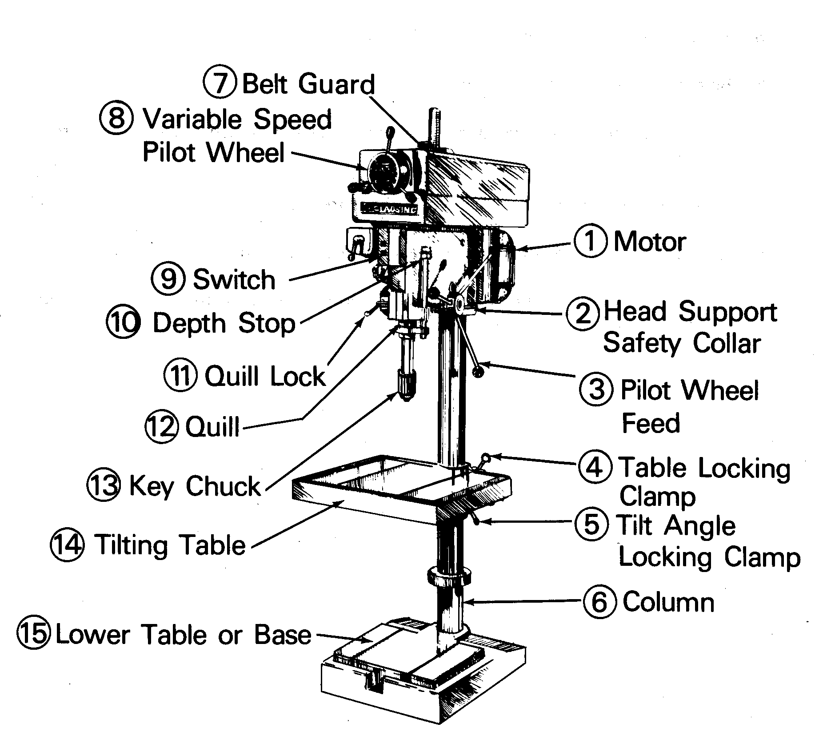

Portable Drill
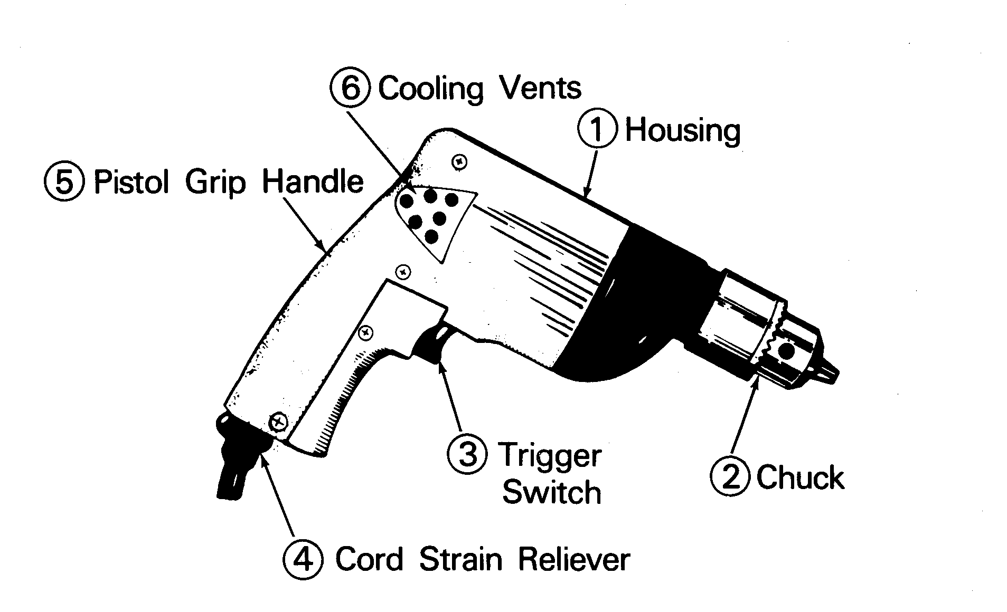

Air Impact Wrench
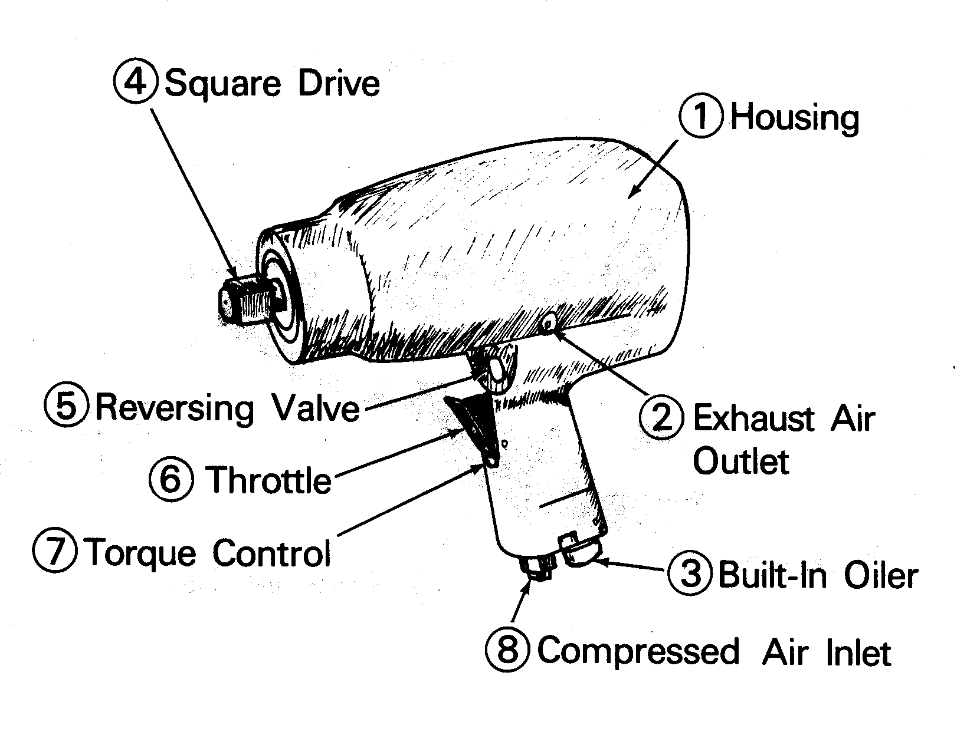

Portable Grinder
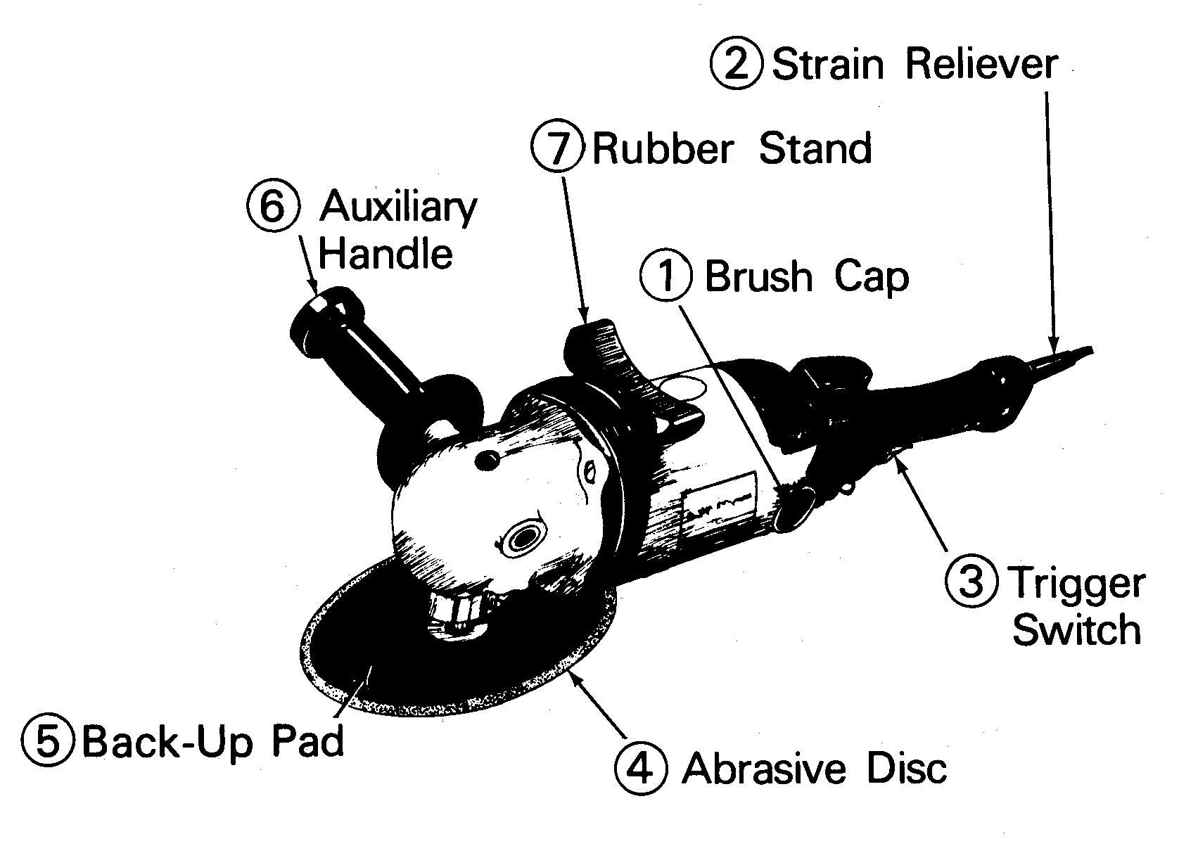

Grinder
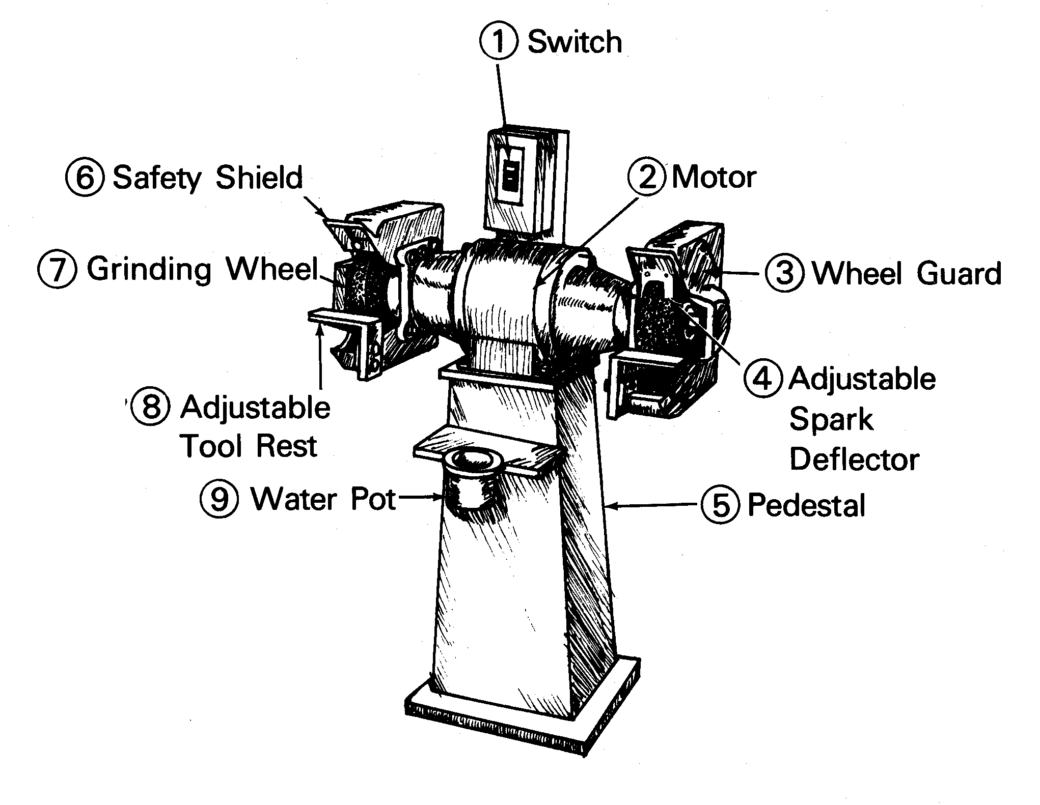

Horizontal Band Saw
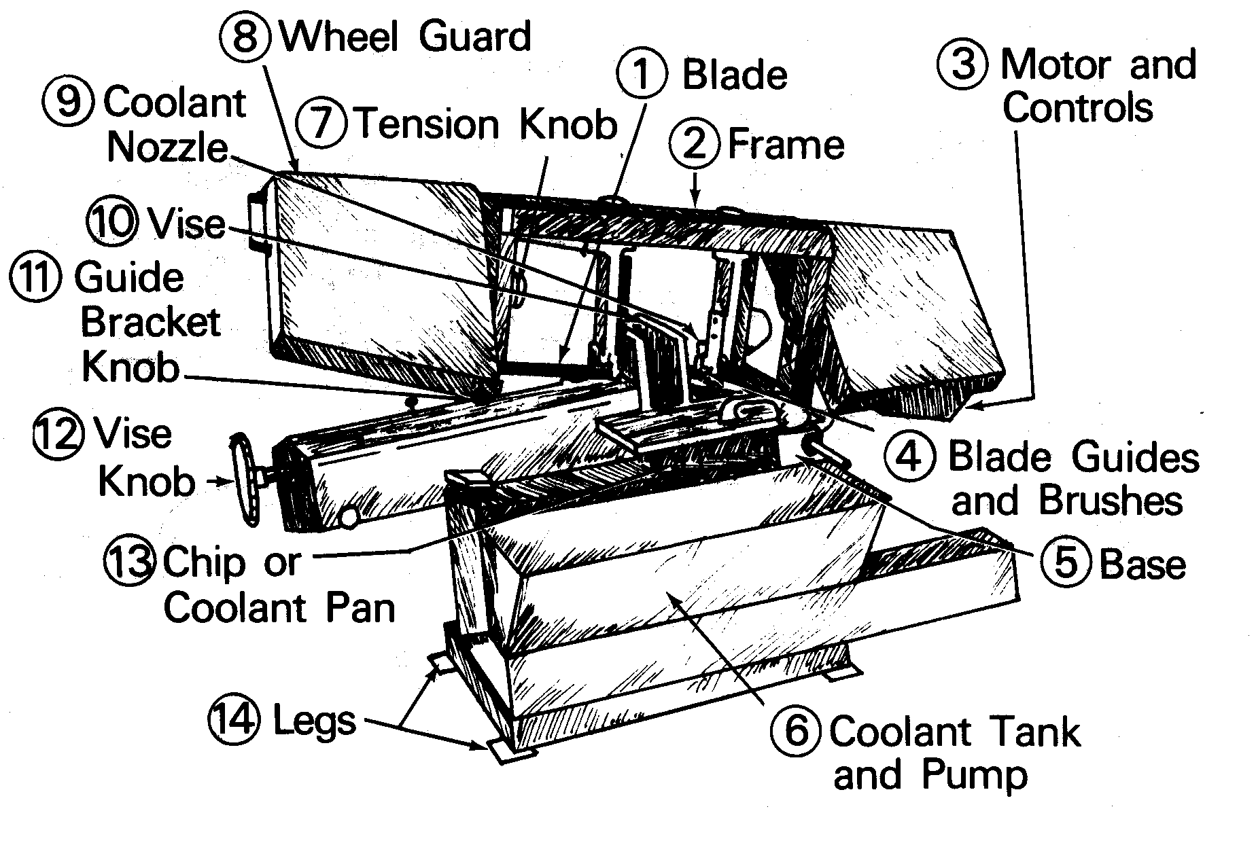

Shear
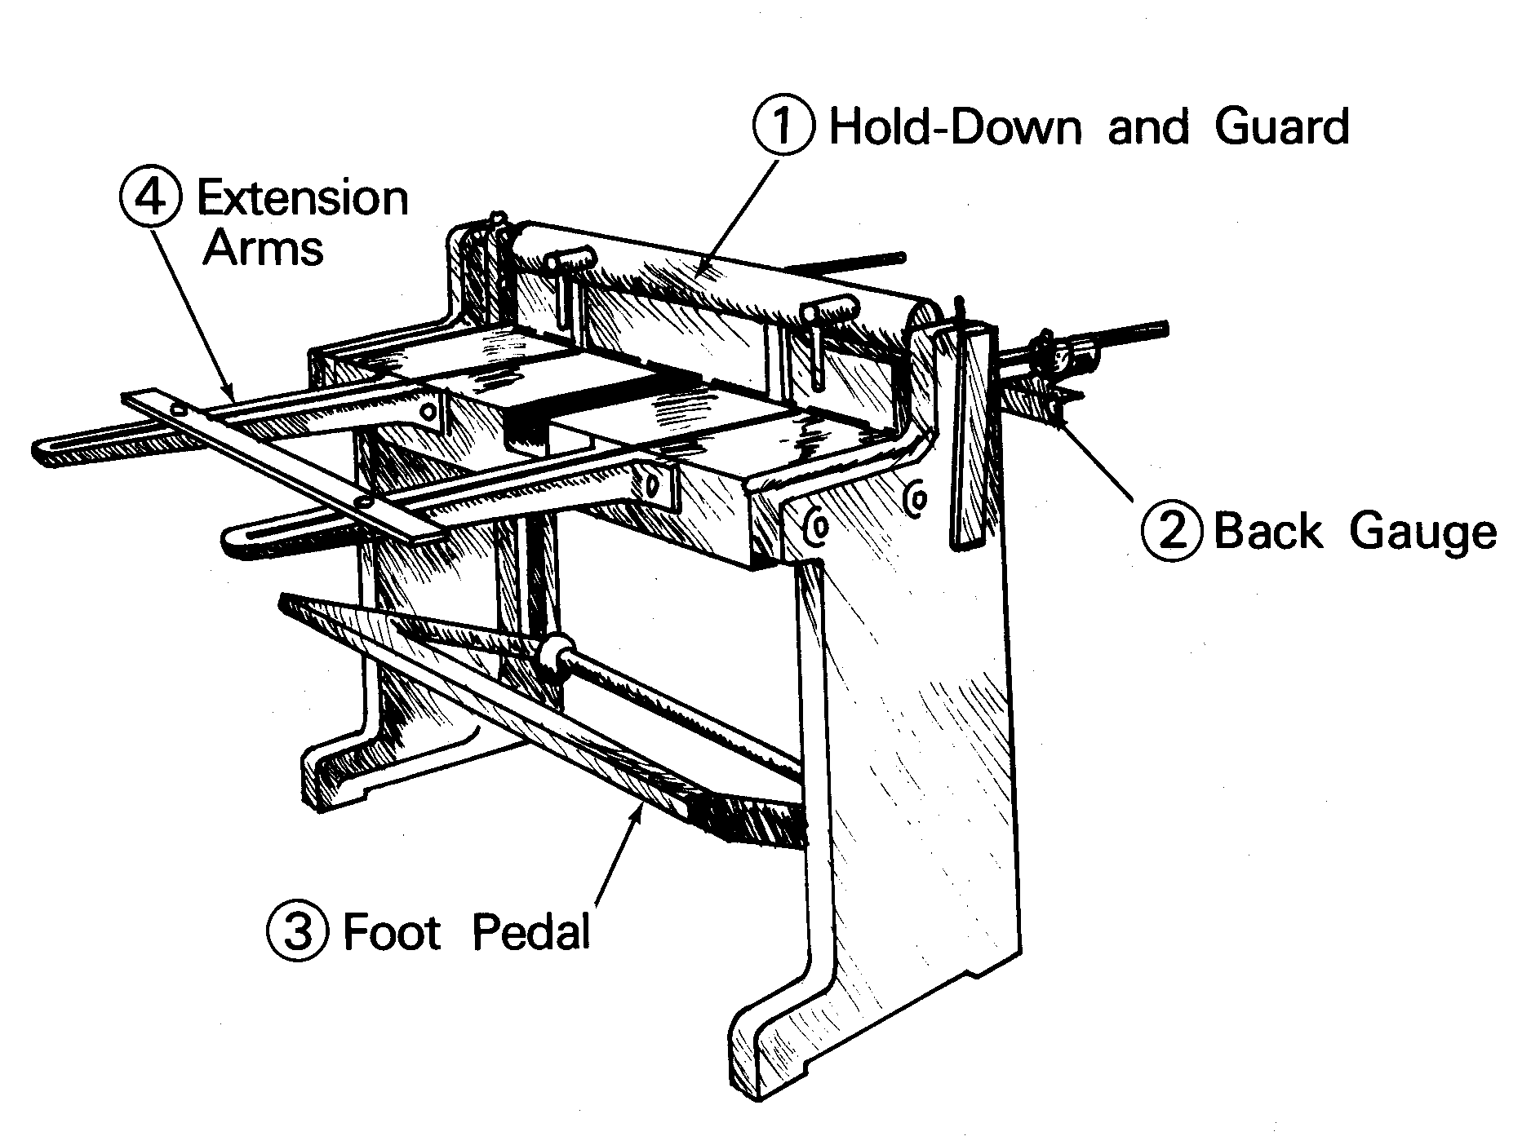

Arc Welder
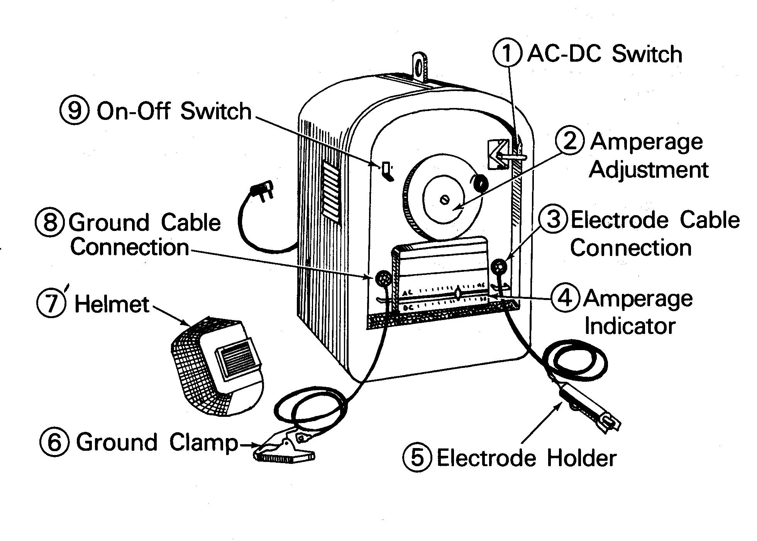

Oxygen-Acetylene Welding
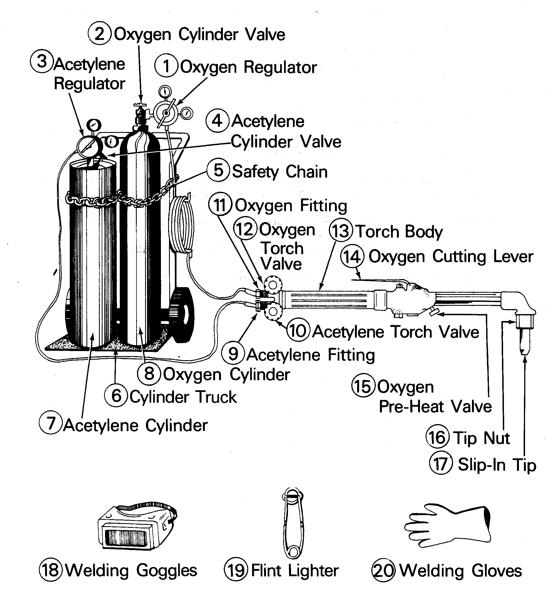

MIG-TIG Welding
