Cornice Brake

There are many types of brakes available to use when working with sheet metal. The cornice brake is the most commonly used. Safety is very important when its time to use the brake.

Key Safety Practices
- Do not place your hand in the cornice brake when someone else is operating the handle.
- Make sure when going to use the brake that no one else is near the counterbalance balls to be hit by them.
- If you are standing in front of the brake, stand back so that you will not be struck by the handles that project from the leaf when is it swung up.
- Never bend rod or wire on any sheet metal brake. This will damage the blade and the bending leaf.
- Never pound on a brake with any type of steel hammer. Always use a wooden mallet.

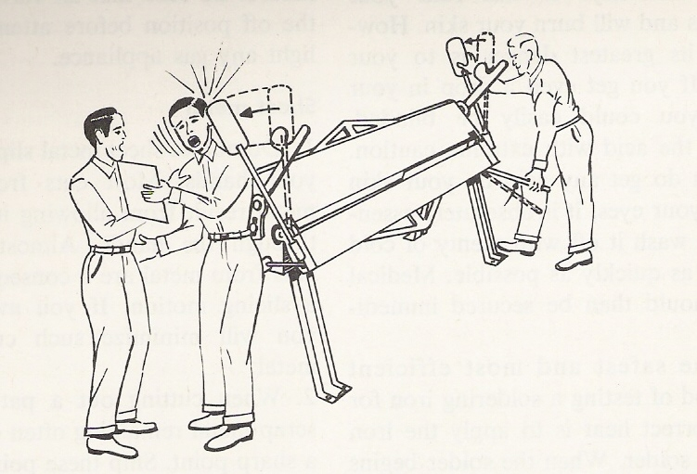

Before using the brake, the operator should be able to identify and know where and what each part is on the brake. A diagram of the brake is provided on the following page; the name is listed following the diagram.
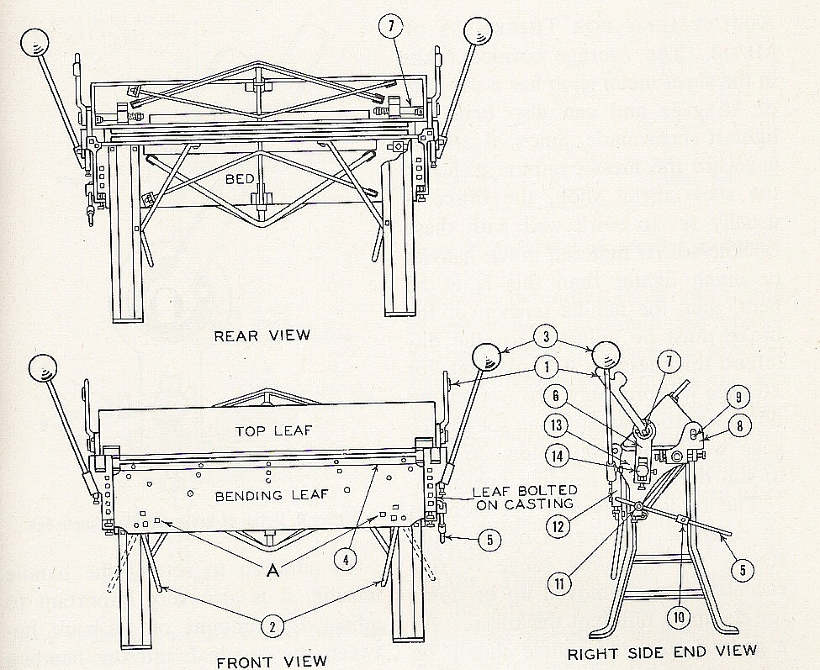

The 3 major parts of the brake are the bed, top leaf and bending leaf (shown in the front and rear views)

Additional parts to the brake are number within the 3 diagrams, labeled with a number
- Clamping handle on each side for holding the sheet in position.
- Two positions handle on each side, for operating bending leaf.
- Balance weights, adjustable to make bending operations easier.
- Upper bending leaf bar, removable when bending small locks.
- Adjustable stop gage, used to form any desired angle.
- Clamping link which operates the top shaft.
- Top shaft
- Slot casting for adjusting the bending bar for various gages of metal.
- Slot casting pin
- Adjusting stop slide on the stop gage for bending locks at various angles
- Stop gage casting
- Bending leaf casting
- Bed end casting
- Link adjusting block

